EFL learners’ procrastination in completing academic writing tasks: The factors and its possible effects

Jarum¹; Dinda Ayudiari²
jarum@umm.ac.id

¹Universitas Muhammdiyah Malang, Malang, Jawa Timur, Indonesia
²Universitas Muhammdiyah Malang, Malang, Jawa Timur, Indonesia

Abstract
Recently, procrastination has become one of the crucial problems for many students. This can affect the learning outcomes. Responding to that issue, this study was conducted to investigate procrastinating behavior encountered by the English Department students during their Academic Writing task completion. It investigates (1) the factors contributing to students’ procrastination in completing their tasks, and (2) the effects of students' procrastination on their achievement. Qualitative research design was applied. Thirty EFL learners of English Language Education Department in one of Indonesian private university participated in this research. To collect the data, questionnaire was used in the form of closed-ended and open-ended questions. From the collected data, it was found out that the students' procrastination was influenced by two major factors; internal and external. The internal factors include perfectionism, self-regulation failure, low self-efficacy, sensation seeking, lack of motivation and laziness. Meanwhile, the external factors include family background, social environment, task characteristic, distraction, another task completion, and device. In addition, procrastination has caused several effects for the students; they are health issues, decreasing productivity, losing opportunities, self-regret, losing self-confidence and a fear of getting a low score. The pedagogical implications of the research findings are further elaborated and recommendations for future work are highlighted as well.
Keywords: academic writing, procrastination, task

Introduction
Naturally, people will prioritize their duties based on their importance scale. As there will be not just one job that people do, procrastination, then, could be the choice. Doing procrastination was considered as a common thing (Liu et al., 2020; Steel & Klingsieck, 2016), not claiming someone for being good or bad. Regrettably, nowadays, the meaning of this term goes in a negative direction. Procrastination is incorrectly labeled for people who constantly delay task fulfillment without a concrete purpose.
Nowadays, procrastination has completely turned into a common behavior among folks. For students all around the globe, procrastination has been a crucial problem that unconsciously might lead the doer into a serious academic issue. Procrastination affects from the primary level students up to the high education level students. All the worse, adults are also struggling with this action (Ojo, 2019). Commonly, students who contribute to procrastination will procrastinate to work on their projects, collect their homework, and review the materials before the examination. All these problems could be triggered by their decision where they prefer to do unimportant activities like playing social media and hanging out instead of doing their duty.
Solomon and Rothblum (1984) in Jones and Blankenship, (2021) discovered that among all students, at least half of them represent continual procrastinators and one-third of them procrastinate on and off. Based on the data above, it can be identified that most of the students are academic procrastinators. Indeed, even though they are confronting a similar problem, the reason might be diverse. Some procrastinators assume that task needs to be organized orderly by spending more time to prepare the idea (Burka & Yuen, 2008). On the other hand, some procrastinators simply deny to complete the task. This denial happened because they think that the task does not meet their eagerness. That is why they do not have enough passion to complete the task as soon as possible.
Responding to such an issue, numerous studies have been conducted related to the practice of procrastination in the school environment. A study on the students and teachers of the Islamia University of Bahawalpur, Pakistan, found that academic procrastination is provoked by internal and external factors. Lack of self-management and self-motivation are known as the internal cause of procrastination. Otherwise, the family and school environment are presumed as the external factor (Hussain & Sultan, 2010)
Similarly, Setiyowati et al. (2020) found that procrastination is caused by fatigue, personality, and motivation as the internal factor. Then, the control and parenting style, as well as the quality of the task becomes the external factors of procrastination. They also mentioned that the effect of procrastination inflicts negative emotions. Then, Ojo (2019) discovered that instead of exploring their academic life eagerly, students of secondary school in Nigeria tend to waste their time on a temporary enjoyment where it does not highly contribute towards their achievement. Consequently, students were unready to learn and tend to experience failure in the teaching-learning process. That is why students are more likely to encounter procrastination.
Reviewing some relevant research findings before, it can be concluded that research on academic procrastination has been conducted at various places and levels. In academic contexts, procrastination is a common phenomenon. It has been examined from a wide range of theoretical perspectives, and numerous causes and effects have been proposed. However, research regarding the contributing factors toward the students’ procrastination in EFL setting remains underexplored. Thus, the current research is aimed at analyzing students’ procrastination, notably in the Academic Writing course in English Language Education Department, specifically in one of private universities in Indonesia. More specifically, it is proposed to: (1) find out the factors contributing to students’ procrastination in completing the Academic Writing tasks, and (2) find out the effects of students' procrastination on their Academic performance.

Literature Review
Essentially, the word procrastination comes from the root word “procrastinate” which means to delay. Procrastination originated from the Latin word, procrastinus. Zacks & Hen, (2018) explains that the word procrastinus is genuinely created by two other words which are pro means “forward” and crastinus means “belonging to tomorrow.” These words are combined into one, so it becomes procrastinus or “will be continued by tomorrow.” This definition is a sign that procrastination existed a thousand years ago.
Procrastination is an act to leave something that should be fulfilled behind and will be completed in another moment (Steel & Klingsieck, 2016). When a person has a bunch of deadlines that should be done at the same time, frequently, not all those deadlines can be handled completely. Some humans might not be able to handle two things at one time. That is one of the reasons why people delay their tasks. Ariani and Susilo, (2018) mentions that delaying is one of the ways to schedule well-organized activity. Meaning that the term procrastination referred to both positive and negative kinds of action. Procrastination can be positive actions if one procrastinates because they have to do something urgent that needs to be done first. That is why they will delay the task in order to do the other task. On the contrary, it represents a negative kind of action, if one procrastinates due to unimportant issues.
Unfortunately, the usage of this word, slightly aimed at the negative kind of action. Procrastinator is known for willingly leaving all the bustle behind for the sake of temporary enjoyments. Low awareness regarding the dangerous risks they will have to confront later makes the procrastinator be categorized as a person who has terrible personalities by the folks (Briody, 1980). Moreover, Beutel et al. (2016) explains that doing procrastination might damage the individual’s point of view toward an obligation. Procrastination will affect the way the individual executes that obligation.
The massive development of procrastination cases, specifically in the academic area has been increasing throughout the years. Based on another study, 75 percent of university students are active procrastinators, where 50 percent of students procrastinate all the time and assume that it is getting worse (Burka, 2008). It is clarifying that procrastination has turned from a choice to a behavior. Procrastination influences six main areas of human life, they are education and work area, daily activities area, health area, leisure area, relationship area, and social life area (Gropel & Kuhl, 2006; Klingsieck, 2013). However, behind all those things above, there must be a lot of factors that make a procrastinator become a procrastinator.

In the psychoanalytic concept proposed by Freud in 1953, the incomplete tasks will cause feelings that threaten the human ego. This will cause feelings of discomfort and restlessness towards the doer. Freud also stated that one of the signs that a person's ego feels insecure is anxiety (Siaputra, 2010). Accordingly, avoidance is used as a mechanism to avoid those possible threats. By avoiding a task, it will make the doer feel secure and safe at the moment. Blatt and Quinlan in 1967 stated that procrastinator generally only make decisions based on current conditions, and do not consider the future possibilities. Thus, when they are confronting the problems posed by their procrastination behavior, they will experience difficult times (Siaputra, 2010).

The existence of human behavior always has a beginning. Likewise, the appearance of procrastination must have a starting point until it is adopted as a habit by the folks. The factors are categorized into two major parts, which are internal and external factors. Internal factors encompass perfectionism, self-regulation failure, low self-efficacy, and sensation seeker. While, the external factors of procrastination include family background, social environment, distraction, and task itself (Steel & Klingsieck, 2016).
Being a procrastinator is not going to happen automatically. There is always stimulation that turns up from inside or outside one body. The stimuli that derive from the inside of one body is known as an internal factor. This factor is highly related to the mental, physical, or personality condition of an individual. The development of the internal factor is influenced by the way one treats her or himself. The internal factor consists of perfectionism, self-regulation failure, low self-efficacy, and sensation seeking.
              - Perfectionism
Most of the people start to formulate standards for gaining an optimum result of living. Those who purposefully set a complex standard of living known as a perfectionist. For average perfectionists, feeling protected, stable, and worthy of something is a faith that is supposed to be reached by having concrete standards (Briody, 1980).
However, According to Burka (2008), whenever a goal is unable to be reached, an overpowering feeling will straightly attack one. That is why when perfectionists assume that they never get satisfied with whatever thing they have done, they end up giving up on their things and they tend to procrastinate more and more.
              - Self-regulation failure
Self-regulation contributes to largely human living areas. For those who are an active procrastinator, facing inadequate self-regulation is one of their problems. Involving themselves into a lateness task submission is one of the examples of how poorly they deal with self-regulation. Rachlin (2000) states that one of the signs of self-regulatory failure is when one intends to deliberately abandon a task. According to Salzgeber (2018), people tend to postpone managing their tasks because of their detrimental feelings. Meaning that when people are surrounded by various negative feelings, the possibility of them procrastinating increases.
              - Low self-efficacy
According to Ariani & Susilo (2018), self-efficacy is a condition where there is a faith in having a capability to maintain activities and to successfully take the lead of life. Self-efficacy is extremely needed for self-improvement in defending the detrimental lifestyle. Pursuing a goal will be a lot easier when self-efficacy is high. In a similar vein, Wu & Fan (2017) mentions that the tendency of procrastination is getting lower if an individual has a better self-efficacy. Meaning that those who do not have lots of faith in themselves might procrastinate on and on.
              - Sensation seeking
Not all procrastinators are facing negative emotions. For those who voluntarily sacrifice themselves to be a procrastinator, surprisingly, they experience an enjoyment within the procrastination. Doing a task close to the submission time is such an adrenaline trigger for several people. Probably, in a sensation seeker’s mind, having this strategy is able to increase their capability in completing a task. Otherwise, if they do not use that strategy, the challenging effect will disappear (Steel, 2007; Revelle, 1997; Sommer, 1990). Indeed, in the beginning, they might feel the enjoyment of what they are doing. However, Steel (2007) mentioned the excitement of being a sensation seeker will not last long, even, it might ruin their future career. That could be caused by one who is prioritizing their desire first instead of their needs.
Procrastination, however, is not only driven by internal factors. External factors discovered in the environment around the procrastinator also contributes significantly to procrastination. They include family background, social environment, task characteristics, and distraction.
- Family Background
Family is the first environment that humans live in shortly after they are born. That is why a family relationship is closely intertwined. According to Burka (2008), all families will automatically teach life important lessons to their children. Even most newly married couples have planned their kids' future life in order to ensure that their kids will fulfill their expectations. Later on, these family values will highly affect human career, personality, and behavior. Therefore, the possibility of having procrastinated behavior might be heredity or the result of miss parenting.
Besides, every family does have its own method of raising a child. For instance, being a member of a pressuring family means being an achievement-oriented kind of person. Where this kind of family expects their members to gain a lot of achievements. For certain people, it might be an encouragement. While for others, it might be the cause of their procrastination.
- Social Environment
Human characters and personalities can be built by their social environment. The social environment can be in the form of neighborhood, friendship, or relationship. For those who are not well-communicated with their family, they tend to socialize more with their social environment.
The social environment can bring both positivity and negativity. Unfortunately, the negativity seems a lot easier to be spread over the environment rather than the positivity. As stated by Burka (2008) the procrastination habit could be constructed by one past experience, the way they socialize, and the current condition of the environment they live in. Meaning that being a procrastinator might be part of the negative effects caused by the environment. Moreover, it is strengthened by the mindset of helping each other is being a priority instead of self-prioritizing. Therefore, one tends to procrastinate for doing other requests.
- Task Characteristic
A task is something that needs to be accomplished by the folks. In accomplishing a task, people might face several obstacles that they might not have expected before. The task characteristic is assumed to be one of the obstacles. The heavier the quality and the quantity of a task, the more difficult it is to be done.
In addition, humans have different ways of dealing with an issue. They tend to discover a pleasant way to deal with issues instead of the hard one. When one is going through hardship, they might be surrounded by lots of negative thoughts like fear, hopelessness, boredom, fatigue, and anxiety. Similarly, according to Burka (2008), the reason for someone's task avoidance is because the task characteristics give the doer negative senses. Thus, in completing the task, the doer tends to feel pressured. This pressuring emotion can lead the person to be a procrastinator.
- Distraction
Distraction also becomes a part of external factors that lead one to be a procrastinator. After receiving a task, some students try to do it when they have leisure time, but unfortunately, they get distracted easily by doing other unnecessary things (Ojo, 2019). In fact, the distractions can appear from inside and outside the human body. The inside distractions are impulses and thoughts. Meanwhile, the distractions that come from the outside are other activities, mobile phone, social media, and digital platforms (Ojo, 2019).
In this case, the external distractions are influencing more than the internal ones. It is because the external distraction seems more visible and noticeable than thought. Therefore, one will be getting puzzled by the things that can capture their attention. When one finds enjoyment in doing something that is unnecessary, they will procrastinate their task.
For certain people, being a procrastinator is not a thing to be satisfied. Surprisingly, most of them are feeling discomfort by procrastination. As time goes by the number of people who aspire to get rid of procrastinate behavior is around 95% (O’Brien, 2002; Steel, 2007). This high rate might show up because the folks start realizing that the damaging consequences of procrastination will affect their life sooner or later. Unfortunately, the procrastination consequence will not only descend the doer, but it is possible to affect the procrastinator's surroundings. Doing procrastination continuously might face crucial consequences, like health issues, decreasing productivity, losing opportunities, and self-regret.
- Health Issues
The most considerable risk of procrastination is suffering a health problem. Procrastination is indeed able to affect both the mental and bodily health of one. In most cases, most procrastinators will experience stress. Burka (2008) highlights there is an intense relation between stress and procrastination. Procrastination is highly contributing to stress because when having a stressful mind, the body will experience exhaustion. Therefore, it makes one tend to postpone all activities. Moreover, when humans experience prolonged stress, the brain starts to lose its function to optimize the brain cells growth and to secure itself from a breakdown (Burka, 2008). This health problem can provoke another mental disorder, like anxiety disorder and depression.
Besides those mental disorders above, Pychyl (2013) mentions that active procrastinators tend to procrastinate on their primary health care and needs. Therefore, most procrastinators are facing several health problems, like having irregular eating patterns, dealing with sleep apnea and lack of exercise. Those mild health problems might be able to lead to the procrastinators of having a serious illness and disease. According to Burka (2008), anemia and thyroid disorders are the serious illnesses that can appear when one tends to become an active procrastinator.
- Productivity Degradation
When people procrastinate all the time, their productivity will decrease gradually. One of the indicators of unproductivity is laziness. Once laziness influences people to not do an activity, it will be challenging for them to start it over. Briody (1980) states that the word lazy refers to a reluctance in performing a certain activity because of uninterest in the activity. Meaning that, whenever people detect something that does not relate to their interest, they might not be going to complete it.
- Losing Opportunities
Commonly, procrastinators tend to decline a certain task because it does not fit their preference. Whereas, the task might become a requirement that is related to their career, academic, health, or another important aspect. Thus, if they refuse to complete it as soon as possible, they might lose a certain opportunity in their life. Cavusoglu & Karatas (2015) mentions that losing opportunities, experiencing self-blame, self-regret, and fear of failure are the common signs of a procrastinator's life. Moreover, for those who procrastinate without any certain excuse, the distance between them and failure is getting closer (Beswick et al., 1988). Which means, they are not going to reach out to their dreams.
- Self-regret
Leaving all the bustle behind by procrastinating it for the sake of temporary pleasure can make one feel free and unpressured. But once they realize that they are procrastinating, it is already overdue. It makes the possibility of losing a chance possible enough for them. Then, regret, stress, and blame will be the only emotion they feel. Burka (2008) states that people who procrastinate will be surrounded by negative emotions such as regret, disappointment, self-penalization, and hopelessness. At the end of the day, when the bad impact of procrastination appears, the procrastinator will feel apologetic to themselves for what they have done.

Method
The Research methods section describes in detail how the study was conducted. A complete description of the methods used enables the reader to evaluate the appropriateness of the research methodology. The participants/subject/population and sample used in the study should be stated. What, how, to whom the instruments used in the study should be explained. How the data was analyzed in the study should be described.
Creswell (2009) highlighted the process of constructing spacious presumptions up to determining the method to gain the information in research is known as part of research designs which, broadly, represent strategies that contributed to guidance during the research process. This strategy or plan was applied to find a result of the research problem that is discussed. By following the research design, the process will run sequentially. In this research, qualitative research design was applied. Leavy (2017) defined this type of research design accentuates the observation process to obtain numerous data that is going to be transformed into descriptive data. In other words, the data that have been collected through questionnaires will be presented in a text format.
Qualitative design was used to explore procrastination in the English Language and Education Department environment largely. Also, the researcher wants to comprehend the procrastination factors and effects based on the participants' perspectives. Through using this type of research, it is hoped that the research questions will get an honest and real answer from the participants. Accordingly, the result of this research might give a solution to decrease academic procrastinators and increase students’ productivity.
Research setting
The population of this study was the eighth semester students of English Language and Education Department in one of Indonesian private universities that has accomplished the Academic Writing class. The number of the students was around 200 students from which 15% or 30 students were selected the sample using proportional quota sampling technique (Gay, Mills, & Airasian, 2012).
The selection of those students was done by using proportional quota sampling technique. Proportional quota sampling is a non-random sampling technique. According to Sedgwick (2012), proportional quota sampling is a sampling technique where the total number of the participants that is going to be researched has decided before the data collection process started. Not only the number of the participants that has been settled, the strata of the participants also has been selected. In this study, the researcher uses gender, age, and class to become the subgroup or strata. By using this sampling techniques, the data collection process will less time-consuming.
The reason for selecting 30 students to become the research sample is because those 30 students are considered adequate to represent the entire population of the eighth-semester students. According to Gay, Mills, & Airasian (2012), one of the indicators of determining a sample in a qualitative study is representativeness. From those 30 students, the researcher will take 15 female students and 15 male students to make it fair. For the age range, the average age of the participants is 20 up to 22 years old. Also, the researcher will distribute the questionnaires to the students from A, B, C, D, and E small class. 6 students each class will be enough to complete the questionnaires. By distributing the questionnaires that way, the researcher will be able to know the factor and the effect of procrastination based on different gender, age, and class.
Data collection and analysis
In collecting the data from the sample, the researcher used a questionnaire as the tool. The use of questionnaires is aimed for gaining relevant and rational information about procrastination. Here is a further explanation of the instrument and procedure of the data collection.
As mentioned before, for gaining the information, the researcher provides a questionnaire as the instrument. Brown (2001) states that a questionnaire is an instrument that consists of a set of statements or questions, where the participants can elaborate their responses through writing a sentence or selecting the provided answer. The use of questionnaires assumed can operate the research more effectively and efficiently. For the type of questionnaire, the researcher uses a combination of closed-ended and open-ended questions.
The use of this combination is presumed to be able to produce the data needed by researchers. According to Brown (2001), a closed-ended question is the type of question where the participants have to choose one of the provided responses that can answer or respond to the question. Then, to ease the data collection, the researcher uses the closed-ended question that provides two optional responses; yes or no. It is also known as the Dichotomous question (Cohen, Manion, and Morrison, 2007).
Meanwhile, an open-ended questionnaire is a kind of questionnaire that provides some blank space where the participants can write their responses instead of choosing the provided one. Cohen, Manion, and Morrison (2007) highlighted that an open-ended question produces a deep and honest answer. This type of questionnaire is selected to give a space for the students to answer several questions in the questionnaire freely.
The researcher used this kind of combination for the research instruments because the researcher wants to collect concrete data to answer the research questions. Through this questionnaire, the participants can respond to the questions by selecting the provided responses or write on the provided blank space. By combining the closed-ended and the open-ended questions, the researcher is going to find out the participants’ responses towards procrastinating action that occurred during their Academic Writing course.
Unfortunately, due to the current unstable conditions, it is almost impossible for the researcher to distribute the questionnaire directly to the participants. Therefore, to ease the research process, the questionnaire was distributed online through Google Form. Later on, the participants will access the questionnaire by clicking the Google Form link that was sent by the researcher

Finding
The data that has been collected through questionnaires would be presented in this chapter in accordance with the research questions, namely: (1) What are the factors contributing to students’ procrastination in completing their Academic Writing tasks (2) What are the effects of students’ procrastination on their Academic Writing achievement. From these major parts, both the factors and effects will be separated into smaller part. That is how the result would be elaborated in this chapter.
The factor of the students’ procrastination
The data obtained from the questionnaire were then analyzed further. After analyzing the data, it was found that the procrastination done by the eighth-semester students of the English Education Department was caused by several internal and external factors.
The internal factors are generally related to a person's physical and psychological conditions that lead them to a certain habit or behavior. According to the participant's responses in the questionnaire, there were several internal factors that contributed to their task procrastination during the Academic Writing course, such as perfectionism, self-regulation failure, low self-efficacy, and sensation. The details are presented in the following figure.
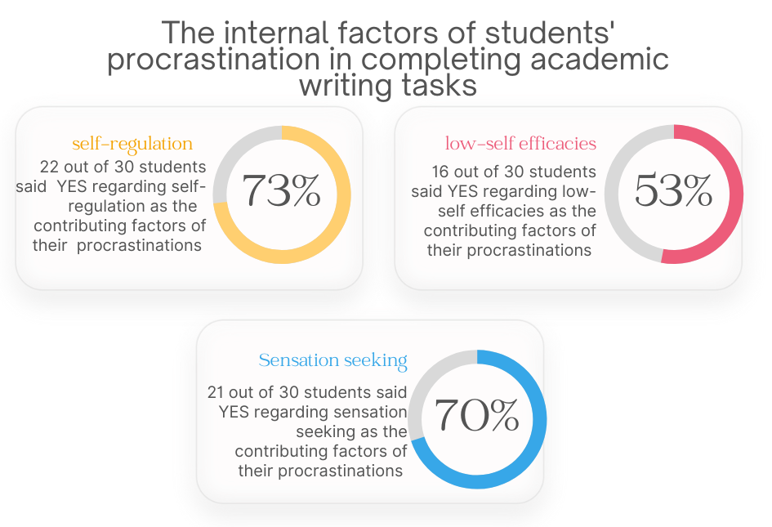
Figure 1. The findings related to the internal factors of students’ procrastination in completing academic writing tasks

Based on Figure 1., the first internal factor concerns perfectionism. Based obtained data, perfectionism was experienced by the majority of the participants as their procrastination factor. There are 22 out of 30 students who answered YES to the question related to this factor. They feel disappointed on themselves if they did not reach their expectation, for example having a good score on their writing. Therefore, they took very long time in finishing their task because they want to make their work perfect. It, unfortunately, makes them procrastinate their task, which is in fact worse for them.
The next factor is self-regulation. The result of the questionnaire said that self-regulation failure is one of the factors behind students’ procrastination. The examples of self-regulation failure include low time-management skill, inability to determine priority on their activities, spending too much time for fun, etc. In this case, there are 8 students who have low time management skill. Yet, only 2 out of 30 students that confirm they always late in submitting the writing task.
The next internal factor is Low self-efficacy. Based on the participants answers from the questionnaire, Low self-efficacy also influenced their procrastinate action during Academic Writing course. 16 out of 30 participants chose YES. They confirm that they did not believe they could complete the writing tasks because of their low writing ability. Low self-efficacy makes them avoiding the task regularly.
The last internal factor is sensation seeking. Sensation seeking becomes one of the procrastination factors faced by most of students. Based on the questionnaire, 21 out of 30 participants confirmed that they delay Academic Writing tasks due to the challenging emotion. They deliberately looking for that emotion only for satisfaction. Several participants added that they feel less stress when they procrastinate. However, most of them tend to feel stress when procrastinating due to seeking for sensation.
The surroundings factors were called the external factors. The external factors are usually influenced by people, things, and certain conditions that happened in the procrastinator's neighborhood. There are several external factors contributing to the participants’ procrastination during their Academic Writing Course task completion, namely family background, social environment, task characteristic, and distraction. The data was shown as follows.
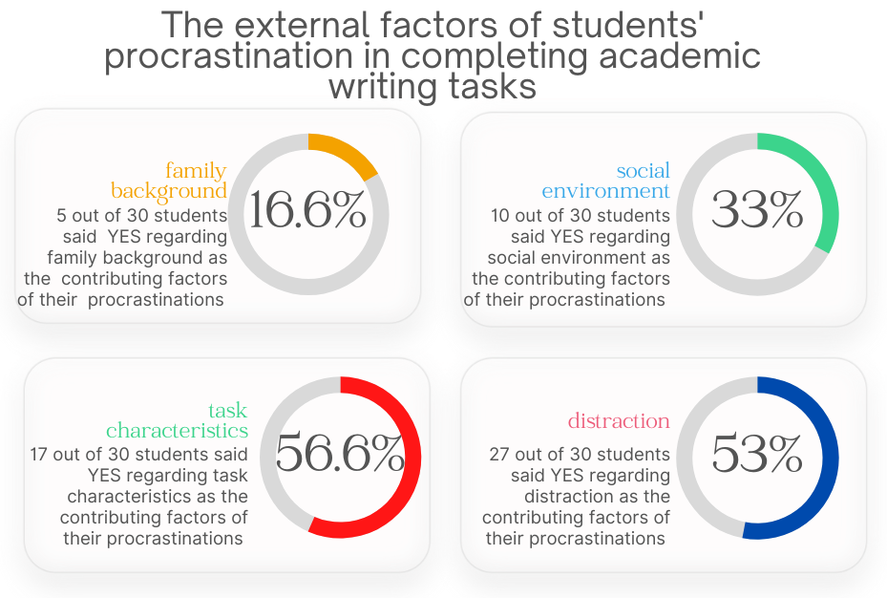
Figure 2. The findings related to the external factors of students’ procrastination in completing academic writing tasks

According to the Figure 2., the first external factor is family background. As the result of the questionnaire, family background taking a part in making students into a procrastinator. It could be caused by parenting pattern, culture, or lifestyle that is adopted by their family. However, it is experienced only by 5 participants. The majority of the students did not see that their procrastination habit influenced by their family.
The second external factor is social environment. The negative side of social environment contributes to students’ procrastination habit. 10 of 30 participants confirm that social environment influences their Academic Writing postponement. The students deliberately procrastinate Academic Writing task because they like to please other’s business first rather than their priority.
The next external factor is task characteristics. 17 out of 30 participants confirmed that the main reason for their task postponement was because the task was hard to do. Academic Writing is known as one of the difficult courses for English Education Department students. The difficult tasks inflict negative emotions like scared, boredom, fatigue, and anxiety where they tend to distract students when they were doing the tasks.
Another external factor is distraction. 27 out of 30 students answered that they were getting distracted by things around them. It could be because they did not gather their attention to only focus on doing the assignment they need to work. Therefore, most of the participants procrastinated their Academic Writing assignments because of external distractions, like gadgets, social media, and others unnecessary activity.
Beside the factors that have been mentioned before, from the result of open-ended questionnaire, several participants added another procrastination factors based on their experiences. The factors have been classified into four factors, they are another lack of motivation, laziness, another task completion, and device.
The first factor that added by 8 out of 30 participants is lack of motivation. As mentioned by the 28th participant that a lack of motivation and not having ideas to start writing the assignment (Not knowing where to start writing) was became some participants' problem as well. They felt like they did not have any interest and excitement when they wanted to do the Academic Writing task. Moreover, when they did not comprehend the assignment competently, it was way harder for them to start writing.
The second factor is laziness. The 26th participant mentioned that the factor of his procrastination was laziness. Laziness also becomes an obstacle for 6 out of 30 students when they have to finish Academic Writing assignments. Laziness can arise because there is no interest in doing something. Therefore, they choose to leave their Academic Writing assignments behind.
The next factor is another task completion. 6 out of 30 students mentioned that they usually complete the task or activities based on the sequence. It started with the one which has the closest submission time. In this case, the students seem to have another task that needs to be completed earlier than the Academic Writing task. For instance, the 1st participant mentioned that "most of the time I prefer to finish another assignment that considered had to be done first.” Therefore, some participants need to postpone the Academic Writing task several times.
The last factor that is added by 2 out of 30 participants is device. The 4th and the 9th participants mentioned that device & internet connection was the factor of their procrastination. This factor is also crucial for students. When the device does not support the task completion, they have to look for other ways to handle the situation. For example, they have to borrow someone else's device with an adequate internet connection. This condition will waste their task completion time.
The effect of the students’ procrastination
After regularly procrastinating on the task, the participants are facing various effects. The effects that caused by procrastinating frequently are health issues, decreasing productivity, losing opportunities, and self-regret. Those effects have been influenced the students’ achievement and learning process. Not only for Academic Writing course, but also in other courses. The result of the students’ responses regarding the effects of their procrastination was explained in the following figure.
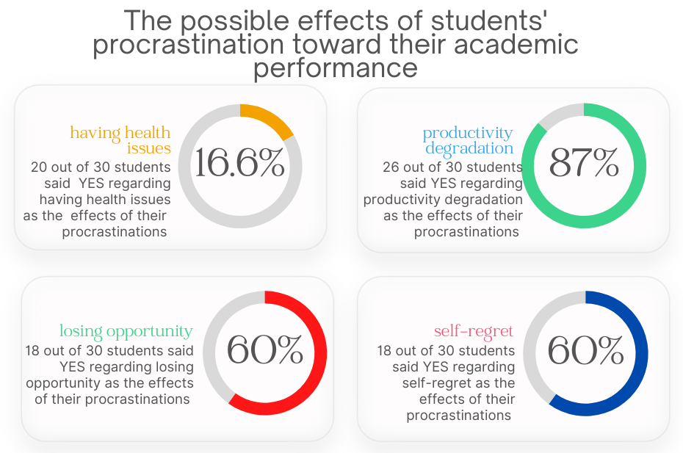
Figure 3. The students’ responses regarding the possible effects of their procrastination toward their academic performance

The first effects of procrastination experienced by the participants is having health issues. From the questionnaire, the participants who suffering health issues, particularly stress and anxiety due to the task postponement are 20 out of 30 participants. This number is high enough to confirm that most of the participants experienced several mental sicknesses whenever they were postponing an assignment during the Academic Writing class. They feel burdened because the Academic Writing assignment was getting harder, while the students were getting more unexcited to complete it. The worst is they are always haunted by having a bad score or even failing to pass the course which makes them more stressed.
The second effect caused by procrastination is productivity degradation. 26 out of 30 participants confirmed that after they delay their writing assignments too often, their productivity begins to decrease. Indeed, it was going to affect their score. Not only for the Academic Writing course, but it might also affect the other courses. They were easily distracted because they could not focus on what they were doing. Then, it could make them complete the task later.
Another effect caused by procrastination is losing opportunities. 18 participants confirmed that due to postponing the Academic Writing tasks often, they had lost learning opportunities. The opportunity to increase writing skill and getting a good score for Academic Writing course have gone because they procrastinate the tasks a lot.
The last effect of procrastination is self-regret. 18 out of 30 participants confirmed that after postponing too many tasks during the Academic Writing class, they regret what they have done. Moreover, when they receive low scores for Academic Writing or even, they did not pass the course, they will be disappointed because they did not do their best for their learning process.
Beside the effect that has been mentioned before, several students added some procrastination effects based on their experiences. Those added-factors are classified into losing self-confidence and fear of having a low score,
The first effects is losing self-confidence. 2 out of 30 participants said that they lost their self-confidence when procrastinating too much on their Academic Writing tasks. Here, the 5th participant answer that "I lose my confidence to write." It could have happened because after they got the material, they didn't do the task directly. Therefore, they forgot about the Academic writing materials that have been delivered, and it makes their writing skills not improved significantly.
The other procrastination effect mentioned by 2 out of 30 participants is fear of having a low score. The 27th participant mentioned "I am wondering a lot about my score. Will it make me satisfied or not?" They were afraid that their procrastination would affect their Academic Writing score. It is because when they do write tasks in a short time, their work will not be optimal. Therefore, they were afraid of having a low score.

Discussion
According to the data obtained from the questionnaire, it can be concluded that the students' procrastination in completing the Academic Writing task was caused by both internal and external factors. The internal factor that most influenced them was perfectionism and sensation seeking. Meanwhile, self-regulation failure and low self-efficacy were not actually experienced by most students. Besides, the researcher found that several students add lack of motivation and laziness as the reason for their procrastination. These factors were not mentioned before by the researcher.
Laziness and lack of motivation are two closely related factors. These factors also tend to make students feel unmotivated in the learning process. That is why these two factors are added by some students as factors that affect the habit of their procrastination. Students' laziness is caused by a lack of motivation in learning. When this happens in Academic Writing courses, it will make them fall behind in the lecture process. Therefore, they are more likely to postpone their writing assignments and on.
The result of this study shows a similarity to Hussain & Sultan (2010) and Triyono (2018) result study. It says that motivation becomes the root of students' procrastination. Lack of motivation made the students feel uninterested and unexcited during the Academic Writing teaching and learning process. It was influenced their performance on doing the academic Writing task. Students tend to postpone the Academic Writing task because the task was quite complicated, while they have no intention of doing it.
Whereas for external factors, distraction becomes the dominant factor experienced by the students during their writing task completion. The other factors like family background, social environment, and task characteristics were not experienced by the majority of students. However, it shows similarity to Hussain & Sultan (2010) study result which mentioned that family background is one of the external factor of procrastination. Furthermore, the students add another task completion and device as the external factors of their task postponement.
One of the reasons students procrastinate is because they have to complete tasks sequentially. At that time, there could be tasks from other courses that are accepted before the Academic writing assignment. They need to do those assignments first because they need to submit them first rather than their Academic Writing tasks. Therefore, it makes them have to postpone the writing task so all tasks can be completed optimally. As for devices, students will experience difficulties if they do not have devices that support them to carry out their tasks, such as laptops, computers, and the internet. Thus, this will hinder their academic writing assignments.
The procrastination action caused several effects. The effects that most students experienced are health issues and productivity degradation. For the health issues, students state that they felt stressed, overthinking, and anxious when delaying too many Academic Writing assignments. In line with the study conducted by Triyono (2018) that mentioned the effect of procrastination inflicts negative emotions. The negative emotions cause stress, anxiety, and other mental health issues as experienced by the students during and after the Academic Writing course. Besides, procrastination decreased the students' productivity. After they delay Academic Writing tasks too often, it makes them get more familiar with task postponement and start to establish it into a normal learning behavior. Also, procrastination causes self-regret and losing opportunity, yet they only affects several students. Furthermore, the researcher finds that procrastination causes losing self-confidence and fear of getting a low score.
Losing self-confidence is generated by the habit of students delaying Academic Writing tasks continuously. Hence, it begins several of them to be hesitant about their writing skill. Which, good writing skill needed in taking the Academic Writing course. Those who do not have confidence in their writing skills will find it complicated to produce writing tasks. Furthermore, for the higher semester students, the writing course will become harder and serious. It means that losing the confidence to write is very detrimental for English students. It also made students feeling unsure about their scores. The fear of getting a low score is a tangible form of the negative impact caused by procrastination. This fear will always exist as long as one is an active procrastinator. Moreover, this fear will be more affecting the students when the reason behind their procrastination is for the sake of temporary enjoyment. It makes them feel disappointed for not doing their best and they will worry about their learning outcomes.
The result of this study has a similarity to Ojo's (2019) study result. Both of the studies show that procrastination causes failure in the learning process. Some procrastination effects that have been found will not only harm students in the learning process, but those effects can also affect how they run their lives. This is why procrastination is very important to know its motives and effects to the doer because it is going to be useful for finding solutions to prevent procrastination behavior, particularly academic procrastination.

Conclusion
Based on the result of this study, the researcher finds out that the students' procrastination is influenced by two major factors; they are internal and external factors. These factors have a huge role in turning out students into an active procrastinator. The research finding shows that the most-faced internal factors are perfectionism and attention seeking. Meanwhile, the least-faced factor by the students is self-regulation failure and low self-efficacy. Besides, the researcher found that lack of motivation and laziness became the cause of academic procrastination of several students. From the external side, the result shows that the most-faced factor is distraction. The majority of the students confirmed that they were getting distracted by gadgets, social media and other activities outside their Academic Writing class. On the contrary, family background, social environment, and task characteristics were not experienced by many students. Most students decline that their procrastinating behavior was inherited by their family members. Moreover, the researcher found two other factors; they are another task completion and device.
Procrastination has several effects on the students' academic life. The most-faced effects by the students are health issues and productivity degradation. Meanwhile, the least-faced effect was losing opportunity and self-regret. Besides, there are two more effects that affect several students which are losing self-confidence and a fear of getting a low score.
To sum up, procrastination behavior has influenced the academic life of the students in various ways. Procrastination is caused by various factors and causes various effects to the doer. This study was focusing on a procrastination case that happened during the Academic Writing task completion. However, the results that have been found could give perspective on procrastination cases that occur in another field. It is still possible to enlarge this kind of research in the future by conducting a deeper investigation.

References
Ariani, D. W., & Susilo, Y. S. (2018). Why do it later? Goal orientation, self-efficacy, test anxiety, on procrastination. Journal of Educational, Cultural and Psychological Studies, 2018(17), 45–73. https://doi.org/10.7358/ecps-2018-017-wahy
Beswick, G., Rothblum, E. D., & Mann, L. (1988). Psychological antecedents of student procrastination. Australian Psychologist, 23(2), 207–217. https://doi.org/10.1080/00050068808255605
Beutel, M. E., Klein, E. M., Aufenanger, S., Brähler, E., Dreier, M., Müller, K. W., Quiring, O., Reinecke, L., Schmutzer, G., Stark, B., & Wölfling, K. (2016). Procrastination, distress and life satisfaction across the age range - A German representative community study. PLoS ONE, 11(2), 1–12. https://doi.org/10.1371/journal.pone.0148054
Cavusoglu, C., & Karatas, H. (2015). Academic procrastination of undergraduates: Self-determination theory and academic motivation. Anthropologist, 20(3), 735–743. https://doi.org/10.1080/09720073.2015.11891780
Hussain, I., & Sultan, S. (2010). Analysis of procrastination among university students. Procedia - Social and Behavioral Sciences, 5(August), 1897–1904. https://doi.org/10.1016/j.sbspro.2010.07.385
Jones, I. S., & Blankenship, D. (2021). Year two: Effect of procrastination on academic performance of Year two: Effect of procrastination on academic performance of undergraduate online students. Research in Higher Education Journal, 39, 1–11. https://scholarworks.utrgv.edu/tl_fac/29
Liu, G., Cheng, G., Hu, J., Pan, Y., & Zhao, S. (2020). Academic Self-Efficacy and Postgraduate Procrastination: A Moderated Mediation Model. Frontiers in Psychology, 11(July), 1–9. https://doi.org/10.3389/fpsyg.2020.01752
Ojo, A. A. (2019). THE IMPACT OF PROCRASTINATION ON STUDENTS ACADEMIC PERFORMANCE IN SECONDARY SCHOOLS. International Journal of Sociology and Anthropology Research, 5(1), 17–22. https://doi.org/.1037//0033-2909.I26.1.78
Setiyowati, A. J., Triyono, T., Rachmawati, I., & Hidayati, N. (2020). Academic Procrastination of High School Students in East Java. PSIKOPEDAGOGIA Jurnal Bimbingan Dan Konseling, 9(1), 53. https://doi.org/10.12928/psikopedagogia.v9i1.17907
Steel, P., & Klingsieck, K. B. (2016). Academic Procrastination: Psychological Antecedents Revisited. Australian Psychologist, 51(1), 36–46. https://doi.org/10.1111/ap.12173
Wu, F., & Fan, W. (2017). Academic procrastination in linking motivation and achievement-related behaviours: a perspective of expectancy-value theory. Educational Psychology, 37(6), 695–711. https://doi.org/10.1080/01443410.2016.1202901
Zacks, S., & Hen, M. (2018). Academic interventions for academic procrastination: A review of the literature. Journal of Prevention and Intervention in the Community, 46(2), 117–130. https://doi.org/10.1080/10852352.2016.1198154

