Developing Multimodal Mindful Material for Secondary School in Indonesia Post Covid-19 Pandemic
Qonita Aulia Rahma¹, Irene Nany Kusumawardani²,
auliaqonitablue@student.ub.ac.id
¹Pendidikan Bahasa Inggris , Universitas Brawijaya
² Pendidikan Bahasa Inggris, Universitas Brawijaya

Abstract
This article determines the students' perception towards the usage of multimodal in learning activities, especially English language in the class. The long pandemic has changed the students' learning style, making them back pushed into the usual classroom activity when they are offline but with some upgrading innovation. With the multimodal mindful material approach through student workbook (LKS). Media that are familiar with offline class students will adapt to the usual learning atmosphere but can still ensure that students have a broad learning experience and a free learning style. Therefore, it is possible for the teacher to accept their different learning abilities. The subjects of this research are 25 ninth grade students of SMPN 15 Malang using research and development methods. Data analysis taken with questionnaire, observation, and documentation with reference model ADDIE (Analysis, Design, Development, Implementation and Evaluation.)
Keywords: multimodality, students perception, learning motivation, mindful learning

Introduction
Prolonged pandemic seems to have an impact on the learning-teaching in the school. Because of the social distancing that was ordered by the government, the face-to-face learning that usually conducted in the school suddenly changed to online learning (Siahaan, 2020). Students who usually studied in the school then forced to learn at home independently because of the pandemic, now might study in the school anymore resulting in a transition (Carolina, et. al. 2022) and of course it damages their motivation because of the constantly changing rules. This is proven in a case that happened in China, not to mention students age children only, but most people also experience anxious and tense moods during isolation (Qiu, et.al. 2020). Abdillah and Su’eb (2022) also stated that students who have experienced their studies at home or blended learning become quieter and less motivated than those who participated in in-person learning.
The motivation itself is described as the booster for someone to improve their abilities with studies and training for gaining the better things for themselves. Motivation comes from the word “motives” that means hypothetical construct to explain people's destination based on their strategic and intention (Fitriani, Agustina, 2022). It can be seen in the students, when they have high motivations for learning it will affect their performance and vice versa (Firmansyah, 2021) on their educational background.
Nowaday it's not the new things that motivation is very affecting the students' minds, so it is very influential to build the conditions and the learning quality, not to mention during the vulnerable pandemic because of interaction restrictions and so many tasks are piled up in the online class. (Fidiniki, Fernanda, 2021) Pandemic also give big damages to social relationships, physical activity, and nutritions and reduce the social activities between their friends, family, neighbors (Ammar, et.al, 2020) but increased their interaction on media social that gives an impact to their anxiety and cardiovascular disease (Mattioli, et.al 2020)
Therefore, as the teacher who pay attention and observing in this condition, it is required to compose and implement the lesson plan, assess and evaluate the learning outcomes, develop and implement improvement programs, and giving enrichment to the students (Kemendikbud, 2010) to rebuild the motivation and improve the students’ spirit learning that have been got down causing of the past pandemic.
This transition will give many impacts towards the learning innovations for students and chances for teachers to adapt it into the learning media by using the technology in online class while face-to-face learning is re-enacted. Jayananda, et.al (2020) showed that the media development nowadays have been influenced by the technology, so that it can be developed through audio, visual, audiovisual, even other technology that can be applied in a learning media.
With the goals of rebuild the students’ motivation that have been down caused of the unstable changes, english language activity desired to make students more active and critical so that directly involved to make the more meaningful learning. Of course to make meaningful learning, it should begin with a clear systematic and objective framework so that students can develop their thoughts systematically, logically, and critically (Jayananda, et.al, 2020). This framework can be served with the students' workbooks (LKS) as a guide to achieve a learning goal. Purniasih (2017) defines students' workbooks (LKS) as a sheet of paper that contains an instruction to carry out a task that is related to the subject of the study.
The usage of students' workbooks (LKS) in the classroom itself is expected to change the strategic of learning which the teacher being the center of the class, to be how to enrich the students learning experience independently so that can grow the motivation of the study because of the structured format and able to give the attractiveness to the students to learn the material being taught. (Sakdiah, Kurniati, 2019)
One of the media that can accommodate the students’ needs in this pandemic transition is students' workbooks Mindful Multimodal that can facilitate the needs and the differents of students learning style and variations so that except can give the worth experience and improving the creativity, it also can take the advantages of technology and strengthen the communication between teachers and students. Marlina (2018) stated that mindful learning is the ability to make a decision, take an action, and know the specific impact for themselves with rational reason. While the multimodal learning itselfs described as many of the instructional elements sensory mode (visual, written, aural) that have been collaborated and presented in one learning environment for considering the changing needs of today's students and to take advantage of existing technological advancements. (Bouchey, et.al, 2021)
Mindful learning approach is a way to develop students' mindset and creativity by accommodating the new information and awareness of learning (Marlina, 2018) so students are expected to explore and construct their new knowledge and ability with consciousness by socializing with peers to make more meaningful learning. Mindful learning is seen as effective in the context of English learning to enhance students' language skills, collaboration, communication, and creativity (Saputra, et.al. 2020). By ADDIE methods that are constructed in students' workbooks Mindful Multimodal, mindful learning will be created effectively and give the students a chance to learn independently so that their curiosity is growing and their mindset will become more critical because it is honed with the openness of available information and their motivation step by step will increased while learning in post pandemic situation.
While learning with multimodal have been known for a long time and enough to have a lot of positive impact because students can learn better while facing with their own learning style (Taufiq, 2021) so students expected to be more critical and active in learning-teaching atmosphere with exploring the things around it. Multimodal learning also aims to promote the students' encouraging voice and focus on students preferences by shaping the content of learning, giving the response options, and the good instructional delivery (Nouri, 2018, Puong, et.al, 2017) so that the teacher can identify the student’s need for learning.

Method
This research was conducted in SMP Negeri 15 Malang jl. Bukit Dieng Permai No. 8 Pisang Candi, Kec. Sukun, Malang City, East Java 65146. This research is using descriptive qualitative methods and the subjects are 25 of ninth grade students. While the variables that have been used are LKS, English Language knowledge load, English Language ability load, and multimodal approach.
This research was using the developmental model ADDIE (Analysis, Design, Development, Implementation, Evaluation). At the stage of (Analyze) analysis of curriculum, material, and basic competence have been done in class 9 theme “Let’s Live a Healthy Life.” Then, in the stage of (Design) it begins to design the students' workbooks that are structured to produce the blueprint after compiling with the multimodal approach and developed from thematic learning in the school. In the third stage is (Development) after getting validation from a practitioner (teacher) then to the next step (Implementation) and (Evaluation) to 25 students of Ninth grade of SMPN 15 Malang.
Instrument that has been used in this research is questionnaire to collect the data that related to the evaluation of the usage of students' workbooks Mindful Multimodal in the form of Google Form. The contents of questionnaire are load some instruments of assessment that test the validity of students' workbooks Mindful Multimodal; (1) from the segment of students' workbooks which covers the clarity of instructions, the clarity of learning objectives which appropriate with basic competences and core competences material “Let’s Live a Healthy Life”, a content suitability with the level of ability and students development, (2) from the segment of serving the students activity, the language are used is easy for understanding (3) from the segment of multimodal activity which covers the design, visual, font, color selection in students' workbooks (4) from the physic which covers the attractive fonts, and proportional students worksheet. While the assessment that has been used is using ordinal scale. STS (Saya Tidak Setuju) for very disagree, TS (Tidak Setuju) for disagree, N (Netral) for neutral answer, S (Setuju) for agree, and SS (Sangat Setuju) for Very Agree of answering the question.

Result and Discussion
Through the English Language, students should be more active and responsive towards the learning process so that it can create the ability to communicate critically and think logically.

In general, students' worksheets contain practical instructions for experimenting with practice questions that invite students to participate in the learning process. Most of the teachers still using the students worksheet in the printed book to accommodate students learning so that technology utilization in offline classes can’t b maximized so that innovation is needed to take advantage of technology and put them together in a worksheet that can accommodate a variety of student learning style, named students' workbooks Mindful Multimodal. As for the appearance of the students' Workbooks Mindful Multimodal after this validity test, has an attractive appearance. This can be seen from the survey which shows that 92% of 25 students agree with this opinion.

In the first appearance of English learning, students' workbooks given from the teacher are interesting.

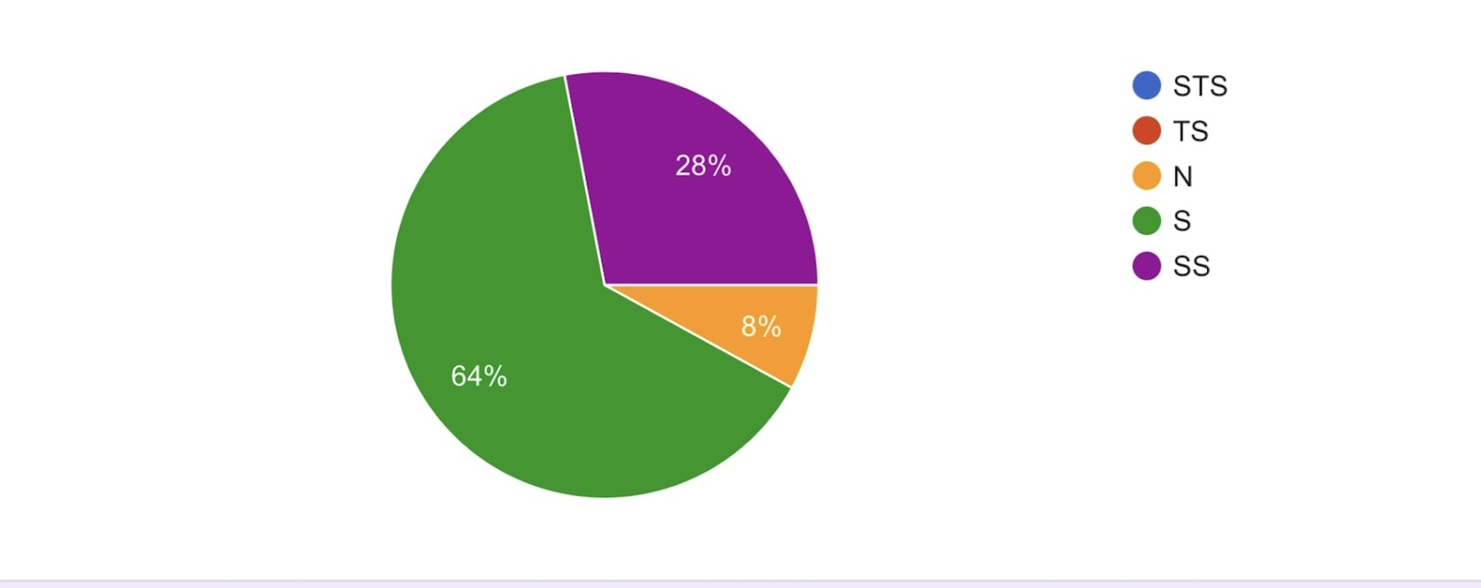

Picture 1. Score of students attention toward students’ workbooks mindful Multimodal

The variety of assignments, layouts, readings and others in the student workbook amazes my attention to learning English.

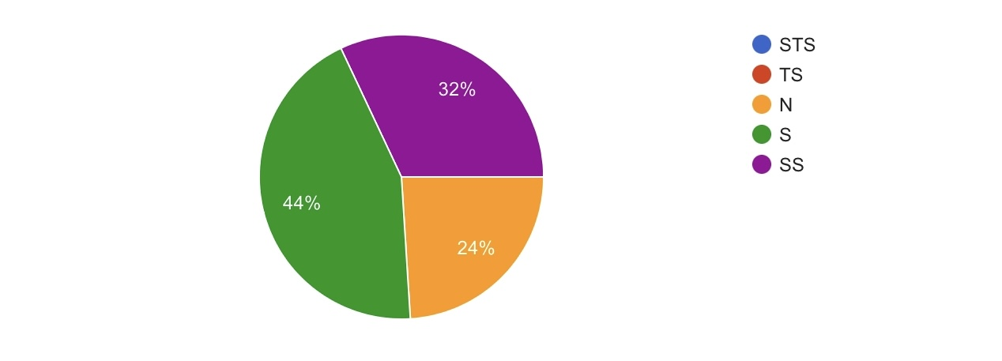

Picture 2. Score of students opinion towards LKS Mindful Multimodal

The development of this students’ workbook Mindful Multimodal has been carried out in accordance with the development of ADDIE. The research of validity aspect is also carried out such as the clarity guide for using the students’ worksheet, the comprehension of ability, the suitability of abilities with the level of development of students. (2) from the serving segment such as the language used is easy to understand because there are translations of every available context, the structured and neat format (88% from respondent). This can be seen from the diagram below if the majority of the students agree on the structure and content of the given multimodal worksheet (92% from the respondent).

The translations in students’ workbooks help me to understand the meaning of the English language.

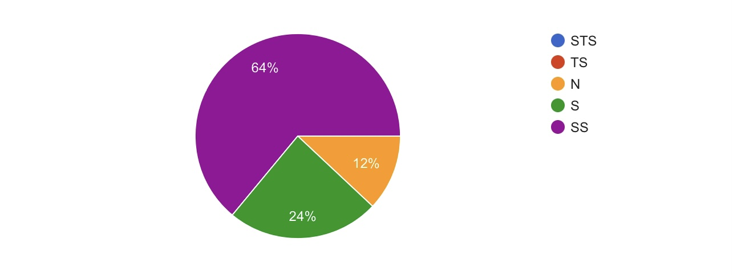

Picture 3. Score of students’ understanding towards students’ workbooks Mindful Multimodal

The structure in students' workbooks is more organized so that makes it easier for me to learn the English language.

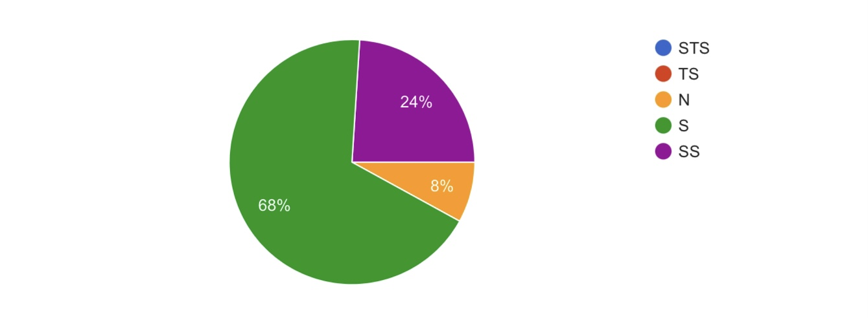

Picture 4. Score of students perception towards the structure that have been displayed in students’ workbooks Mindful Multimodal

(3) from the multimodal segment that serves the design, linguistics, and spatial. This is approved by the majority of respondents as seen from the table below (92%) and students’ workbooks given a score 80% from the respondent who filled out the survey.

Students workbooks “Let’s Live a Healthy Life is interesting and I like the designs and colors of it.

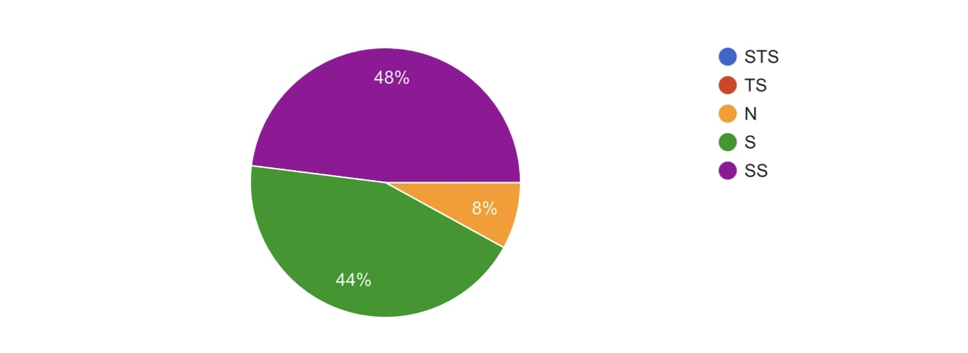

Picture 5. Score of students insight towards the design and colors in Students’ Workbooks Mindful Multimodal

The names in worksheet 1 (Finding Nemo) and worksheet 2 (Omona :o) in students’ workbooks attract my attention.

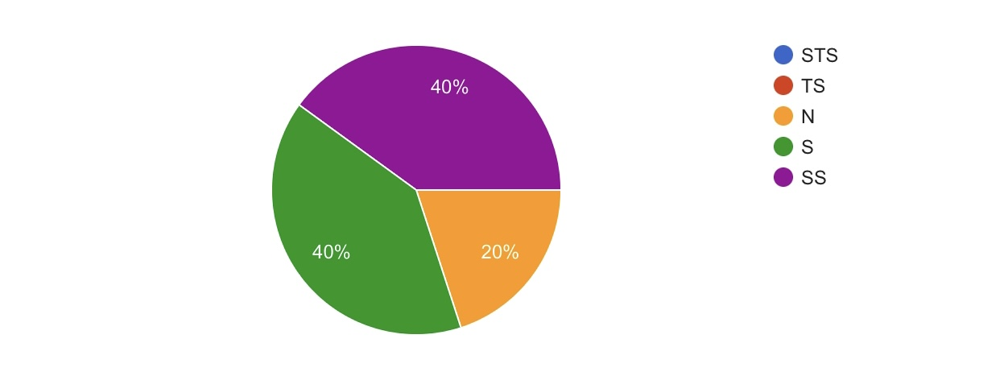

Picture 6. Score of students minds towards the activity topic in students’ workbooks Mindful Multimodal

(4) from the physical segment such as the use of the attractive and appropriate fonts, color selection in images and attractive and proportional designs.

In the future, I hope I can learn English with interesting and organizing students’ workbooks.

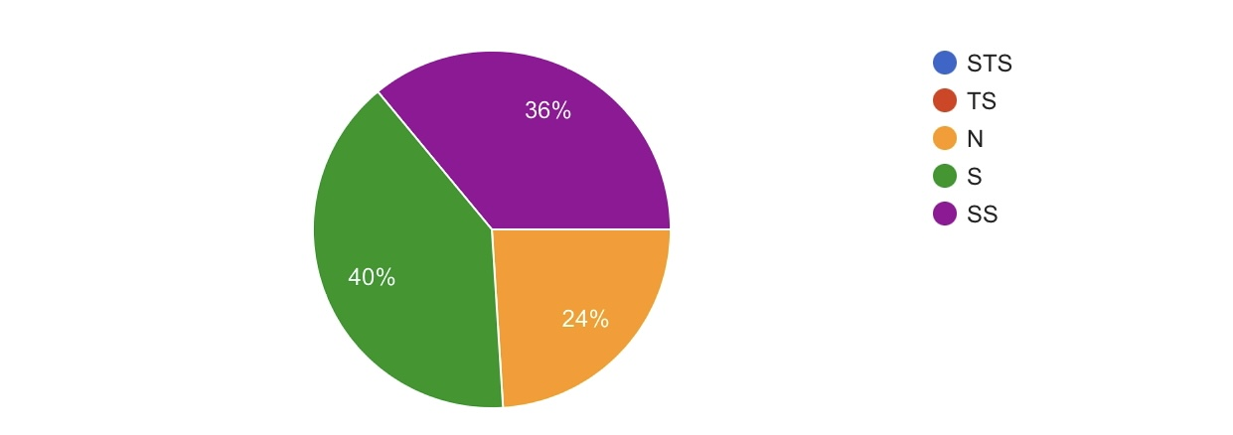

Picture 7. Score of students expectations towards LKS Mindful Multimodal

The next is a table diagram of students' motivation towards the use of students’ workbooks Mindful Multimodal as teaching materials and learning guides at school. As many as 68% of the respondents consider their learning motivation when using students' workbooks Mindful Multimodal tends to increase and feel enthusiastic when using students’ workbooks Mindful Multimodal in teaching and learning activities (76% of respondents).

My motivation towards learning the English language has increased after using the students’ workbooks.

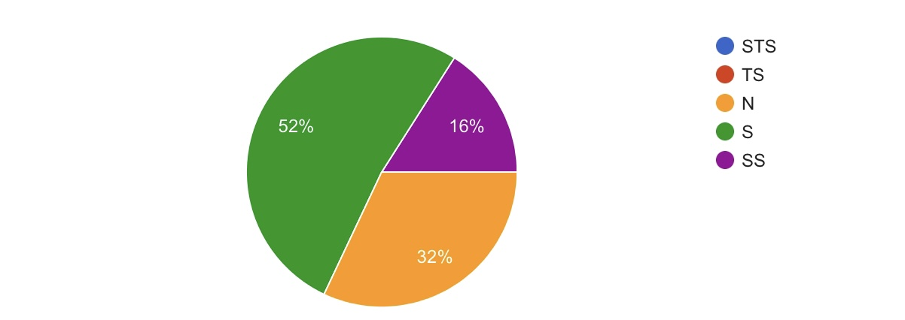

Picture 8. Score of students perception towards the motivation of learning English using LKS Mindful Multimodal

I feel enthusiastic about learning English in the classroom using the students' workbooks that are given.

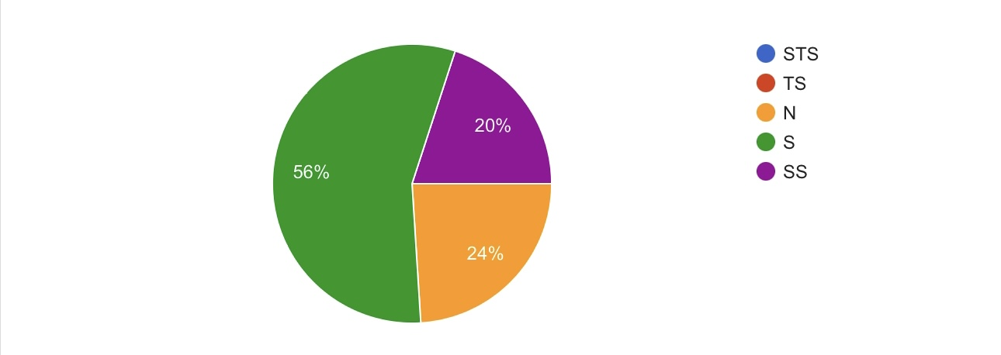

Picture 9. Score of students enthusiasm towards LKS Mindful Multimodal

The use of students workbooks Mindful Multimodal received quite a positive response from respondents as a teaching medium that accommodates students in offline classes after the pandemic. Apart from its attractive design, this LKS Mindful Multimodal is also communicative and interactive, as can be seen from the cover which is decorated with marine and sky ornaments to make it look fresh and pleasing to the eye and the dominant blue sheet of paper.

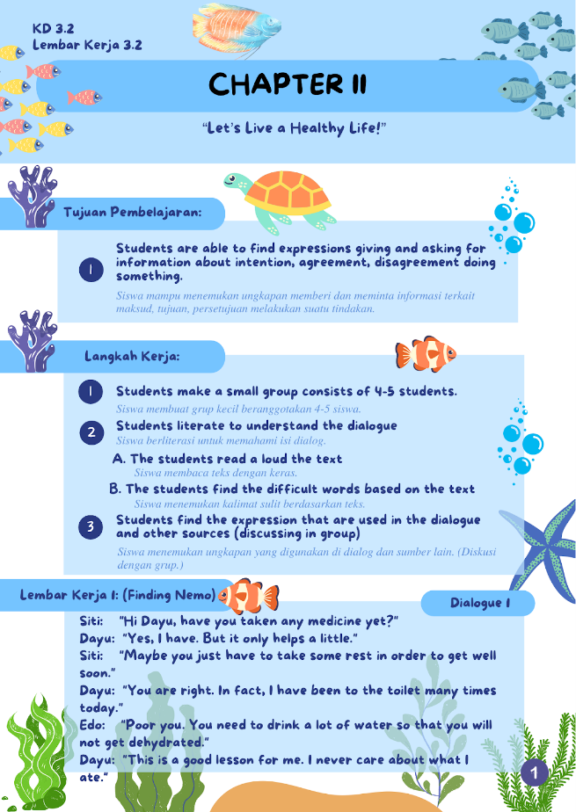

Picture 10. Students workbooks mindful of multimodal appearance.

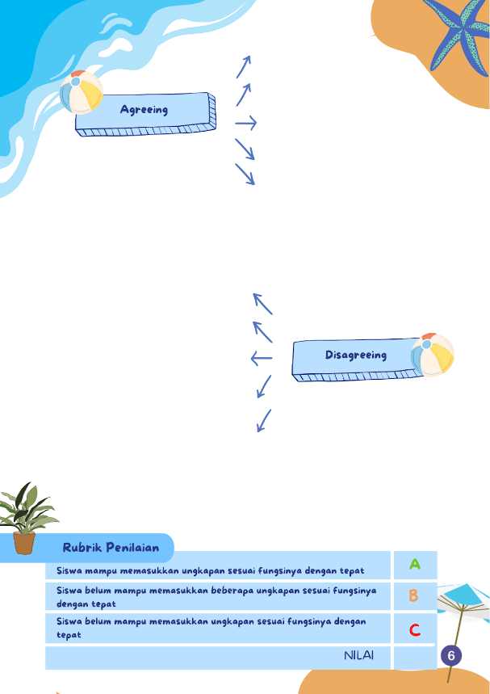

Picture 11. One of Students' workbooks mindful multimodal exercise and assessment page.

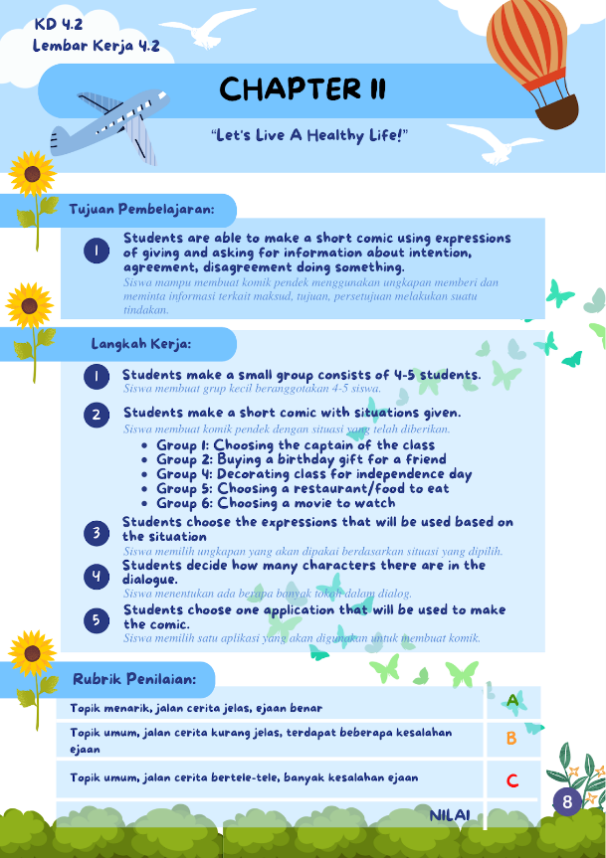

Picture 12. Students Workbooks mindful multimodal group works page.

Purnama, (2010) also revealed that blue color can give the impression of something and stimulate challenges, and provide a psychological response to beliefs, technology, conservatives, and orders to the audience. The title font used is large (29 cm) and unique but still clear (More Sugar fonts) so as to create a relaxed atmosphere but still serious in learning. In the content section, the learning objectives, work steps, and worksheets in the chapter are also described in a coherent manner so that students who do not receive school textbooks do not have to worry about not being able to follow the lesson. Assignments and assessments as well as construction of work assignments such as making mind maps, dialogues, and comics based on these dialogues are written in a neat format so that students can also estimate the results they get from the tasks they are trying to do. The creation of worksheet names is also made unique (finding nemo worksheets: which are in accordance with the learning objectives to find expressions of agreement and omona worksheets: which are in accordance with the learning objectives to select and conclude expressions based on their functions. There is a power-point presentation displayed on the screen Class LCDs during the teaching and learning process that are in accordance with the contents of the multimodal worksheet also help students guide assignments and understand the lessons given, which as a percentage of audiovisual design in multimodal principles, as well as small word translations in student’s workbooks Mindful Multimodal that are inserted in the assignment command make students better understand the assigned task.

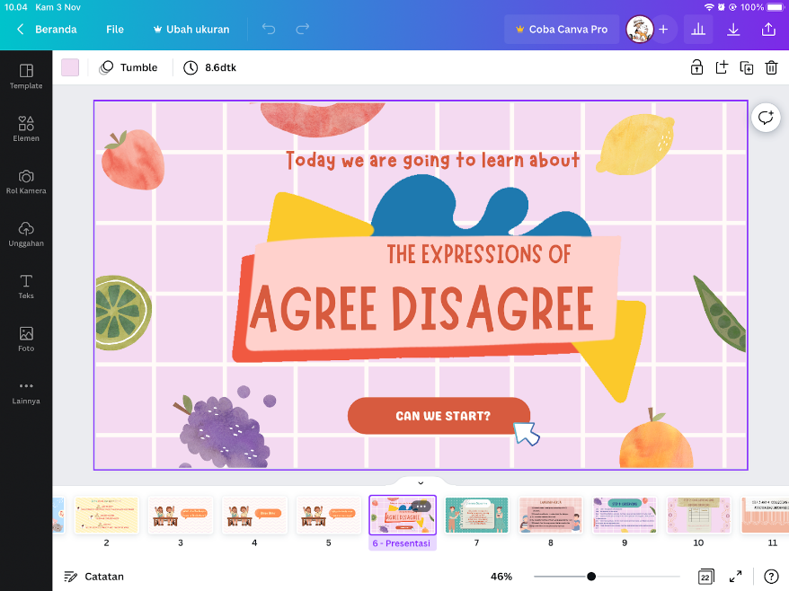

Picture 13. PowerPoint front view

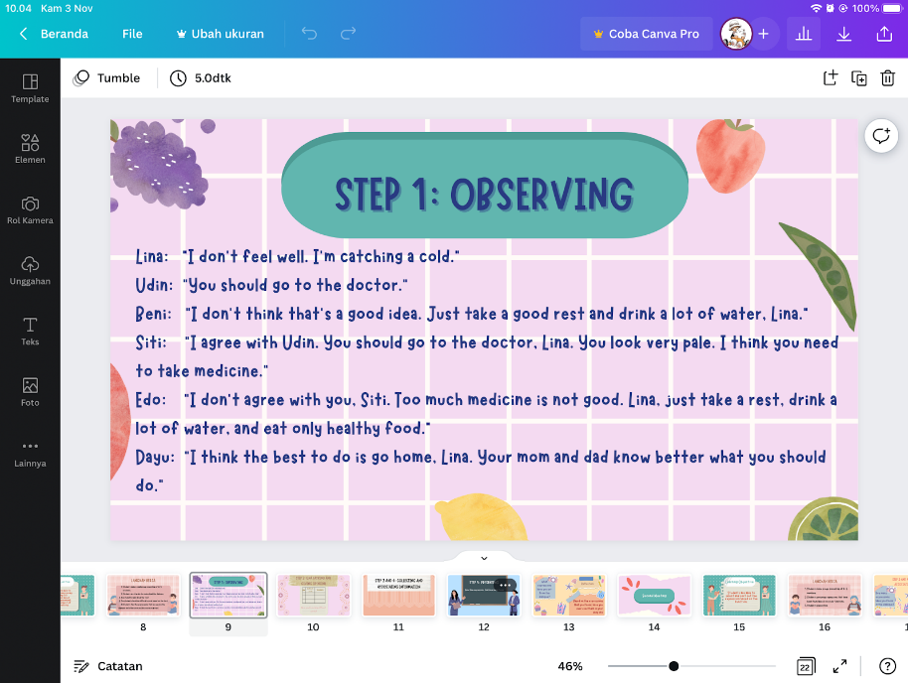

Picture 14. Material example in PowerPoint

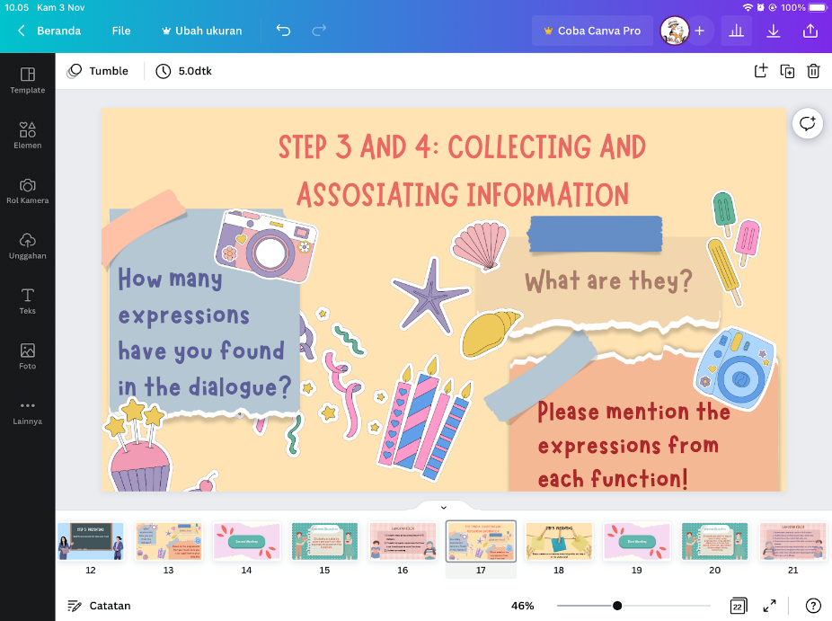

Picture 15. Reflection page for students

Thus, this Students’ Workbooks Mindful Multimodal product can be in a very good and reliable category to use because the measurement results obtained are consistent and in accordance with predetermined criteria so that the results of this study can be said to be valid and can increase students' motivation for their learning activities in the classroom by utilizing various media such as visual, audiovisual, and so on.

Conclusion
The development of LKS Mindful Multimodal is using the ADDIE model (Analysis, Design, Development, Implementation, and Evaluation) that has been evaluated to 25 of ninth grade students of SMPN 15 Malang. Improving the students’ motivation in this post pandemic era really needs to be driven for the advancement of education and student development and teachers should create many innovations and adapt to what happened in the past such as give the chance to do the range activity tasks with their friends and make collaborative learning (Abdillah, Su’eb, 2022) so that students can again feel a comfortable and interactive learning atmosphere in offline classes.
Acknowledgement (if any)

Great thanks honorably given to IDEAS Journal and students of class 9 SMPN 15 Malang graduation 2022 as the respondents that have supported and helped in this research.
References
Abdillah, Jibriil Ahmad; Su’eb, Sueb. Students’ Learning Motivation toward the Implementation of Blended Learning during Post-Pandemic EFL Classroom. Pioneer: Journal of Language and Literature, [S.l.], v. 14, n. 1, p. 278-297, June 2022. ISSN 2655-8718. Available at: https://ojs.unars.ac.id/index.php/pioneer/article/view/1706. Date accessed: 09 nov. 2022. Doi: https://doi.org/10.36841/pioneer.v14i1.1706.
Al Fajri, Taufiq Akbar. (2021). Pentingnya Penggunaan Pendekatan Multimodal dalam Pembelajaran. Malang. Fakultas Ilmu Administrasi, Universitas Brawijaya. DOI: https://doi.org/10.21776/ub.waskita.2018.002.01.5
Ammar A, Chtourou H, Boukhris O, Trabelsi K, Masmoudi L, Brach M, Bouaziz B, Bentlage E, How D, Ahmed M, Mueller P, Mueller N, Hsouna H, Aloui A, Hammouda O, Paineiras-Domingos LL, Braakman-Jansen A, Wrede C, Bastoni S, Pernambuco CS, Mataruna L, Taheri M, Irandoust K, Khacharem A, Bragazzi NL, Strahler J, Washif JA, Andreeva A, Khoshnami SC, Samara E, Zisi V, Sankar P, Ahmed WN, Romdhani M, Delhey J, Bailey SJ, Bott NT, Gargouri F, Chaari L, Batatia H, Ali GM, Abdelkarim O, Jarraya M, Abed KE, Souissi N, Gemert-Pijnen LV, Riemann BL, Riemann L, Moalla W, Gómez-Raja J, Epstein M, Sanderman R, Schulz S, Jerg A, Al-Horani R, Mansi T, Jmail M, Barbosa F, Ferreira-Santos F, Šimunič B, Pišot R, Pišot S, Gaggioli A, Zmijewski P, Apfelbacher C, Steinacker J, Saad HB, Glenn JM, Chamari K, Driss T, Hoekelmann A, On Behalf Of The Eclb-Covid Consortium. COVID-19 Home Confinement Negatively Impacts Social Participation and Life Satisfaction: A Worldwide Multicenter Study. Int J Environ Res Public Health. 2020 Aug 27;17(17):6237. Doi: 10.3390/ijerph17176237. PMID: 32867287; PMCID: PMC7503681.
Bouchey, B., Castek, J., Thygeson, J. (2021). Multimodal Learning. In: Ryoo, J., Winkelmann, K. (eds) Innovative Learning Environments in STEM Higher Education. SpringerBriefs in Statistics. Springer, Cham. https://doi.org/10.1007/978-3-030-58948-6_3
Carolina, Nona, Azizah, Siti Nur, Sholihah, Laila Melati Nur, Rosyidah, Ummy, Purwanti. (2022). Analisis Pengaruh Transisi Pembelajaran Jarak Jauh ke Pembelajaran Tatap Muka terhadap Kesehatan Mental Pelajar Pasca Pandemi Covid-19: Yogyakarta: Jurnal Seminar Nasional Psikologi Universitas Ahmad Dahlan.http://seminar.uad.ac.id/index.php/SNFP/article/view/9598
Fernanda, M. S., & Fidiniki, A. . (2021). Peranan Kesehatan Mental Remaja Saat Pembelajaran Daring Pada Masa Pandemi. Jurnal Pendidikan Tambusai, 5(3), 8591–8599. Retrieved from https://jptam.org/index.php/jptam/article/view/2359.
Fitriani, Leni. Agustina, Dwi. (2022). Students’ Motivation to Complete the Study in the Pandemic Time: Some Reflections for Post Pandemic Era: Pekalongan. English Language Literature and International Conference: Vol. 5 No. 1. https://jurnal.unimus.ac.id/index.php/ELLIC/article/view/9668
Hermawan, Budi. April 2013. Multimodality: Menafsir Verbal, Membaca Gambar dan Memahami Teks.Bandung. Jurnal Bahasa & Sastra, Vol. 13 No. 1. DOI: https://doi.org/10.17509/bs_jpbsp.v13i1.756
Jayananda, DPAP, Aryana, IBP, Lasmawan, IW. August (2020). Pengembangan Lembar Kerja Siswa Berbasis Multimodal Melalui Analisis Muatan Pengetahuan dan Keterampilan IPA Pada Tema Peristiwa Dalam Kehidupan Kelas V Sekolah Dasar: Singaraja. Jurnal Penelitian dan Evaluasi Pendidikan Indonesia, Vol 10 No 2. DOI: https://doi.org/10.23887/jpepi.v10i2.3512
Kemendiknas. (2010). Permendiknas No. 35 Tahun 2010 tentang Petunjuk Teknis Pelaksanaan Jabatan Fungsional Guru dan Angka Kreditnya. Jakarta: Pusat Pengembangan Tenaga Kependidikan.
Marlina (2018). Implementasi Pendekatan Pembelajaran Mindful Learning Dalam Meningkatkan Aktivitas Dan Hasil Belajar Pendidikan Agama Islam Pada Siswa Kelas VIII A Di SMP Budaya Bandar Lampung Tahun Pelajaran 2018/2019. Fakultas Tarbiyah dan Keguruan, Universitas Islam Negeri Raden Intan Lampung. http://repository.radenintan.ac.id/4825/
Mattioli AV, Sciomer S, Cocchi C, Maffei S, Gallina S. (2020) Quarantine during Covid-19 outbreak: Changes in diet and physical activity increase the risk of cardiovascular disease. Nutrition, Metabolism & Cardiovascular Diseases.;30:1409–1417 DOI: 10.1016/j.numecd.2020.05.020
Nouri J (2019) Students multimodal literacy and design of learning during self-studies in higher education. Technol Knowl Learn p. 24:683. DOI:10.1007/s10758-018-9360-5
Phuong AE, Nguyen J, Marie D (2017) Evaluating an adaptive equity-oriented pedagogy: a study of its impacts in higher education. J Effect Teach 17(2):p. 5–44. https://repository.isls.org/bitstream/1/1609/1/496-503.pdf
Purnama, Sigit. 2010. Elemen Warna dalam Pengembangn Multimedia Pembelajaran Agama Islam: Al-Bidayah, Vol. 2 No. 1 p.113-129. https://media.neliti.com/media/publications/284641-elemen-warna-dalam-pengembangan-multimed-bd89f442.pdf
Qiu J, Shen B, Zhao M, Wang Z, Xie B, Xu Y. A nationwide survey of psychological distress among Chinese people in the COVID-19 epidemic: implications and policy recommendations. Gen Psychiatry. 2020 Mar 6;33(2):e100213. Doi: 10.1136/gpsych-2020-100213. Erratum in: Gen Psychiatry. 2020 Apr 27;33(2):e100213corr1. PMID: 32215365; PMCID: PMC7061893.
Riinawati. (2021). Hubungan Konsentrasi Belajar Siswa Terhadap Prestasi Belajar Peserta Didik Pada Masa Covid-19 di Sekolah Dasar: Edukatif: Jurnal Ilmu Pendidikan Vol. 3 No. 4 p. 2305-2312. DOI: https://doi.org/10.31004/edukatif.v3i4.886
Saputra, Made Julio, Piscayanti, Kadek Sonia, Agustin, Dewa Ayu Eka. (2020). The Effect of Mindful Learning on Students’ Writing Competency. Jurnal Pendidikan Indonesia vol. 9 No. 4 DOI: https://doi.org/10.23887/jpi-undiksha.v9i4.25484
Siahaan, Matdio, 2020. Dampak Pandemi Covid-19 Terhadap Dunia Pendidikan: Jurnal Kajian Ilmiah No. 1 p.1-3 DOI: https://doi.org/10.31599/jki.v1i1.265

