TEACHERS’ STRATEGIES TO HANDLE DISRUPTIVE STUDENTS IN FREEDOM WRITERS MOVIE
Norliani
norliani@stkipbjm.ac.id
STKIP PGRI Banjarmasin

ABSTRACT

The objective of this research was to find out the teachers’ strategies to handle disruptive students in Freedom Writers movie. This research used descriptive qualitative research. The source of data in this research is obtained from the movie “Freedom Writers”. The instrument of this research is the researcher herself. In collecting the data, the researcher used an analysis document. The data sources documented in this study is in the form of the content in the Freedom Writers movie. Techniques of data analysis are: watching the movie repeatedly, noting the strategies that the teacher did and, categorizing the data by using Harmer ‘s theory (2001) and by Hue & Lie (2008) . The finding showed that the teacher applied verbal strategies that proposed by Hue & Lie (2008), from six verbal strategies, the teacher used two strategies namely boosting interest, and calling on students, besides that, the teacher also applied two strategies that proposed by Harmer (2001), they are talk to individual and use activities. with this research hopefully it can provide an overview how to deal with disruptive students in the classroom.
Keywords: Disruptive Students, Freedom Writer movie, Teacher Strategies

Introduction
Education is the process where an individual gets knowledge and It is also where a person develops skills essential to daily living, learns social norms, develops judgment and reasoning, and learns how to discern right from wrong. Education helps remove poverty and hunger, giving people the chance at better lives. This is one of the biggest reasons why parents strive to make their kids attend school as long as possible. Apart from school, we can also get education from our parents. school as institution consist of a group of people working together cooperatively, rather than unilaterally, to achieve a common goal. One of the important elements of school is teacher, because the teacher has a big task to educating their students, to transfer knowledge, guiding, training, assessing, evaluating and also to change their bad into good habit.
One of the greatest challenges for teachers is creating an environment focused on learning and teaching. It is more than managing the behaviour of students - it involves creating an optimal classroom environment where learning and teaching can take place effectively. Even the teacher totally prepared before teaching, there are always those unexpected bumps in the road--one being difficult students, for this situation teacher must manage the class, Classroom management is the process by which teachers and schools create and maintain appropriate behaviour of students in classroom settings. One of the keys to effective classroom management is the development of a quality relationship between the teacher and the students in the classroom.
In teaching and learning process teacher must have skills in managing the class he teaches. Class management is one of the fundamental skills of teaching. In this case, the teacher must have the ability to control and inspire a class There are many things that teachers have to overcome when teaching in the classroom, one of the problems is the students uncooperative or disruptive behaviour during the teaching and learning process, they have not enjoyed working with, Lack of cooperation can take many forms: chattering in class not listening to the teacher, not doing homework, lateness, rudeness. Haroun and O’Hanlon (1997) define disruptive behaviour as an activity which caused distress for teachers, which disturbed good order in the classroom, and cause trouble, which led teachers to make continual comments to the students. Umar and Khair (2022), in their research found there are eight kinds of disruptive behaviour found namely inattention, apathy, moving about the room, annoying others, cheating, needless talk, disrupting, and exaggeration talk.
The case raised in the movie Freedom Writers” is taking stories from a Vocational secondary school in Long Beach, specifically the experience of one classroom of 203 with an English teacher and a new female guardian named Erin Gruwell. She is very intelligent and creative in educating her students. In this film, the teacher or Mrs Gruwell taught her students, and she used some strategies to handle this situation. Based on the background above, the researcher interested to search the teachers’ strategies to handle uncooperative student in the teaching and learning process. Why the researcher took this movie because the theme of this movie was education and gave benefit knowledge how to manage the class. the aim of this research is to find out what are
Hue & Lie (2008) as cited in Umar and Khair, suggested two strategies in dealing with students’ disruptive behavior, nonverbal and verbal intervention strategies. If the situation was very worse or some more disruptive behavior takes place, the teacher can do the nonverbal strategies, but if this strategy was not successfully the teacher can apply the verbal strategies. There are four strategies in non-verbal, planned ignoring, signal interference, proximity inference, and touch interference. Whereas, there are six verbal strategies, praising peers, boosting interest, calling on students, using humor, asking questions and request and demands.
Harmer (2001) said there are five strategies that the teacher can do to handle disruptive students, talk to individuals (teachers can speak to individual members of the class outside the classroom. Write to individuals, ( the same effect can be achieved simultaneously with all students by writing them a letter. Use activities (teachers can make it clear that some of the more enjoyable activities which students like to do will only be used when the class is functioning properly. Make a language -learning contract (teachers can talk directly on the students about issue of teaching and learning. In this research, the researcher used both theories, by harmer (2001) and Hue & Lie (2008), about the strategies used by teachers to handle disruptive students.
The issue about how to manage the students in the classroom is not new, so many researchers did in this field one of them the study by Umar and Khair (2022), the title of their research was teacher’s Strategies in Reducing Students’ Disruptive Behavior in Indonesian EFL Classroom, and the result of the research was the teacher applied some strategies namely, proximity interference, touch interference, signal interference, calling out names, asking question, request & demands, and psychological punishment. The differences between this research and the previous research are the object of the research, the theory that the researcher used and the method of the research..
Method
This research was descriptive qualitative research, which aims at describing the teacher strategies to handle disruptive students found in the “Freedom Writer” Movie. The source of data in this research is obtained from the movie “Freedom Writers” to describe the teacher strategies to handle disruptive students applied by the teacher that found in the movie since this film has much good value about how are the roles of educator in the teaching and learning process to create a good atmosphere to students actively and passionately.
The instrument of this research is the researcher herself. In collecting the data, the researcher used an analysis document. The data sources documented in this study is in the form of the content in the Freedom Writers movie. Techniques of data analysis are: watching the movie repeatedly, noting the strategies that the teacher did and, categorizing the data by using Harmer ‘s theory (2001) and by Hue & Lie (2008).
Results
After the researcher watched and analyzed the data, it is found that the teacher applied verbal strategies that proposed by Hue & Lie (2008), from six verbal strategies, the teacher used two strategies namely boosting interest, and calling on students, besides that, the teacher also applied two strategies that proposed by Harmer (2001), they are talk to individual and use activities.
Table 1. Teacher’s Strategies to handle disruptive student proposed
by Hue & Lie (2008) and Harmer (2001)

No | Strategies | Yes | No |  | minutes
1 | Hue & Lie (2008)  - Nonverbal strategies
1 | - planned ignoring, |  | √
1 | - signal interference |  | √
1 | - proximity inference |  | √
1 | - touch interference |  | √
1 | - Verbal Strategies
1 | - praising peers |  | √
1 | - boosting interest | √ |  |  | 14:31, 19: 44, 30:06
1 | - calling on students | √ |  |  | 15:11, 28: 14
1 | - using humor |  | √
1 | - asking questions |  | √
1 | - request and demands |  | √
2 | Harmer (2001)  - talk to individuals | √ |  |  | 01: 34: 59  01: 49: 32
2 | - write to individual
2 | - use activities | √ |  |  | 41: 38
2 | - make a language learning contract |  | √

Discussion
Based on table 1 above, we can see that the teacher or Mrs. Erin applied four strategies to handle disruptive student.
- Boosting interest.
Picture 1, Mrs Erin applied boosting interest
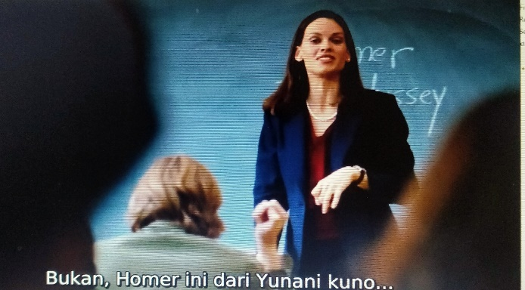
The picture above depicts that Mrs. Erin used booting interest when she taught about the epic poem of Homer the Odyssey. when she wrote homer's name on the blackboard, and one of her students said, he only knows about Hormer the Simpson. Mrs. Erin just laughed and she explained that this Homer was from Ancient Greece and bald like the Homer simpson.
Picture 2. Mrs Erin applied boosting interest
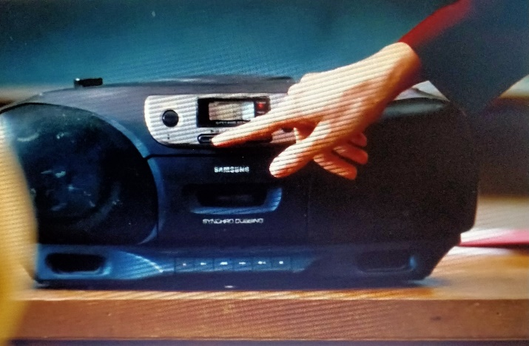
In scene 19:44 we can see, Mrs. Erin also uses a booster interest to attract the attention of her students, because we can see clearly when Mrs. Erin come and taught for the first time, all the students in the class have no desire to study, they come late, make up, chat with friends, sleep, read magazines, and to get their attention Mrs Erin plays music in front of the class when discussing about Tupak Shakur.
Picture 3. Mrs. Erin applied boosting interest

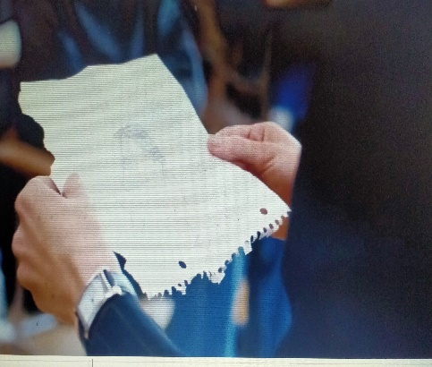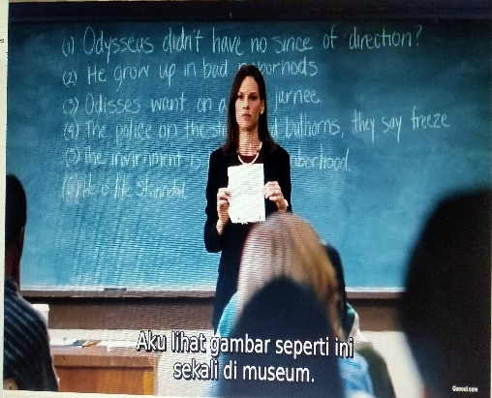

in scene 30: 06 Mrs. Erin also uses boosting interest, to overcome students who interfere with the teaching and learning process. During the lesson, one of the students named Tito drew a sketch of Jamal's face, and when Mrs. Erin found out she also told him a similar drawing that she had seen in the Museum.
- Calling on Students
Picture 4. Mrs. Erin applied calling on students
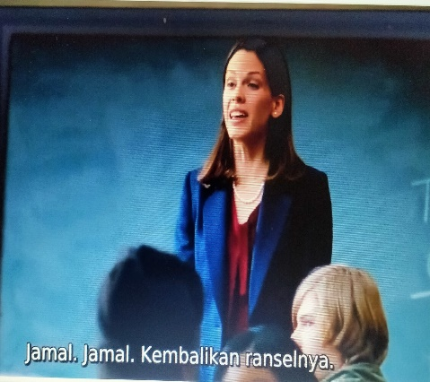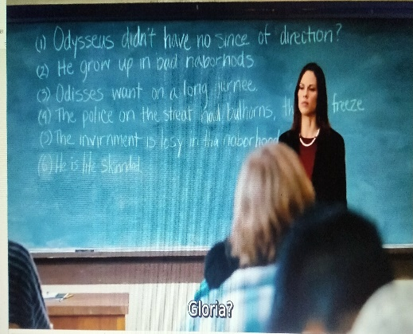
Mrs. Erin used to call on students’ strategy when Jamal took Gloria's bag, Mrs. Erin asked Jamal to return it, we can see it happened in the scene 15:11. Mrs. Erin also uses calling on students’ strategy at the scene 28: 14, she called gloria and asked her to read a sentence about the odyssey poem by Homer, it was done because she saw gloria does not pay attention and only reading magazines.
- Talk to Individual
Picture 5. Mrs. Erin applied talk to individual
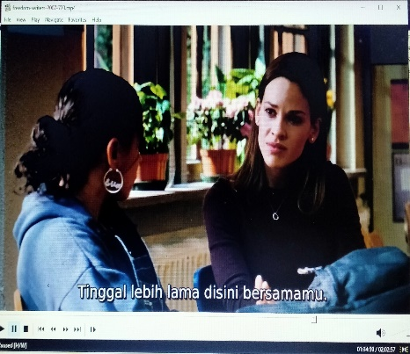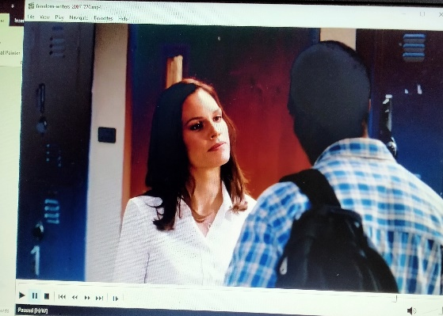

From the picture above, showed that Mrs. Erin is a teacher who really cares about her students, this proven when we observe from the teaching and learning process in the classroom, Mrs.Erin always communicates to all her students by accepting feeling, praising or encouraging, accepting or using students' ideas, asking questions, lecturing and giving directions. The teacher also interacted with individual students by accepting feeling, reminding noisy students, and helping the student’s work. It has happened when one of her student named Andre didn't go to class because he felt he couldn't get good grades, and Mrs, Erin is encouraging and motivating that he will definitely succeed in getting good grades, besides that, Mrs. Erin also accompanied Eva to study and listen to Eva's story.
- Use Activities
Picture 6. Mrs. Erin applied use activities strategy
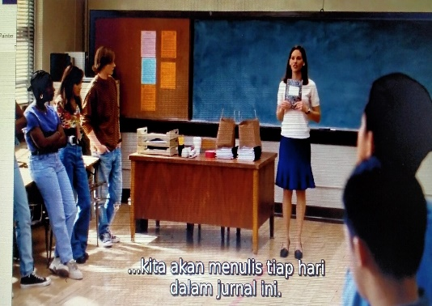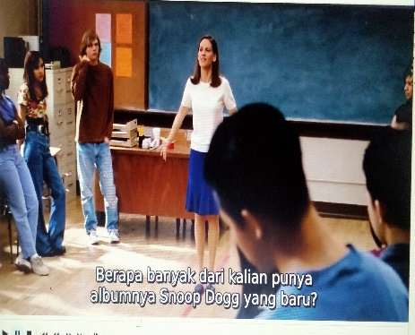

In the picture above we can see, that when she taught, she used some activities to attract students' attention, because they do not interest in learning, one of the activities was game. We can find it in scene 41:38.
Mrs. Erin applied these strategies because she wants to create an effective teaching and learning process, and as a teacher she can control students’ behavior.

Conclusion
Based on the data finding and the discussion above, it can be concluded that the teacher in this case Mrs.Erin applied four strategies namely, boosting interest, calling on the students, talk individual, and use activities to handle disruptive students found the Freedom Writers movie, with this research hopefully it can provide an overview how to deal with disruptive students in the classroom. In these parts, the researcher will give some suggestion, the teacher should manage the classroom, control their student’s behavior for example uncooperative student, to prevent the situation, teacher should choose the best way to handle it. The finding of this research can not be generalized because the subject of the research is movie, and for next researcher, it is suggested to observe the real situation in the classroom and can use the other strategies.

References
Haroun, R, & O’Hanlon, C (1997), Teachers’ Perceptions of Discipline Problems in a Jordanian Secondary School, Pastoral Care in Education

Hue, M., & Lie, W (2008), Classroom Management: creating a positive Learning Environment. Hongkong University Press

Harmer Jeremy, (1998), How to Teach English, An Introduction to the Practice of English Language Teaching: London Longman

Umar & Rahmat Khair (2022) Teachers’ Strategis in Reducing Students’ Disruptive Behavior in Indonesian EFL Classroom, English Review: Journal of English Education. Volume 10, Issue 2, June 2022

O’Ferral Beaty Ellen Mary, Alan Green & Fred Hanna, (2010), Classroom Management Strategies for Difficult Students: Promoting Change through Relationship, Middle School Journal, March

Saun Saunir, Evajustika Gultom, (2016). The Role of Classroom Management in Creating an Effective English Learning, Journal of English Language Teaching Volume 5, No 1, Series A, September 2016

Suswanto Gading (2020), An Analysis of Classroom Management in English Teaching Learning Process at SMPN 19 Seluma In Academic Year 2019/2020, English Education Study Program Faculty of Tarbiyah and Tadris, State Islamic Institute of Bengkulu
Rinawati (2020), The Effect of Classroom Management on Students’ Learning Outcomes at SMP Negeri 2 Anggereja Enrekang. English Education Department . Muhammadiyah University.

https://drive.google.com/file/d/1Th4EQ_S9J-Yjofsr6cRFjaiZ5R6xsxP8/view?usp=share_link

