Figure 1.1 A cover of Arabic textbook

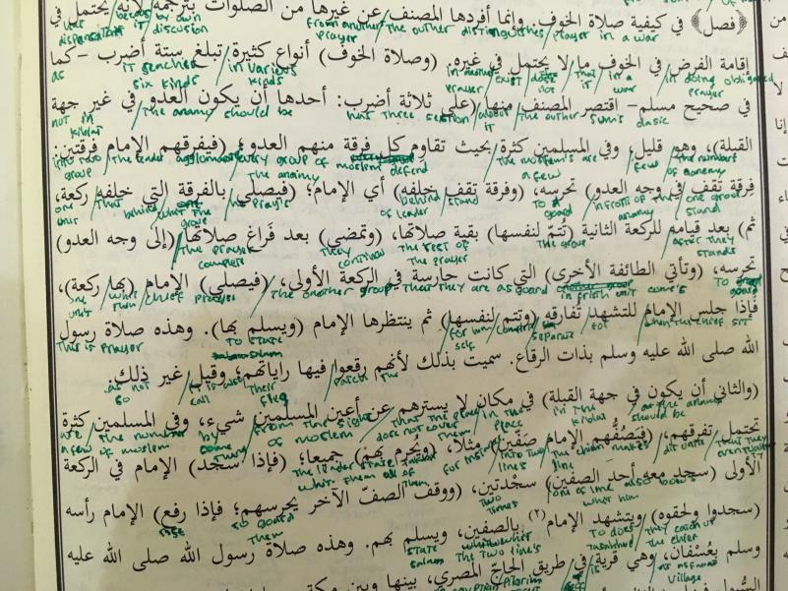

Figure 1.2 A sample of content in the Arabic textbook

Figure 1.3 A sample of a learner’s written book in arranging the translated words

Interview list:

1. Describe how does your teacher use the Arabic textbook in classrooms?
2. Do you think the use of an Arabic theological text as a resource affects your learning?

In what way? Is it a hindrance? Would you prefer a different approach? Why?

1. What strategies do you feel help you to learn? Give examples.
2. When your teacher asks you a question, do you feel confident or worried about getting it wrong?
3. In your opinion do you feel this strategy helps you?
4. Do you enjoy/respond to this strategy? Why or why not?
5. How do you communicate your idea from Arabic textbook into English?

Do you find it difficult? Why?

How do you overcome your difficulties in the class?

How do you communicate these difficulties to the teacher?

1. How do you think your teacher knows when you have learned something?
2. If there was one thing your teacher could change or add to their teaching to help you with your learning, what would it be?