Researchers identified six sub-themes from coding. The sub-themes consist of assessment, classroom activities, learning outcomes, preparation, teaching materials, and teaching methods.

- The implementation of CBLT in assessment
This section presents the data of assessment in CBLT implementation. The researchers identify four sub-themes of assessment. From the interviews, the informant mentions kind of the assessment that they used as follows:
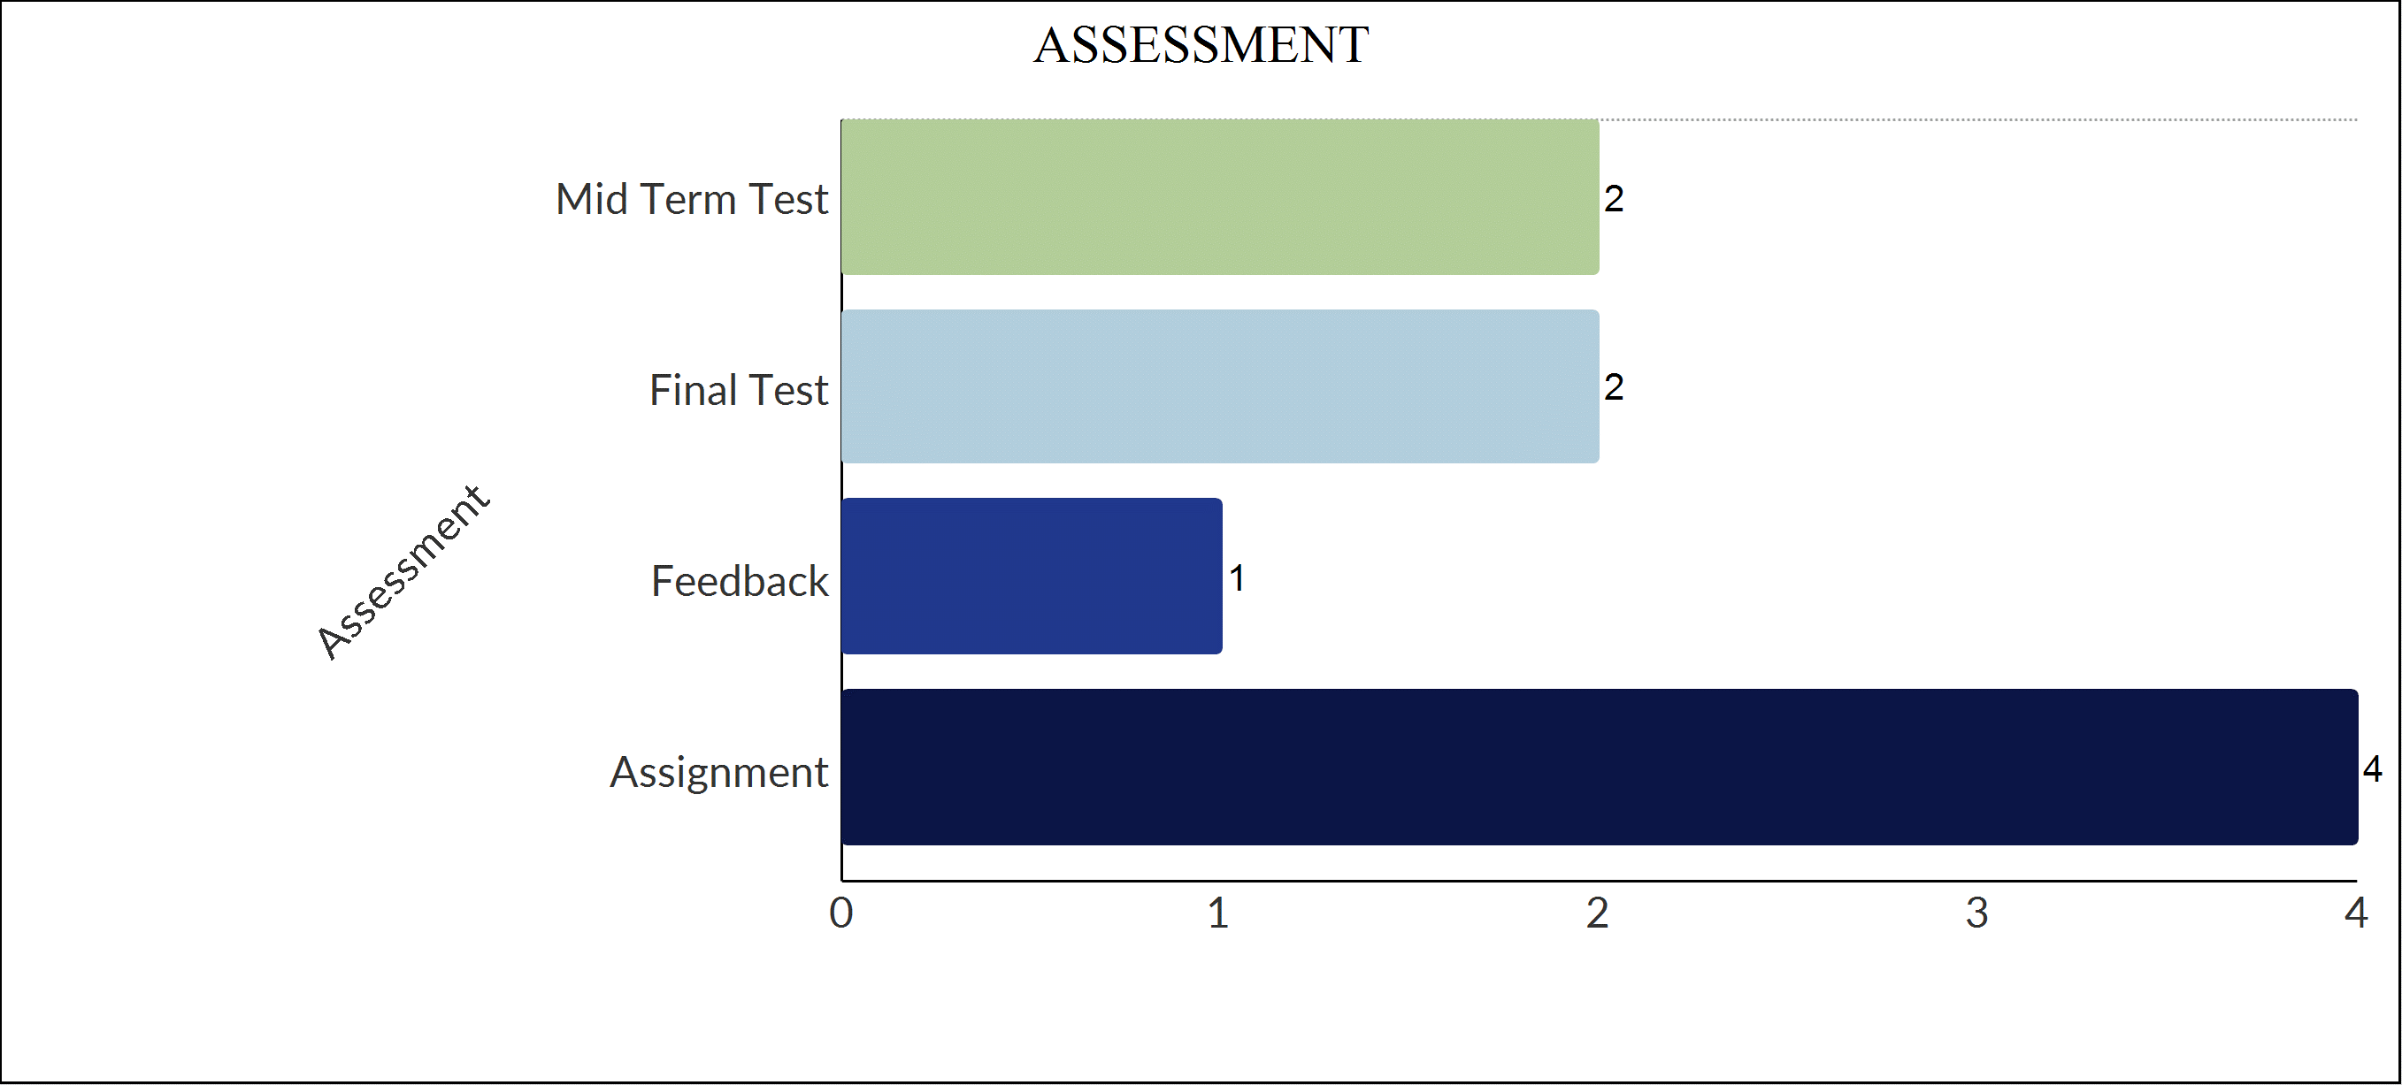
Assessment
Chart. 1 The assessment of teaching and learning process on CBLT
The bar chart shows the implementation of CBLT in ESP courses. The assessment consists of the mid-term test, final test, feedback, and assignment in teaching ESP courses. The most popular assessment in the implementation of CBLT on ESP courses is the assignment. The informant mentioned that assignment is a kind of assessment for students since students learn ESP courses. Also, the final test and mid-term test are involved in the assessment of CBLT. The informant stated that feedback is part of implementing CBLT in ESP courses.
- The implementation of CBLT in classroom activities
This section illustrates classroom activities in ESP courses. Data implies that there are nine sub-themes of classroom activities toward CBLT implementation in ESP courses.
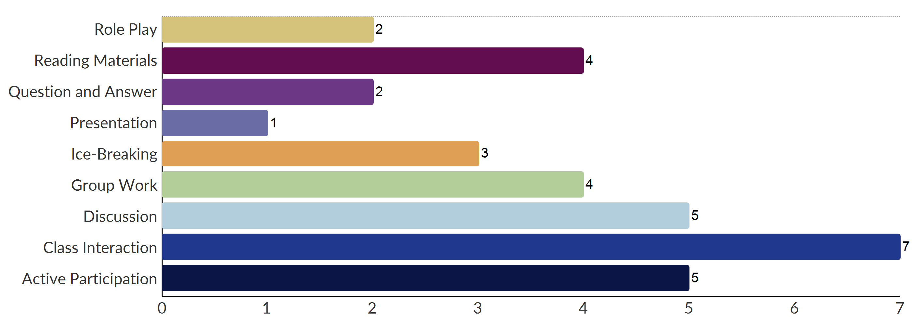
Classroom Activities
Chart. 2 Classroom activities in CBLT
The bar chart illustrates the classroom activities in the implementation of CBLT in ESP courses. overall, it can be seen that both lecturers and students responded to types of activities in CBLT in ESP courses. The most response in classroom activities is class interaction. Lecturers and students mentioned that class interaction is dominated activity class in teaching and learning ESP courses. Students more participate in the classroom. This shows discussion activity and active participation class is subthemes of CBLT implementation in ESP courses. Also, reading materials is a subtheme of classroom activities in CBLT in ESP courses. Interestingly, either the lecturers or students have a responsibility toward classroom activities. Four informants said that reading materials are more classroom activities in CBLT in ESP courses and this is reading activities in the classroom.
- The implementation of CBLT in learning outcomes
This section describes the finding of the implementation of CBLT in ESP courses on learning outcomes. The researchers identify sub-themes in learning outcomes. Researchers identified in learning outcomes toward students’ comprehension in ESP courses as follows:
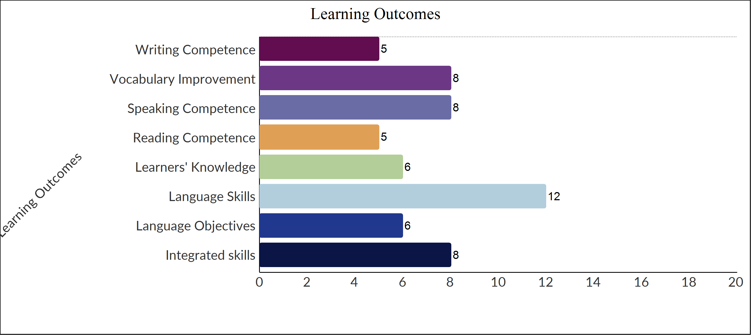
Learning Outcomes
Chart. 3 Learning outcomes of CBLT
The bar chart provides findings on the learning outcomes of CBLT in ESP courses. The most popular learning outcome in ESP courses is language skills such as speaking, vocabulary, writing, and reading. It can be seen from chart 3 the informants reported significantly more language skills in CBLT for ESP courses than others. Similarly, vocabulary skills and speaking skills are significant learning outcomes in CBLT. Also, the informant mentioned that through reading materials, they can improve their reading skills.
- The implementation of CBLT in teaching preparation
This section provides the findings of the implementation of CBLT in ESP courses toward teaching preparation.
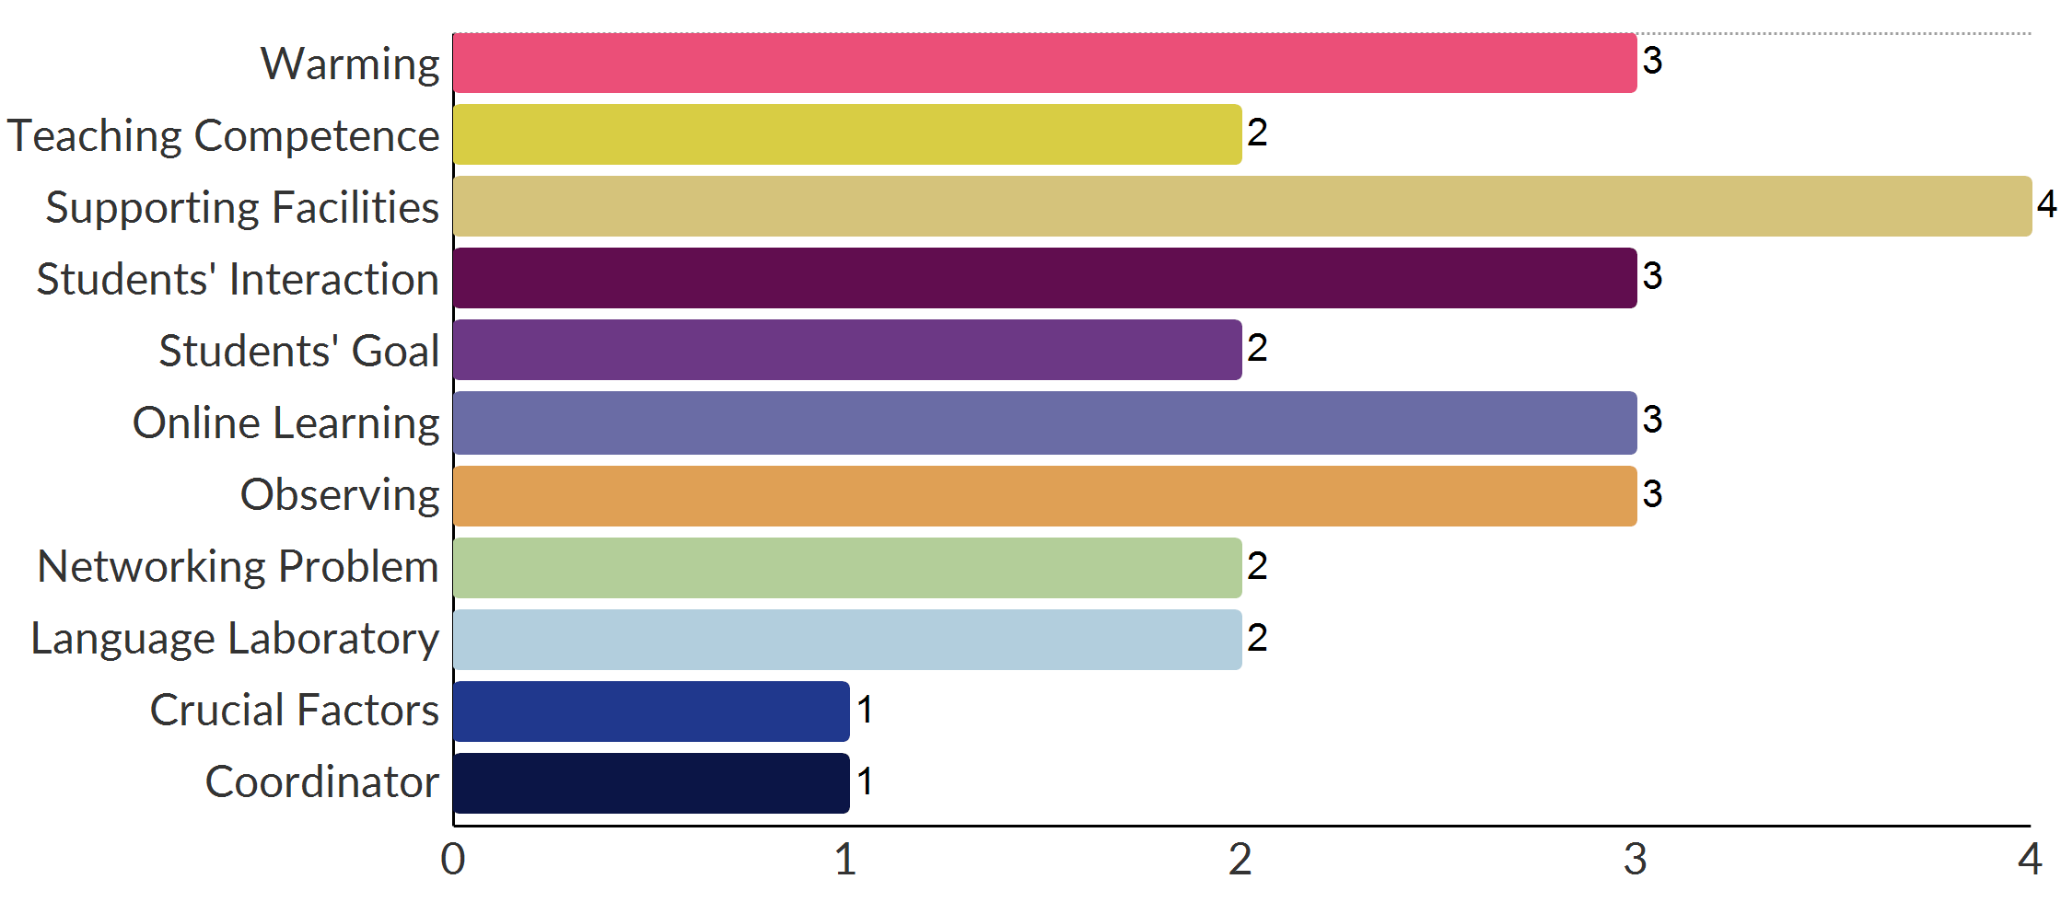
Preparation
Chart. 4 Teaching preparation in CBLT
The data shows that there are eleven sub-themes of teaching preparation in CBLT in ESP courses. From the chart, it can be seen that the greatest teaching preparation in ESP courses is supporting facilities. The informant mentioned that supporting facilities is necessary and important teaching preparation for CBLT implementation in ESP courses. Lecturers prefer to conduct online learning in CBLT in ESP courses. Informants mentioned that the students’ interaction is part of teaching preparation for lecturers in teaching ESP courses. However, informants mentioned that networking is a problem in teaching preparation because of some reasons. Also, informants mentioned that teaching competence is necessary for teaching preparation in CBLT implementation in ESP courses. Informant mentioned that students have objectives in learning ESP.
- The implementation of CBLT in teaching materials
This bar chart shows the implementation of CBLT in ESP courses. It consists of sub-themes of teaching materials as follows:
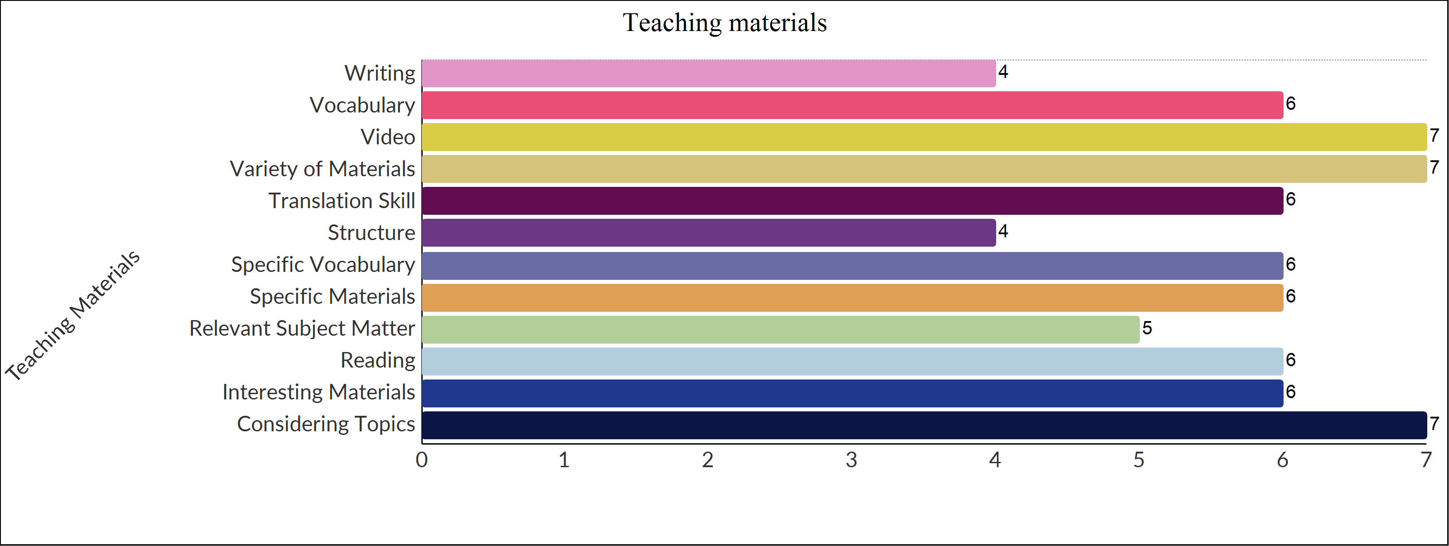
Teaching materials
Chart. 5. Teaching materials toward CBLT
CBLT in ESP courses at Indonesian Higher Education considers teaching materials as shown in the chart. 5 that the most responses from the lecturers that are considering teaching materials in CBLT in teaching ESP courses. Another finding related to teaching materials on CBLT in ESP courses is a variety of materials which the most considered in teaching ESP courses such as vocabulary materials which has various topics in teaching ESP. Informants said that relevant subject materials and reading materials are interesting teaching materials for ESP. Another finding is writing materials that involve structure in teaching ESP courses. Also, the informant said that translation skills are a sub-category of teaching materials.

- The implementation of CBLT in teaching methods

This section provides the findings of the implementation of CBLT in ESP courses. The researchers identified subthemes of teaching methods as follows:
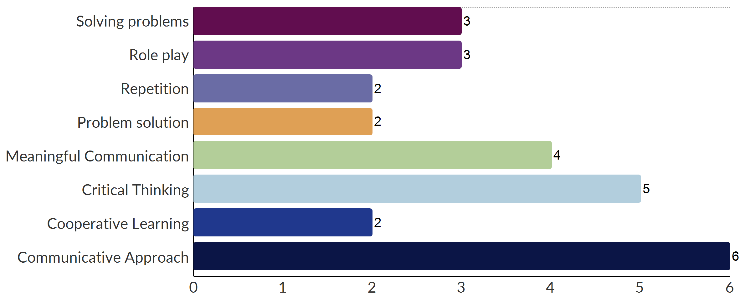k
Teaching Methods

Chart. 6 Teaching methods in CBLT
Chart. 6 shows that the implementation of CBLT in ESP courses is a teaching method. In the theme of teaching methods, there are eight sub-themes of teaching methods. It turns out that the data shows that the communicative approach is the most significant teaching method out of all teaching methods categories. Next, critical thinking is also one of the methods in teaching ESP courses by CBLT. This shows that meaning full communication is also part of teaching methods. Four informants said that meaning full communication plays a very important role in teaching methods for certain reasons. Furthermore, solving problems and role-play are also sub-theme of the teaching methods. This shows in chart 6 three informants said that the two sub-themes were part of the teaching methods. Also, repetition, problem solutions, and cooperative learning involve teaching methods of CBLT in teaching ESP courses.
Discussions
This section provides a discussion of the implementation of CBLT in ESP courses. It is mainly concerned with the implementation CBLT in ESP courses. The researchers identified six sub-themes of the implementation of CBLT in ESP courses, namely, assessment, classroom activities, learning outcomes, teaching preparation, teaching materials, and teaching methods.

Figure 1. An illustrated process of CBLT for ESP

