STATEMENT LETTER

Those who signed below:
Author I
Name : MOHAMMAD IMAM SUFIYANTO, S.Si.,S.Pd., M.Pd.
Job title : LECTURER
Institute : IAIN MADURA

Author II(If there are)
Name : ROYCHAN YASIN,S.S,M.Pd.I
Job title : LECTURER
Institute : IAIN MADURA

Hereby declares that our article entitled "Instructional Learning Model Based on What’s app Media Problem In Pandemic Period" that we have proposed, has never been published and is not being considered and expected to be published elsewhere. Herein we also convey that, all authors have actively contributed to the preparation of this text and expressed their agreement with its contents.
If in the future a discrepancy is found with this statement, then I am willing to be prosecuted as the rules apply. Thus this statement was made to be used as an article submission condition for The PEDAGOGIK Journal of Islamic Elementary School.

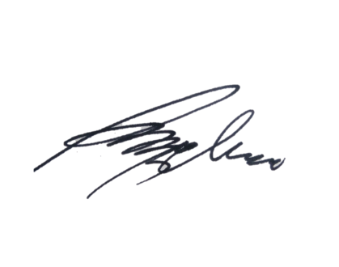
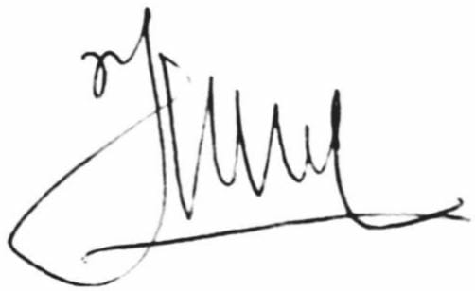
Author I Author II (If there are)

(MOH. IMAM SUFIYANTO) (ROYCHAN YASIN)

