STATEMENT LETTER

Those who signed below:
Author I
Name : Nursupiamin
Job title : Lecture
Institute : IAIN Palu

Author II (If there are)
Name : -
Job title : -
Institute : -

Hereby declares that our article entitled "Pemanfaatan Daun Kelor Dalam Pembelajaran Matematika Di Tingkat SD/MI" that we have proposed, has never been published and is not being considered and expected to be published elsewhere. Herein we also convey that, all authors have actively contributed to the preparation of this text and expressed their agreement with its contents.
If in the future a discrepancy is found with this statement, then I am willing to be prosecuted as the rules apply. Thus this statement was made to be used as an article submission condition for The PEDAGOGIK Journal of Islamic Elementary School.

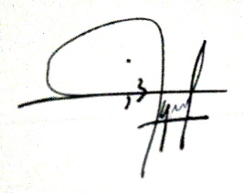
Author I

(Nursupiamin)

