The EFL Students’ Internal Factor Causing Critical Listening Anxiety At IAIN Palangka Raya

Firman Billy Fanandi
firmanazriel01@gmail.com

³ FTIK, State Islamic Institute of Palangka Raya , Kalimantan Tengah, Indonesia

Abstract
In learning, worry and anxiety are natural things experienced by humans. In the same vein, anxiety can be caused by obstacles in the process of learning to listen. This happens to students to master listening skills. Therefore, this study aims to determine the factors that influence students' listening anxiety in the Critical Listening class at the State Islamic Institute of Palangka Raya. To answer this question, the researcher used mixed methods. Participants in this study amounted to 51 participants. Researchers distributed questionnaires and conducted interviews with participants. Based on the findings, there are two factors that influence students' listening anxiety. The first factor was the tension and concern of English to listen to audio. The second factor was lack of confidence in listening to audio

Keywords: Listening Anxiety, Listening Skill, EFL

Introduction
Listening is an essential part of learning English as a foreign language. Other skills such as writing, reading, speaking and listening seem to be very important skills as they are the most commonly used skills in everyday life. Learning to listen will help us greatly improve our speaking skills. In order to communicate correctly, meaningfully and naturally, people need to listen to different types of English repeatedly and continuously. This means that listening provides voice input, so people who do not hear cannot learn the language.
Anxiety occurs when learners encounter very difficult or unfamiliar activities (Scarcella & Oxford, 1992). Fear is a natural reaction to a student during the listening process. Out of control of student anxiety can interfere with the listening process. As a result, anxiety can affect a student's psychology and grades. The problem of hearing anxiety has been studied by previous researchers. Chang (2008) states that high levels of listening anxiety can affect students in a variety of situations. Examples: test, exam, listening performance. Similarly, Hasan (2000) states that the identified problems that caused hearing anxiety were "missing parts of the text, failed word recognition, obscure pronunciation, and fast speech speed." In addition, Flowerdew and Miller (1992) found that 78% of learners experienced anxiety when listening to fast-paced English speeches.
There is a lot of research on listening Anxiety and the impact in learning listening in the class. The anxiety that students faced makes researchers want to explore and find out what the internal factor can impact students' on learning listening. The research question of this research is what are the level of critical listening anxiety among EFL students and what are the internal factor causing critical listening anxiety for EFL Students.
The focus of this Research is to find the Internal factors causing students' Anxiety in Critical listening course of English Education Study Program of IAIN Palangka Raya. The anxiety faced by students at IAIN Palangka Raya when listening is that students feel confused by what is being heard, because students feel they have not received much vocabulary, and feel less confident in listening to audio. And there are several factors that affect students' anxiety in listening, namely, attitude factors, psychological factors, experience factors, motivation factors, and environmental factors.
Method
To answer research questions, researchers use the mixed method. According to Ary, Jacobs, Sorensen and Razavich (2019), the mixing method is a combination of quantitative and qualitative research, and the results can provide a more detailed understanding. In addition, the purpose of the mixed method is to collect and analyze quantitative and qualitative data. Moreover Creswell (2012), say a mixed-method study is one in which the researcher gathers and analyzes data, integrates findings, and makes conclusions.
In this part, Sequential design was a kind of Mixing Method used by researchers. According to Ary et all (2019), Sequential Design is a design in which the first step in Data Analysis influences the decisions made in the next step.A research participant or subject is a person who participates in research. The students in the fourth semester of English Education in the academic year 2019/2020 at IAIN Palangka Raya will be the subject of this study with totals 51 students.
In this study, researchers use questionnaires and interviews. The questionnaire was distributed to all students. Before distributing the questionnaire to the students, the researchers consulted with the instructor. The number of questions in each questionnaire was 17. After calculating the data, the researchers tried to compare the results of the data with the theory they found. Then collect the Data collected by Google Forms. The final step is an interview. The Interview was conducted to obtain stronger evidence from the statements contained in the questionnaire. Before the Researcher conducted the interview, the Researcher explained the purpose of the interview and the Researcher analyzed the questionnaire. Participant was selected by researchers based on the results of the questionnaire.
Researchers analyze the results of the interview and compare it to previously created documents. The data obtained from the information provided during the interview was recorded on tape and transcribed verbatim. We then analyzed the data through data reduction, data presentation, and inference.

Results
- What are the level of critical listening anxiety among EFL students’
Table 1. Result Level of Listening Anxiety
No | Respondents | Total Skor | Level of Anxiety | Max Score | Min  Score
1 | SM | 76 | Middle | 85 | 17
2 | AAR | 77 | Middle | 85 | 17
3 | PYS | 76 | Middle | 85 | 17
4 | NAA | 75 | Middle | 85 | 17
5 | ANF | 75 | Middle | 85 | 17
6 | NPR | 81 | High | 85 | 17
7 | MA | 89 | High | 85 | 17
8 | ARN | 55 | Low | 85 | 17
9 | NS | 67 | Middle | 85 | 17
10 | WAL | 81 | High | 85 | 17
11 | RK | 64 | Middle | 85 | 17
12 | AR | 51 | Low | 85 | 17
13 | HS | 83 | High | 85 | 17
14 | SS | 74 | Middle | 85 | 17
15 | NS | 71 | Middle | 85 | 17
16 | FN | 69 | Middle | 85 | 17
17 | UK | 77 | Middle | 85 | 17
18 | AF | 70 | Middle | 85 | 17
19 | BFD | 80 | Middle | 85 | 17
20 | FI | 87 | High | 85 | 17
21 | MIA | 62 | Middle | 85 | 17
22 | RA | 76 | Middle | 85 | 17
23 | SM | 57 | Middle | 85 | 17
24 | KO | 64 | Middle | 85 | 17
25 | LA | 74 | Middle | 85 | 17
26 | AA | 72 | Middle | 85 | 17
27 | SNA | 88 | High | 85 | 17
28 | SRA | 60 | Middle | 85 | 17
29 | WL | 63 | Middle | 85 | 17
30 | NPR | 88 | High | 85 | 17
31 | MA | 74 | Middle | 85 | 17
32 | NA | 69 | Middle | 85 | 17
33 | UM | 65 | Middle | 85 | 17
34 | TS | 77 | Middle | 85 | 17
35 | MI | 61 | Middle | 85 | 17
36 | YA | 77 | Middle | 85 | 17
37 | FDR | 57 | Middle | 85 | 17
38 | IL | 76 | Middle | 85 | 17
39 | SWP | 27 | Low | 85 | 17
40 | NH | 60 | Middle | 85 | 17
41 | NFRH | 58 | Middle | 85 | 17
42 | ZH | 57 | Middle | 85 | 17
43 | FFNS | 85 | High | 85 | 17
44 | NH | 77 | Middle | 85 | 17
45 | MS | 58 | Middle | 85 | 17
46 | IH | 60 | Middle | 85 | 17
47 | EA | 62 | Middle | 85 | 17
48 | IF | 64 | Middle | 85 | 17
49 | NH | 70 | Middle | 85 | 17
50 | VHT | 58 | Middle | 85 | 17
51 | SL | 52 | Low | 85 | 17
Average |  | 69 | Middle
The Students have a level of anxiety towards listening in the moderate category, after calculating the total score from the questionnaire with the highest score was 85 and the lowest score was 17, because the score obtained by students is in the range of 50-70 so indicated at the moderate level. with these results there are certainly factors that cause students to have anxiety about listening even more so in the internal factors of the students themselves, namely, Tension and Worry over English Listening to Audio and Lack of Confidence in Listening English to Audio
- What are the internal factor causing critical listening anxiety for EFL Students’
  - Tension and Worry Over English Listening to Audio
- Item 1
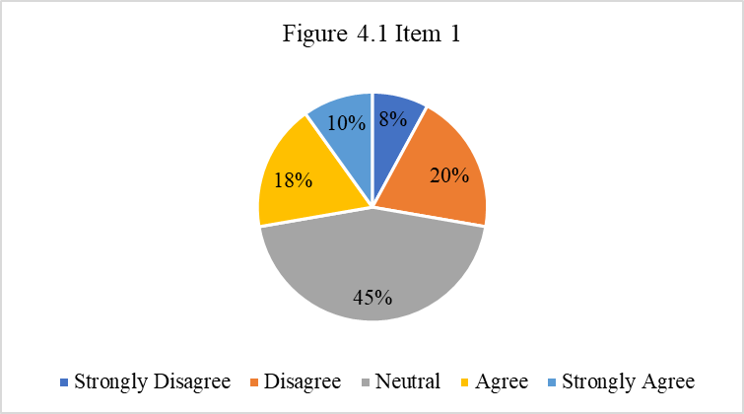
Item 1, “My Thoughts Become Jumbled and Confused when Listening to Important Information in English”. There were 29 Student who Chose Option Neutral (45%). 5 tudents chose Option Agree (18 %). 3 Students chose option strongly agree (10 %). 10 Students chose option disagree (20 %) and 4 students chose option Strongly disagree (8%)

- Item 2

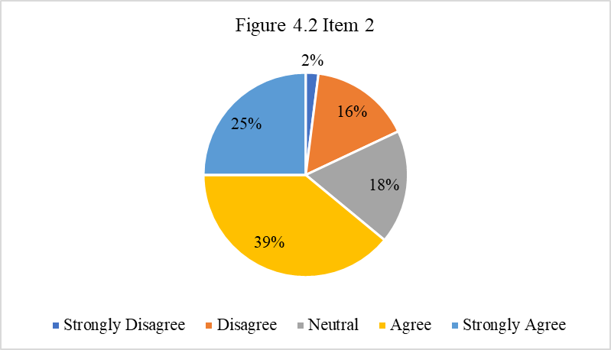
Item 2, “ It Frightens me when I cannot catch a Key Word of an English Listening Passage”. There were 9 Student who Chose option Neutral (18%). 20 Students chose option Agree (39 %). 13 Students chose option strongly Agree (25 %). 8 students chose option Disagree (16 %) and 1 Students chose option Strongly Disagree (2%)

- Item 3
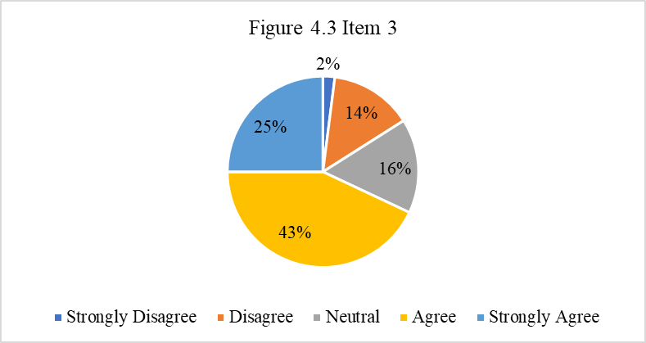

Item 3, “I Get Worried when I Cannot Listen to English at my own Pace”. There was 8 student who chose option neutral (16%). 22 Students chose option agree (43 %). 13 Students chose option Strongly agree (25 %). 7 students chose option Disagree (14 %) and 1 Students chose Option Strongly Disagree (2%)

- Item 4

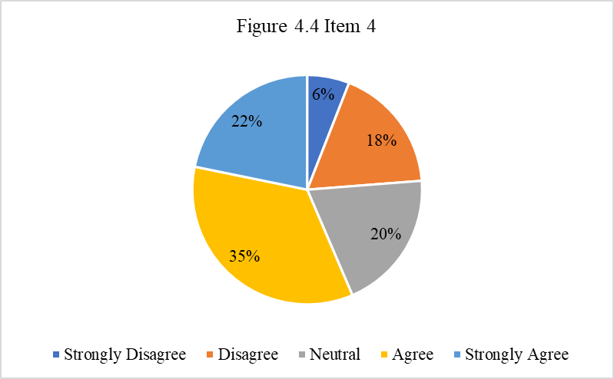

Item Item 4, “I Get Annoyed when I Translate the Words that I do not Understand while Listening to English Recording” There were 10 Student Who chose Option Neutral (20%). 18 Students chose option agree (35 %). 11 Students chose Option strongly agree (22 %). 9 students chose option Disagree (18 %) and 3 Students chose option Strongly Disagree (6%)
- Item 5

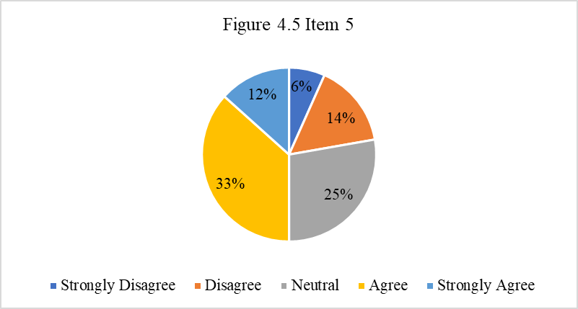

Item 5, “When listening to English, I often Understand the Words but still cannot Quite Understand what the Speaker Means” There were 13 Student who chose option neutral (25%). 17 Students chose option agree (33 %). 6 Students chose option strongly agree (12 %). 12 students chose option Disagree (14 %) and 3 students chose option Strongly disagree (6%)
- Item 6

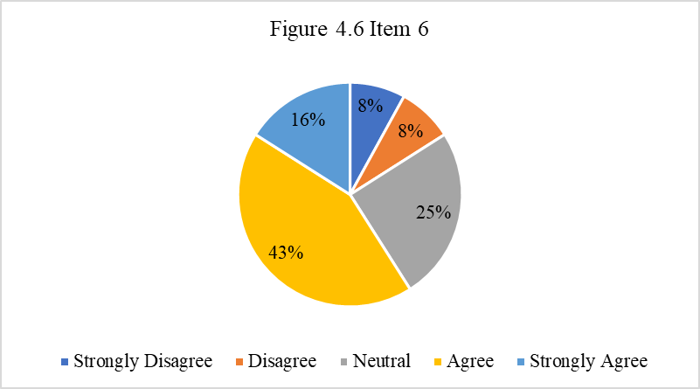
Item 6, “When Someone Pronounces Words Differently from the way I Pronounce them, I find it Difficult to Understand” There was 13 Student who chose Option neutral (25%). 22 Students chose Option Agree (43 %). 8 Students Chose Option Strongly Agree (16 %). 4 students chose option Disagree (8 %) and 4 students chose option Strongly disagree (8%)
- Item 7

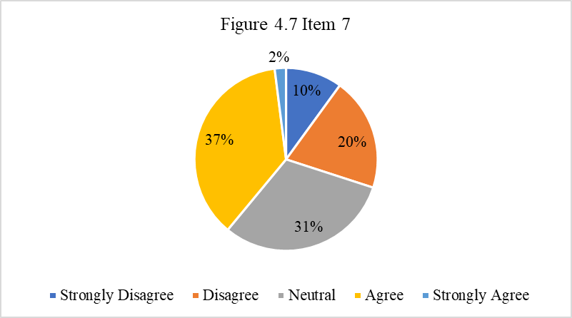

Item 7, “When Listening to English, it is Difficult to Differentiate the Words from one Another” There were 16 Student who chose option Neutral (31%). 19 Students chose Option Agree (37 %). 1 Students chose option Strongly Agree (2 %). 10 Students chose Option disagree (20 %) and 5 Students chose option Strongly disagree (10%).

- Item 8

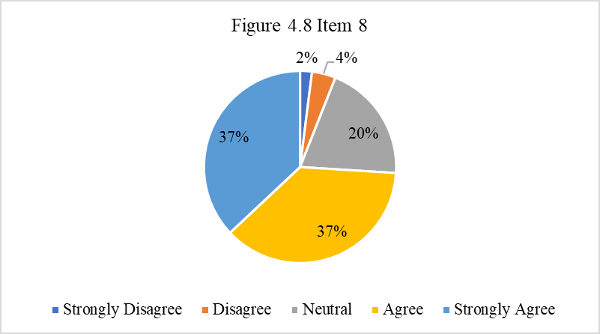

Item 8, “When the English Audio is very fast, I Worry that I might not Understand all of it”, There were 10 Student who chose Option neutral (20%). 19 Students chose option agree (37 %). 19 Students Chose option strongly Agree (37%). 2 Students chose option disagree (4 %) and 1 Students chose option strongly disagree (2%).
- Item 9
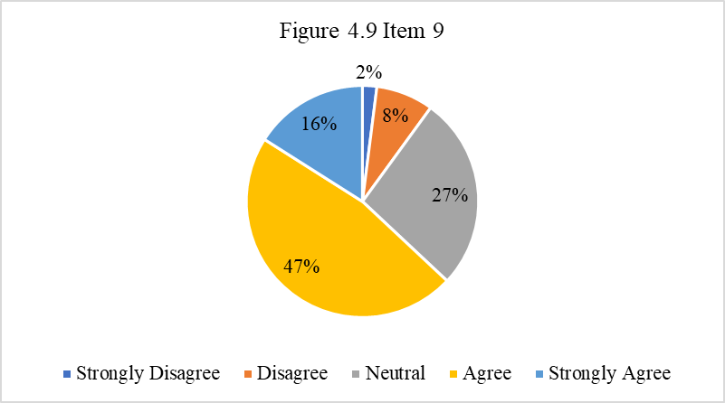

Item 9, “I Get Worried when I have Little time to think about what I hear in English Listening”, There was 14 Student who Chose Option neutral (27%). 24 Students Chose option agree (47 %). 8 Students chose Option Strongly Agree (16%). 4 students chose option Disagree (8%) and 1 Students chose Option strongly Disagree (2%).

- Item 10

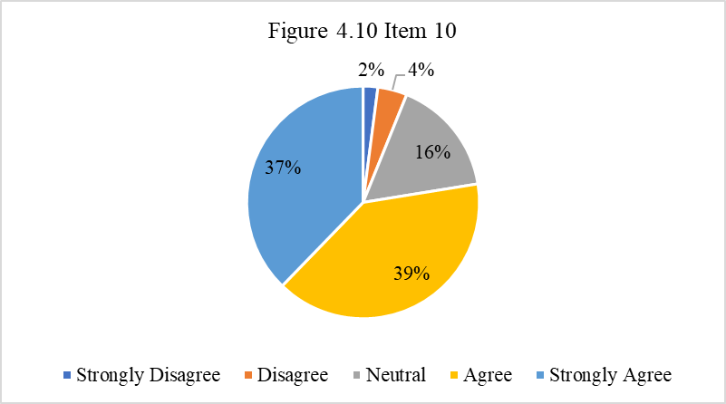

Item 10,” I Get Nervous if a Listening Passage is Read only once during English Listening tests”, there was 8 student who chose Option neutral (16%). 20 Students chose Option agree (39 %). 19 students chose option strongly agree (37%). 2 students chose option Disagree (4%) and 1 students chose option Strongly disagree (2%).
- Item 11

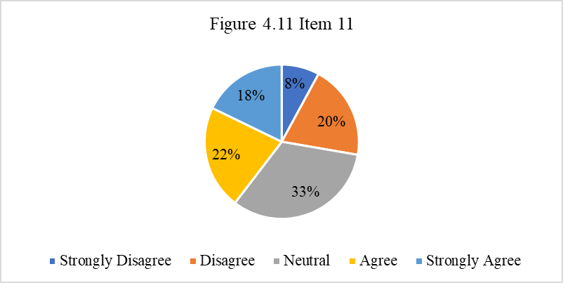
Item 11, “When I am Listening to English, I Often Get so Confused I cannot Remember what I have Heard”, There were 17 Student who Chose Option neutral (33%). 11 Students chose option Agree (22%). 9 Students chose option Strongly Agree (18%). 10 Students chose option Disagree (20%) and 4 students chose option Strongly disagree (8%).

- Item 12
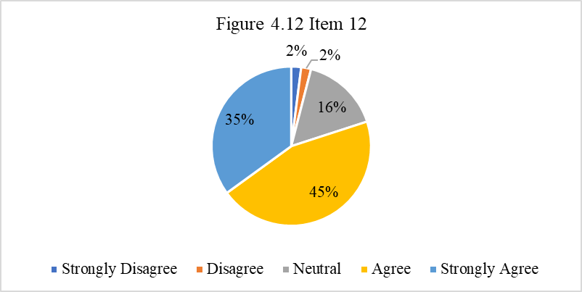

Item 12, “If I let my mind Drift even a little bit While Listening to English, I Worry that I will miss Important Ideas”, There was 8 Student who chose option neutral (16%). 23 Students chose option agree (45%). 18 students chose Option strongly Agree (35%). 1 students chose option Disagree (2%) and 1 Students chose option Strongly disagree (2%).

- Item 13
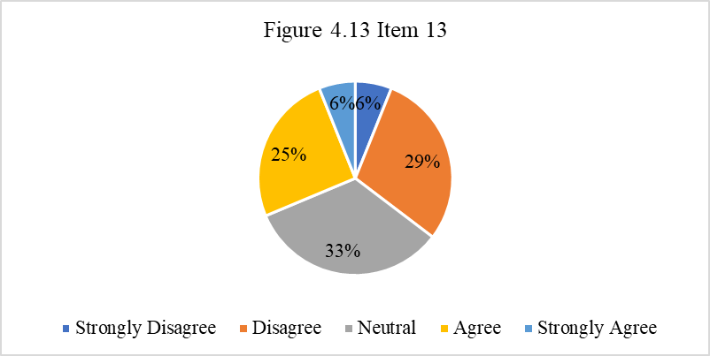
Item 13,” I Keep Thinking that everyone else except me Understands very well what an English Speaker is Saying”, There were 17 Student who chose option Neutral (33%). 13 students chose Option agree (25%). 3 Students chose Option Strongly Agree (6 %). 15 students chose option Disagree (29%) and 3 Students chose option strongly disagree (6%).

- Item 14
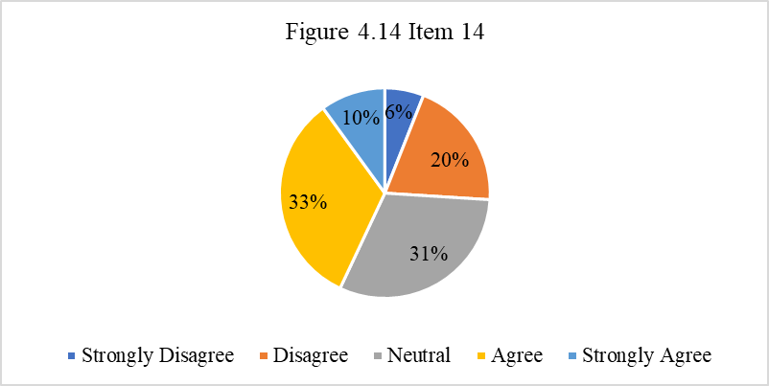
Item 14,” During English Listening tests, I Get nervous and Confused when I do not Understand every word”, There were 16 Student who chose option neutral (31%). 17 Students chose Option agree (33%). 5 students Chose option strongly agree (10%). 10 Students chose option disagree (20%) and 3 Students chose option Strongly disagree (6%).

  - Lack of Confident in Listening English to Audio
- Item 15

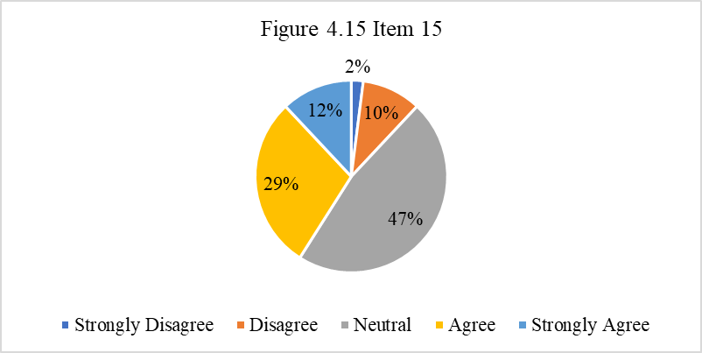
Item 15, “I Feel Confident when I am Listening to English Recording”, There was 24 Student who chose Option neutral (47%). 15 Students chose option agree (29%). 6 Students chose option Strongly agree (12%). 5 Students chose option Disagree (10%) and 1 Students chose option strongly disagree (2%).

- Item 16

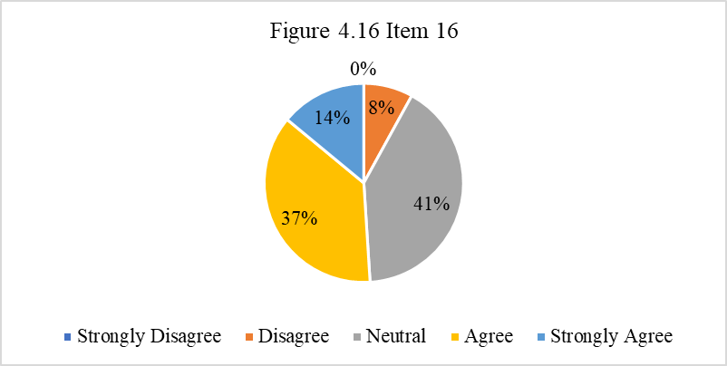

Item 16,” I have no fear of Listening to English Recording as a member of an Audience”, There were 21 Student who Chose Option Neutral (41%). 19 Students chose option agree (37%). 7 Students chose option strongly agree (14%). 4 Students chose option disagree (8%) and 0 Students chose option strongly disagree (0%).

- Item 17
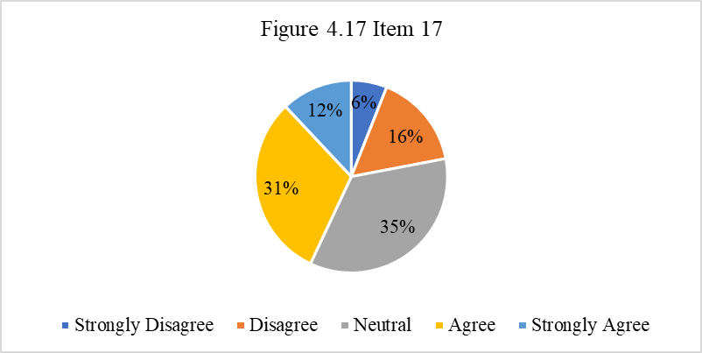

Item 17,” I Feel Uncomfortable in class when Listening to English Without the Written text”, There was 18 student chose option Neutral (35%). 16 Students chose option agree (31%). 6 Students chose option strongly Agree (12%). 8 Students chose Option disagree (16%) and 3 Students chose option Strongly disagree (6%).

- Reslut from the Interview
The interview Data are to support, Expose, and Explain the Experienced Anxiety because of Tension and Worry Over English Listening and Lack of Confidence in Listening to Audio. All of the Interview data explained dealing with the question:
      - Do you feel anxious when listening to English? If yes, can you described what your listening anxiety is like?
MA stated that
"I feel anxious when listening to English if the native speaker is too fast, so I can't get any idea or point from the listening itself."
WAL and TS stated that
"I am anxious when listening if there is a vocabulary that I do not understand, then also the accent used by native speakers, if using accent America can be partially understood but if using British accent it is a bit difficult.
HS stated that
"When listening that I worry is when at the time of the listening exam, because there is a time. So it's very limited to me about that."
NPR stated that
"I am more or less confident when listening to English, for fear of being wrong with the topic being conveyed.
UK stated that
"I don't have any anxiety when listening to English, but in a one-sentence state that I don't understand there I just feel anxious. I have anxiety but it depends on the circumstances.
      - What has affected your listening? What is the most important factor?why?
MA, HS, WAL, TS, NPR and UK stated that:
What influences and factors are most important than the native speaker itself, sometimes from the native speaker speaks too quickly, then the pronunciation is less clear, and most importantly it is from the vocabulary itself, because we are also limited in vocabulary"
      - What do you think causes your anxiety in listening to english?
MA, HS,UK stated that,
I think the most dominant in the lack of vocabulary itself, because with a vocabulary that we do not understand will also have an impact on listening.
WAL, TS, NPR, stated that,
"more to less confident, because listening is a subject that is a bit difficult to understand, also sometimes feel nervous and afraid of being wrong when listening to English.
      - How do you overcome the anxiety you experience during listening, and how do you improve listening skill?
MA, HS, WAL, TS, NPR and UK stated that:
"The way to overcome it is to repeat the audio that is being listened to, then by asking with the lecturer or discussing with friends and follow the instructions of the listening itself. How to improve the listening skills by often listening to English songs, then practicing speaking as well and watching English movies as well"
      - When you get a listening lesson, how do you feel? sad, happy, scared or restless?
MA, HS, WAL, TS, NPR and UK stated that:
"it's more to feel nervous, confuse and so on. but one side there is also a sense of pleasure, its mixed feelings,
      - Do you feel unconfident when listening to English?why?
MA, HS, WAL, TS, NPR and UK stated that:
“Everything goes back to the situation, if for example being in offline college it is more to not confident, while when online lectures it is more relaxed, but overall it is unconfident, because of lack of vocabulary that we have”

Discussion
From the result of the research on the questionnaire, and interview. The research question was “What are the level of critical listening anxiety among EFL students’? and What are the internal factor causing critical listening anxiety for EFL Students’? To answer this question, the data were obtained by the student at IAIN Palangka Raya, the data were obtained by using questionnaire, and interview and the researcher can be concluded that:
- The level of critical listening anxiety among EFL students’
The calculating the score of the questionnaire using Microsoft Excel to determine the categories of each respondent, namely by formula =IF(Z2<57;"Low";IF(Z2<81;"Middle";IF(Z2>=81;"High")))so out of 51 respondents, as many as 8 students have high levels of anxiety against listening, and as many as 38 have anxiety levels against moderate or middle listening, and as many as 5 students have low levels of anxiety. From these data, most students have anxiety levels against listening at the Moderate level or Middle level of Listening Anxiety.
- Tension and Worry Over English Listening to Audio And Lack of Confident in Listening to Audio
Students have internal factors that cause students to feel anxious when listening to English, that is, students worry about audio by speaking English, Because most audio used to teach listening has a high speed, so sometimes students have difficulty capturing the idea or subject message conveyed by native speakers, then the accent used by natives also affects student hearing, students are easier if the accent used by native speakers is an American accent rather than a British accent, and pronunciation that also affects the student's own hearing. then students feel less confident when listening to English, because they lack adequate vocabulary so that students tend not to be confident when listening to English, because by memorizing a lot or having mastery of vocabulary will have an impact on the student's own hearing.

Conclusion
The study concludes that at IAIN Palangka Raya fourth Semester in the critical listening class Academic Year 2019/2020. Students have a level of anxiety towards listening in the moderate category, because the score obtained by students is in the range of 50-60 so indicated at the moderate level. with these results there are certainly factors that cause students to have anxiety about listening even more so in the internal factors of the students themselves, namely, Tension and Worry Over English Listening to Audio and Lack of Confidence in Listening English to Audio.

1. Tension and worry over English listening to Audio
Students on average, the average stated that the worry about English listening audio is due to native speakers being too fast, so students cannot capture every basic idea or important information in a message conveyed. Then with accents used by native speakers that are felt less clear because of the pronunciation.
2. Lack of Confidence In Listening English To Audio
The results were dominated by the positive opinions of the students (104%) and the category was "strongly agree". Students agree that there are uncertainties about internal factors that may affect their hearing ability. And as a conclusion proposal, the researcher would like to propose the following proposal. This is useful and valuable for students, teachers and researchers.1. For students
The researcher recommends that all students always develop their English especially in skills of Listening. Because listening is part of four skill that students should mastered when learning English. and students should always practice by continuing to hone listening skills such as listening to English songs, watching English movies and so on.
2. For the Teacher
To achieve coaching English, the trainer is meant to stimulate and inspire students` in vocabulary and in listening. By providing stimulation and motivation to students, students are expected to be able to overcome the anxiety that students experience towards listening, especially in the internal factors of students themselves

References
Kim, J. H. (2000). Foreign language listening anxiety: A study of Korean students learning English (Unpublished doctoral dissertation, 2000). University of Texas, Austin.

Khairani Ade Guswita and Sugirin(2021) “Factors Affecting Listening Anxiety Of Senior High School Students In English Classroom” https://ejournal.unib.ac.id/index.php/joall/article/view/11462

Gulec, S & Durmus, N. A. (2015). Study aiming to develop listening skills of elementary second grade students. Procedia: Social and Behavioral Sciences, 191, 103-109.
Harumi Kimura (2017) “Foreign Language Listening Anxiety: A Self-PresentationalView”https://www.tandfonline.com/doi/full/10.1080/10904018.2016.1222909

Hussein Elkhafaifi (2005) ” Listening Comprehension and Anxiety in the Arabic Language Classroom” Listening Comprehension and Anxiety in the Arabic Language Classroom - Elkhafaifi - 2005 - The Modern Language Journal - Wiley Online Library

Jafari, K., & Hashim, F. (2015). Comparison of normal and moderately slow speech rates: Listening to students' voices in listening comprehension classes in EFL context. International Journal of Foreign Language Teaching in the Islamic World, 7(1), 18-31.

Jiang, Y. (2009). Predicting strategy and listening comprehension. Asian Social Science, 5(1), 93-97. Retrieved on October 10, 2016 fromwww.ccsnet.org/journal/index.php/ass/article/viewFile/540/521

Khairani Ade Guswita and Sugirin(2021) “Factors Affecting Listening Anxiety Of Senior High School Students In English Classroom” https://ejournal.unib.ac.id/index.php/joall/article/view/11462
Nordquist, Richard. (2020) "English as a Foreign Language (EFL)." ThoughtCo,thoughtco.com/english-as-a-foreign-language-efl-1690597.

Pan, Y. (2016). Analysis of listening anxiety in EFL class. International Journal on Studies in English Language and Literature, 4 (6). Retrievedfromhttps://www.arcjournals.org/pdfs/ijsell/v4i6/2.pdf

Pourhosein Gilakjani, A., & Sabouri, N. B. (2016). Learners’ Listening Comprehension Difficulties in English Language Learning: A Literature Review. English Language Teaching, 9(6), 123-133

Prastiyowati, Santi. (2019). Anxiety On Students’ Listening Comprehension In University Students In Malang. A Journal of CultureEnglishLanguageTeachingLiterature&Linguistics.6.65.10.22219/CELTICUMM.Vol6.No1.65-77.

Xu, F. (2011). Anxiety in EFL listening comprehension. Academy Publisher Manufactured in Finland, http://dx.doi.org/10.4304/tpls. 1.12.1709-1717. 1(22), 1709-1717.

Yo In’nami (2006) “The effects of test anxiety on listening test performance” The effects of test anxiety on listening test performance - ScienceDirect

Zhai, L. L. (2015). Influence of Anxiety on English Listening Comprehension: An Investigation Based on the Freshmen of English Majors. Studies in Literature and Language, 11 (6), p. 40-47.

