The Representation of Social Discrimination
in Zootopia 2 (2025) Movie
Vidya Kartika Dewi¹, Masnia Rahayu²,
^{1,2}Sastra Inggris, Universitas Teknokrat Indonesia, Lampung

Article Info |  | Abstract
Received: 2026-04-22  Revised: 2026-05-28  Accepted: 2026-06-30  Keywords:  discrimination; marginalization; representation;  sociology of literature  DOI: 10.24256/ideas. v14i1. 10257  Corresponding Author:  Vidya Kartika Dewi  vidya_kartika_dewi@teknokrat.ac.id  Sastra Inggris, Universitas Teknokrat Indonesia, Lampung |  | This study examines the representation of social discrimination in Zootopia 2 (2025), focusing on how inequality, prejudice, and marginalization are portrayed through selected dialogues, scenes, and visual symbols. The film was chosen because it presents discrimination through an animated narrative that remains relevant to contemporary issues of stereotyping, exclusion, and unequal power relations. Using a qualitative descriptive method, this research applies Stuart Hall’s Representation Theory and Alan Swingewood’s Sociology of Literature to analyze how discrimination is constructed and represented in the film. Unlike previous studies that mainly discuss discrimination in animated films as interpersonal prejudice, this study examines discrimination as a structural and historical process shaped by ideological control, historical erasure, and social exclusion. The findings reveal that reptiles, particularly through the character of Gary De’Snake, are represented as marginalized subjects whose identities are shaped by dominant narratives and collective prejudice. Therefore, Zootopia 2 functions as a cultural text that not only reflects social inequality but also critiques how power and representation sustain discrimination in society.
1. Introduction
Film is one of the most influential forms of media in modern society, functioning not only as entertainment but also as a medium that reflects social realities, cultural values, and social problems (Faradissa & Laksono, 2024). Through narratives, characters, and conflicts, films portray issues such as inequality, discrimination, stereotypes, and social conflict, allowing audiences to understand how these issues are represented and communicated (Swingewood, 1972). Film is also a visual storytelling medium that conveys meaning through images, dialogue, and narrative structure, enabling filmmakers to express ideas about social life and human experiences (Dwortz et al., 2022).
As a cultural product, film often reflects the social conditions and ideologies present within society (Redzuan Roy & Sahharil, 2020). From a sociological perspective, literary and cinematic works are closely connected to social structures and experiences, making film a reflection of social reality (Anugerah et al., 2022). Furthermore, Hall (1997) emphasizes that representation is the process through which meaning is constructed and communicated through language, images, and symbols. In film, this process occurs through characters, narratives, and visual elements that shape audience perceptions of social issues (Rabani et al., 2024). Therefore, analyzing film as a cultural text provides important insights into how media represents social discrimination and conveys broader social messages (Bordwell & Thompson, 2017).
One animated film that strongly reflects these social concerns is Zootopia 2 (2025), a continuation of Zootopia, which portrays a fictional city inhabited by diverse animal species living together while simultaneously revealing underlying issues of prejudice, stereotypes, and discrimination (Abdul Jabar et al., 2025). The sequel continues this narrative by introducing new social dynamics and conflicts, particularly through the presence of reptile groups that appear socially excluded from mainstream society, suggesting patterns of segregation and marginalization (Varona & Suárez, 2022). These elements make Zootopia 2 relevant to contemporary discussions of stereotyping, exclusion, and unequal power relations, especially in relation to how media constructs and normalizes discrimination through narrative and visual symbolism.
From a theoretical perspective, discrimination in film can be understood not only through representation but also through identity formation and unequal power relations within society. Hall’s theory of representation explains how meaning is socially constructed through language, images, and cultural symbols (Hall, 1997). In addition, Social Identity Theory developed by Tajfel and Turner (1979) explains that individuals tend to classify others into ingroups and outgroups, often resulting in prejudice and discriminatory attitudes toward groups perceived as different. Similarly, Bourdieu (1991) argues through the concept of symbolic power that dominant groups maintain authority by controlling accepted knowledge, legitimacy, and social meanings, allowing inequality to appear natural and socially justified. These perspectives strengthen the theoretical foundation of this study in understanding how discrimination is socially constructed and reproduced through cultural narratives.
Previous studies have demonstrated that animated films function not only as entertainment but also as a medium for representing complex social issues. Several researchers have explored how animation reflects themes such as discrimination, inequality, identity, culture, and gender. Devyana and Nugroho (2024), for example, analyze Elemental and reveal how differences between characters symbolize social inequality and prejudice, while other studies highlight immigrant representation in animated films, emphasizing struggles of identity formation and social adaptation. Similarly, Elman (2022) examines Turning Red, focusing on cultural symbolism in conveying values, traditions, and intergenerational conflict, whereas Fazal (2024) investigates gender stereotypes in children’s animation and finds that traditional gender roles are still frequently reinforced. In addition, Fatima et al. (2026) further explore gender representation in films produced by The Walt Disney Company (Casas, 2025). Taken together, these studies suggest that animated films provide diverse representations of social issues, particularly in relation to identity, prejudice, culture, and gender.
Studies on animation have also shown that representation in animated films is often linked to broader ideological and social concerns. Kjeldgaard-Christiansen et al. (2024) argue that animated narratives frequently construct symbolic meanings through fictional differences, allowing social issues to be represented in ways that are accessible to audiences. Likewise, Jiang (2024) notes that recent studies on animation tend to focus on cultural identity, gender representation, and symbolic conflict, indicating that animated films are important sites for the construction of social meaning. When compared with previous studies such as Devyana and Nugroho (2024) or Elman (2022), it can be seen that most research tends to examine identity, prejudice, or cultural conflict separately. These findings suggest that animation can be used to examine social discrimination; however, many studies still approach the issue through specific aspects individually rather than as a broader and interconnected social structure shaped by ideology and power relations.
Studies related to Zootopia have also highlighted the film’s relevance to social issues, particularly prejudice and discrimination. Zootopia has often been interpreted as a narrative about stereotypes, fear, and social bias between different groups of animals. However, most of these studies emphasize interpersonal prejudice or symbolic conflict between characters rather than examining discrimination as a structural and historically developed process. As a result, although the Zootopia franchise has frequently been associated with social criticism, the representation of social discrimination in Zootopia 2 remains underexplored. Unlike the first Zootopia, which focuses on prejudice between predators and prey, Zootopia 2 introduces reptile groups as socially excluded communities, shifting the issue from interpersonal bias toward broader structural discrimination involving exclusion and unequal participation.
Although previous studies have discussed social representation and social issues in animated films, most of them focus on cultural identity, gender representation, or discrimination in films other than Zootopia 2 (Jiang, 2024). Likewise, studies related to Zootopia generally emphasize prejudice, stereotypes, or symbolic social conflict, but they rarely examine how discrimination is represented as a structural and historically developed process. In contrast, Zootopia 2 introduces a different representational pattern through reptile groups that appear as socially excluded and marginalized subjects, suggesting that discrimination in the film operates not only through prejudice but also through segregation, marginalization, and unequal access to social participation.
Conceptually, this process can be understood through the relationship in which representation constructs ideology, ideology legitimizes power, power shapes social hierarchy, and social hierarchy sustains discrimination and exclusion. This indicates a research gap, as Zootopia 2 has not been widely examined in relation to the representation of social discrimination, particularly from the perspective of how the film reflects broader social structures and power relations.
In addition, previous studies have not specifically explored discrimination in Zootopia 2 through the interconnected dimensions of inequality, prejudice, and marginalization. Therefore, a more focused analysis is needed to understand how the film represents social discrimination not only as an interpersonal issue, but also as a reflection of broader social exclusion and inequality. Based on the gap above, this study aims to examine how social discrimination is represented in Zootopia 2 by focusing on the portrayal of inequality, prejudice, and marginalization through the film’s narrative, dialogue, and visual symbols.
This study draws on Alan Swingewood’s Sociology of Literature, which views literary and cultural works as reflections of social reality (Ittefaq et al., 2022), to understand how the film mirrors broader social conditions and social problems. Accordingly, the research question addressed in this study is: How is social discrimination represented in Zootopia 2 (2025)? The novelty of this research lies in its attempt to analyze discrimination not merely as isolated social issues or interpersonal prejudice, but as an interconnected process shaped by historical erasure, ideological domination, and spatial exclusion, thereby offering a broader understanding of how animated films reflect structural social problems and sustain inequality within society.

2. Method
This study employed a qualitative descriptive design to analyze the representation of social discrimination in Zootopia 2 (2025). A qualitative approach was considered appropriate because it focuses on interpreting meanings and understanding social phenomena rather than measuring them quantitatively. According to Creswell (2014), qualitative research is used to explore and understand meanings that individuals or groups assign to social problems. This method is particularly suitable for analyzing cultural texts such as films because it allows the researcher to interpret narratives, symbols, dialogues, and character interactions. In this study, the analysis was guided by Alan Swingewood’s Sociology of Literature and Stuart Hall’s theory of representation in order to examine how the film reflects broader social realities and constructs meaning through narrative and visual elements (Swingewood, 1972; Hall, 1997).
The object of this research was the animated film Zootopia 2 (2025), produced by Walt Disney Animation Studios. The primary data consisted of dialogues, scenes, character interactions, expressions, and visual elements that represented social discrimination. The unit of analysis in this study was any scene or dialogue indicating unequal treatment, prejudice, exclusion, or marginalization, particularly toward reptile characters. The data were collected by repeatedly watching the official film, identifying relevant scenes and dialogues, and documenting them in analytical notes. To ensure the relevance of the data, the researcher selected scenes based on several criteria: the scenes explicitly or implicitly represented discrimination, involved social conflict between groups, and contributed significantly to the portrayal of inequality, prejudice, or marginalization in the film. In addition, the film transcript was used to verify quotations and to support the interpretation of visual and narrative contexts.
The data were analyzed using thematic analysis. First, the selected scenes and dialogues were reduced and classified based on recurring patterns of discrimination. The coding process focused on identifying forms of unequal treatment, stereotype-based suspicion, exclusion, and marginalization, which were later grouped into three major categories: inequality, prejudice, and marginalization. These categories were then interpreted through Hall’s theory of representation to examine how discrimination was constructed through dialogue, characterization, and visual symbols, and through Swingewood’s sociological perspective to relate the filmic representation to broader social conditions (Hall, 1997; Swingewood, 1972). To maintain the credibility of the analysis, the researcher rewatched the film several times, cross-checked the selected dialogues with the transcript, and reviewed the coding results to ensure consistency between the data, the research focus, and the theoretical framework. All film materials, including screenshots and quotations, were used solely for academic purposes and only to the extent necessary to support the analysis.

3. Result
Representation of Inequality, Prejudice, and Marginalization in Zootopia (2025)
The findings show that social discrimination in Zootopia 2 (2025) is represented through three dominant forms: inequality, prejudice, and marginalization. These forms appear across several contexts in the film, including social gatherings, everyday interactions, and public settings. Among them, prejudice appears most prominently, particularly through fear, suspicion, and negative assumptions toward reptiles. A summary of these findings is presented in Table 1.

Table 1. Representation of Social Discrimination in Zootopia 2 (2025)
No | Scene/Context | Dialogue / Evidence | Type of Discrimination
  Interpretation
1 | Party/ social gathering | “There’s a snake!” | Inequality & Prejudice | Reptiles are immediately feared and treated as socially threatening, showing unequal acceptance and stereotype-based judgment.
2 | Everyday Interaction | “And because she was a snake, everyone believed his lie. Soon, no reptiles were welcome.” | Prejudice | Reptiles are judged based on identity rather than evidence, reflecting stereotype and suspicion in daily interactions.
3 | Public Setting | “Cut off from the rest of the town.” | Marginalization | Reptiles are spatially separated from mainstream society, indicating exclusion from visibility and social participation.

In the party context, discrimination is represented through inequality and prejudice, as shown when the mayor shouts, “There’s a snake!” and the guests panic and run away. In everyday interactions, prejudice appears through stereotype-based judgment, reflected in the statement, “And because she was a snake, everyone believed his lie. Soon, no reptiles were welcome.” Meanwhile, marginalization is shown through the spatial separation of reptiles from mainstream society, as their neighborhood is described as “cut off from the rest of the town.” Overall, these findings indicate that discrimination in Zootopia 2 is portrayed through interconnected forms of inequality, prejudice, and marginalization across different social contexts.
4. Discussion

Animated Film as a Reflection of Social Discrimination: A Swingewoodian Perspective in Zootopia 2 (2025)
In Zootopia 2, discrimination is portrayed not merely as personal bias, but as a structural and historically developed phenomenon. The character of Gary De’Snake serves as a narrative device that reveals a repressed history, showing that reptiles were once part of society before being deliberately marginalized.

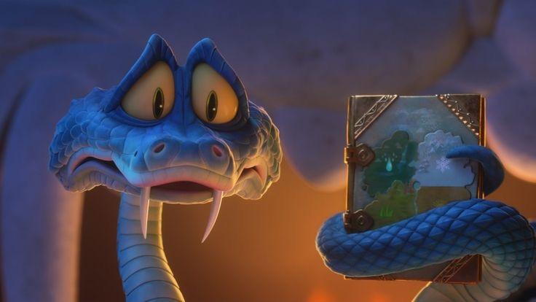

Figure 1. Gary De’Snake holds the journal that contains suppressed
historical evidence about reptiles in Zootopia 2 (2025).

The discovery of the old journal becomes a crucial symbol of resistance because it challenges the official version of history that has long been accepted as truth. Gary’s statement,
“Snakes never hurt anyone; we aren’t the bad guys…
This journal holds the secret that will prove it,”
suggests that reptiles have been systematically misrepresented and denied the right to define themselves. In this sense, the film presents discrimination not only as a matter of unequal treatment in the present, but also as the result of a long process of historical erasure through which dominant groups control collective memory.
This idea is reinforced by the statement,
“And because she was a snake, everyone believed his lie.
Soon, no reptiles were welcome.”
The dialogue demonstrates how prejudice operates through immediate judgment based on identity, where being a snake becomes sufficient reason for exclusion. The phrase “everyone believed his lie” shows how stereotypes are collectively accepted without evidence, while “no reptiles were welcome” indicates that discrimination has moved beyond individual hostility into broader social exclusion. In this regard, the film represents prejudice and marginalization as interconnected processes: stereotypes shape public perception, and those perceptions are then used to justify exclusion from social participation.
From Swingewood’s perspective, this pattern reflects how literary and cultural texts mirror real social structures in which marginalized groups are excluded not only from social opportunities but also from official history (Swingewood, 1972). The findings therefore suggest that Zootopia 2 portrays discrimination as something sustained through inherited beliefs, selective memory, and normalized assumptions. This interpretation also helps explain why scenes such as the mayor’s cry, “There’s a snake!”, immediately trigger panic and fear in the party context. The reaction is not simply personal fear, but the result of a socially constructed meaning attached to reptiles over time. Thus, the film shows that discrimination is reproduced not only through direct acts of prejudice, but also through historical narratives that define which groups are considered threatening, legitimate, or worthy of belonging.
Compared with previous studies on animated films, this finding extends earlier discussions of prejudice by emphasizing its historical dimension. Devyana and Nugroho (2024), for example, show how Elemental represents inequality and prejudice through differences between social groups, while studies on Zootopia and other animated films often focus on stereotypes or interpersonal bias (Anugerah et al., 2022; Elman, 2022).
However, Zootopia 2 develops this issue further by showing that discrimination is tied not only to social attitudes, but also to the control of history and the suppression of alternative narratives. In this way, the film represents discrimination as a broader ideological process rather than merely a series of isolated prejudiced encounters.

Ideological Representation and Power Structures in Zootopia 2 (2025)
The Lynxley family exemplifies ideological supremacy in Zootopia 2, functioning not only as political authorities but also as guardians of historical truth and social legitimacy. Their dominance extends beyond governance into the realm of knowledge production, allowing them to shape collective perceptions of reality and define what is accepted as legitimate knowledge. By portraying reptiles as dangerous or unsuitable for civilized society, they construct a moral justification for exclusion, transforming discrimination into something that appears natural and inevitable. In this way, marginalized groups are not only excluded physically, but also delegitimized symbolically and erased from dominant discourse, limiting their ability to challenge the existing system. The ideological structure and unequal distribution of power in the film can be seen through the hierarchical model illustrated in Figure 2.1.

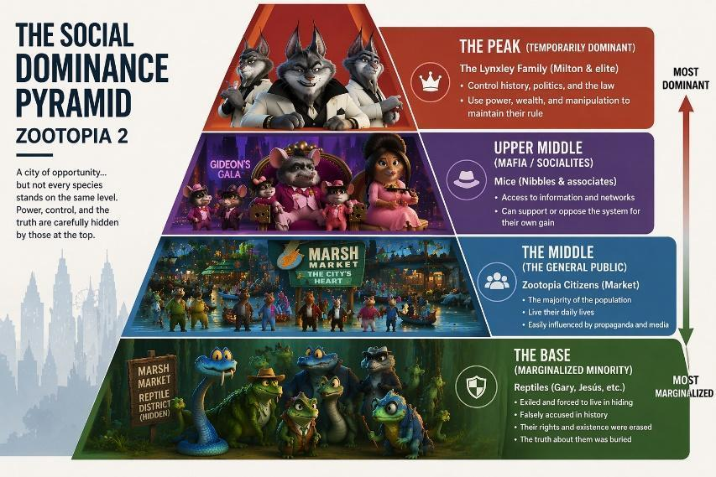
Figure 2.1. A hierarchical representation of social power in Zootopia 2, illustrating the dominance of the Lynxley elite and the marginalization of reptile communities.

As illustrated in the pyramid, the Lynxley family occupies the highest position as the dominant elite, controlling political authority, historical narratives, and the production of social meaning. Beneath them are intermediary actors and the wider public, who function as receivers and reproducers of dominant beliefs through everyday practices and social interactions. At the lowest level are reptile communities, who occupy the most vulnerable position within the hierarchy as targets of exclusion, suspicion, and historical erasure. Rather than merely showing social ranking, this structure reveals how discrimination in Zootopia 2 is maintained through layered relations of power, in which dominant discourse is produced at the top, circulated in the middle, and experienced as marginalization at the bottom. The pyramid therefore demonstrates that inequality in the film is not accidental, but structurally sustained through ideological control and unequal access to power.

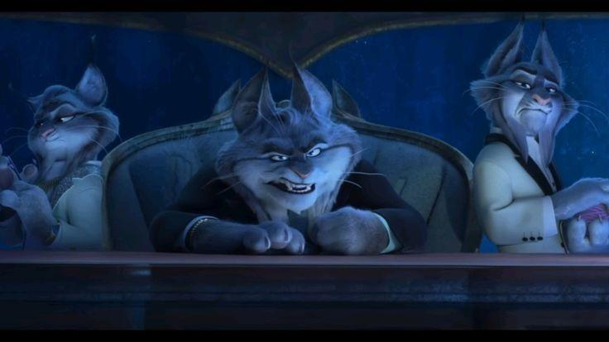
Figure 2.2. The Lynxley family exercised political authority, illustrating their dominance over governance and control of social order in Zootopia 2 (2025).

This dynamic is further emphasized in Figure 2.2, which presents the Lynxley family as the visible center of political authority and social control. Their power is not only symbolic, but also enacted through direct efforts to suppress alternative knowledge that could challenge the official narrative about reptiles. This is reflected in Lynxley’s statement,
“We’ll take the snake down… I want them gone…
You will retrieve the journal and bury them.”
The dialogue reveals that the exclusion of reptiles is inseparable from the suppression of the journal, which contains evidence capable of exposing a hidden history. In other words, the film suggests that power is maintained not only by removing marginalized groups from public visibility, but also by erasing the knowledge that could restore their legitimacy. This reflects Hall’s concept of representation, in which meaning is actively constructed through dominant discourse rather than neutrally reflected from reality (Hall, 1997). The absence of reptiles from official history is therefore not a simple omission, but an ideological act that normalizes their invisibility and justifies their exclusion.
While the Lynxley family represents dominant power within the city, the journey of Judy Hopps and Nick Wilde beyond the urban center introduces an alternative perspective that challenges this constructed reality. By moving outside the dominant social space, they begin to uncover hidden truths and encounter communities that have been excluded from mainstream society. This shift is visually represented in Figure 2.3, where Judy and Nick enter the swamp, a peripheral area inhabited by reptiles. The swamp is significant not merely as a setting, but as a material consequence of ideological exclusion, showing how dominant power shapes not only public narratives but also the spatial organization of society.

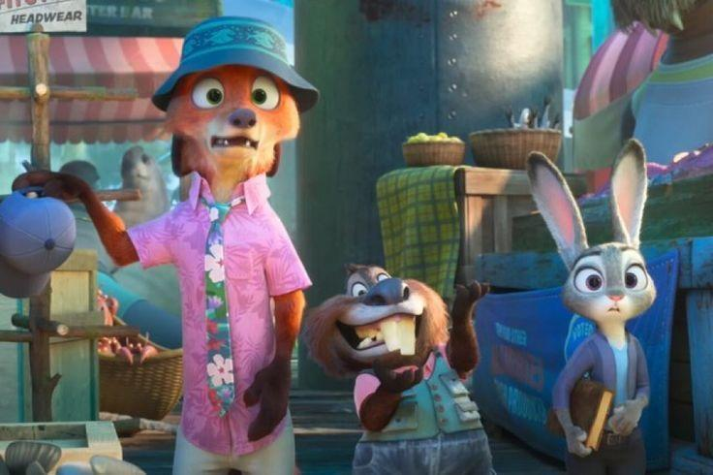

Figure 2.3. Judy Hopps and Nick Wilde enter the swamp, a marginalized and spatially isolated area where reptiles reside, reflecting structural exclusion and the formation of peripheral communities
in Zootopia 2 (2025).

This spatial marginalization is further emphasized through the dialogue between Judy and Nibbles.
“When Zootopia was founded, the whole neighborhood got cut off from the rest of the town. Kinda our own here… that’s probably why reptiles like it. They can just do their thing.”
The phrase “cut off” indicates an intentional act of separation rather than a natural condition. It suggests that the swamp was deliberately excluded from the main structure of the city, reflecting a systematic effort to isolate certain groups from the dominant social space. As a result, the swamp becomes not merely a remote location, but a constructed marginal space shaped by historical and political processes.
This separation reflects a form of structural exclusion in which reptiles are confined to peripheral zones and positioned outside the center of power. As a result, they are compelled to form their own communities while remaining limited in visibility, participation, and legitimacy. From a Swingewoodian perspective, this spatial division reflects how cultural texts mirror real social structures in which marginalized groups are often pushed to the periphery, both socially and geographically (Swingewood, 1972). In Zootopia 2, the swamp therefore functions not merely as a remote setting, but as a symbolic and material representation of inequality, showing that discrimination is reproduced not only through ideology and dominant narratives, but also through the organization of space. Through this representation, the film suggests that power operates across institutions, discourse, and geography, making marginalization appear normalized and difficult to challenge.

Social Criticism and the Role of Film in Addressing Discrimination
In Zootopia 2 (2025), social commentary is conveyed by portraying discrimination as a structural issue rather than merely an expression of individual bias. The supremacy of the Lynxley family illustrates how power operates on an institutional level, particularly through the manipulation of historical narratives that define what is accepted as “truth.” This systemic control enables the exclusion of certain groups, especially reptiles, from both social participation and collective memory. Furthermore, the film demonstrates that such systems are sustained not only by formal authorities but also through alternative and localized power structures, including informal networks and community-based territories. As a result, discrimination becomes normalized and reproduced across multiple layers of society. At the most marginalized level, reptiles represented by characters such as Gary De’Snake experience structural exclusion, as they are denied recognition, representation, and historical legitimacy.
The investigation led by Judy Hopps and Nick Wilde emphasizes the importance of challenging dominant systems by questioning established narratives and uncovering hidden truths. Their journey signifies a shift from passive acceptance toward active resistance against systemic injustice, suggesting that social transformation begins when suppressed histories are brought back into public consciousness. In this regard, Zootopia 2 functions not only as a narrative about discrimination, but also as a cultural text that critiques how ideology, power, and representation work together to sustain inequality. As stated by filmmaker Jared Bush,
“The world of Zootopia is one where we really get to hold up a mirror to human nature. The good, and bad… there’s so much for us to continue to learn and understand about each other.”
This statement reinforces the idea that the film is not merely fictional entertainment, but a reflection of real social dynamics that encourages audiences to examine how prejudice, exclusion, and unequal power relations continue to shape society.
From an educational perspective, the film also offers significant value as a medium for introducing issues of social justice, diversity, and inclusion to broader audiences, including younger viewers. Through animated storytelling, symbolic characters, and accessible conflict, Zootopia 2 translates abstract concepts such as discrimination, marginalization, and ideological control into narratives that are emotionally engaging and socially meaningful. In this way, the film can be understood not only as a form of entertainment, but also as a pedagogical medium that fosters critical awareness of inequality and encourages reflection on the importance of empathy, recognition, and coexistence in diverse societies. Therefore, the social criticism embedded in Zootopia 2 lies not only in its exposure of structural discrimination, but also in its potential to stimulate critical discussion about how societies construct truth, normalize exclusion, and marginalize those considered different.
Overall, the film offers a strong synthesis of representation, ideology, and social transformation by showing that discrimination is maintained through narrative control, institutional power, and spatial exclusion, yet can be challenged through resistance, historical recovery, and the recognition of marginalized voices. This suggests that genuine justice can only be pursued when societies are willing to confront entrenched structures of power and reconstruct more inclusive understandings of truth and belonging. Future studies may extend this discussion by comparing Zootopia 2 with other animated films that address discrimination, prejudice, or social inequality, or by conducting cross-cultural analyses of how animation represents marginalized groups in different social and cultural contexts.

5. Conclusion
This study concludes that Zootopia 2 represents social discrimination through three dominant forms, namely inequality, prejudice, and marginalization, which are consistently portrayed across different social contexts in the film. These forms indicate that discrimination in Zootopia 2 is not merely depicted as individual bias, but as a structural phenomenon shaped by power relations, stereotypes, historical erasure, and unequal social positioning. Through the representation of reptiles as marginalized groups, the film reflects a hierarchical social order in which dominant groups control legitimacy, visibility, and participation, while minority groups experience exclusion and limited recognition. In this regard, the findings demonstrate that Zootopia 2 functions not only as animated entertainment, but also as a cultural text that reflects real social conditions and critiques the normalization of inequality in society. This study therefore contributes to the discussion of social discrimination in animated films and supports Alan Swingewood’s perspective that literary and cinematic works can serve as reflections of social reality.
However, this study has several limitations. First, the analysis is limited to one animated film, which means that the findings cannot be generalized to all animated films dealing with discrimination. Second, this research focuses primarily on textual and visual representation within the film and does not examine audience reception or the broader production context behind the film’s social messages. Therefore, future studies are recommended to conduct comparative analyses between Zootopia 2 and other animated films that address similar issues of discrimination, prejudice, or inequality. Further research may also apply different theoretical approaches, such as audience reception theory or critical discourse analysis, to explore how these representations are interpreted in different cultural contexts and how animated films can contribute to broader discussions of social justice, diversity, and inclusion.
6. References
Abdul Jabar, N. F., Hassannuddin, M. I. A., & Ehsham, N. I. A. (2025). A diachronic corpus analysis of gender representation in Disney animated films (2000–2023). International Journal of Education, Psychology and Counselling, 10(61), 906–920. doi:10.35631/IJEPC.1061062
Anugerah, R. A. J., Surya, S., & Asanti, C. (2022). Scales of prejudice toward the characters as portrayed in Zootopia film. Ilmu Budaya: Jurnal Bahasa, Sastra, Seni, dan Budaya, 6(4), 1420–1427.
Bordwell, D., & Thompson, K. (2017). Film art: An introduction (11th ed.). New York, NY: McGraw-Hill Education.
Bourdieu, P. (1991). Language and symbolic power. Cambridge, MA: Harvard University Press.
Casas, F. (2025). Social representation of children as the logics to discriminate them and their rights. In Diversity and discrimination in business ethics, higher education and society (pp. 207–226).
Devyana, R., & Nugroho, A. (2024). Analysis of discrimination and its effect in the animated film Elemental. International Journal of Research in Education, Language and Teaching. doi:10.30863/ijretal.v5i1.6586
Dwortz, M. F., Curley, J. P., Tye, K. M., & Padilla-Coreano, N. (2022). Neural systems that facilitate the representation of social rank. Philosophical Transactions of the Royal Society B: Biological Sciences, 377(1845). doi:10.1098/rstb.2020.0444
Elman, J. P. (2022). Slothful movements: Disability, acceleration, and capacity feminism in Disney’s Zootopia (2016). Feminist Media Studies, 22(4), 914–931.
Faradissa, T. K., & Laksono, A. (2025). Shattered barriers and resilient voices: Depictions of discrimination in Peter Farrelly’s Green Book (2018). Journal of Syntax Literate, 10(5).
Fatima, S., Hussain, Z., & Munir, E. (2026). Cartoons as social conversations: A sociolinguistics study of speech acts and facework in Zootopia. International Premier Journal of Languages & Literature, 4(1), 366–383.
Fazal, S. (2024). Stereotyping through humour in animated movies: A multimodal analysis. International Journal of Social Science & Entrepreneurship, 4(1), 184–211.
Fleming, R. (2026, January 22). ‘Zootopia 2’ directors & producer on nom for the sequel to an Oscar-winning film & “exceeding expectations” on the global stage. Deadline. Retrieved from https://deadline.com/2026/01/zootopia-2-byron-howard-jared-bush-oscars-nomination-disney-1236692985/
Hall, S. (1997). Representation: Cultural representations and signifying practices. London, England: Sage Publications.
Ittefaq, M., Abwao, M., Baines, A., Belmas, G., Kamboh, S. A., & Figueroa, E. J. (2022). A pandemic of hate: Social representations of COVID-19 in the media. Analyses of Social Issues and Public Policy, 22(1), 225–252. doi:10.1111/asap.12300
Jiang, C. (2024). Exploring discrimination against video games and strategies for reduction: A review of stereotypes, cultural perceptions, and media representation. In Proceedings of the 2nd International Conference on Innovation Management, Psychology, Education and Sociology (IMPES 2024). doi:10.54097/2p4mfn37
Kjeldgaard-Christiansen, J., Boyd, Z., & Hejná, M. (2024). Teaching children to discriminate? A quantitative study of linguistic representation in Disney’s “revival era” animated films. MedieKultur, 40(76). doi:10.7146/mk.v40i76.135083
Rabani, H. D., Wibowo, K. A., & Rahmawan, D. (2024). Analisis representasi dan stereotip gender dalam film animasi anak. Jurnal Komunikasi Global, 13(2), 219–240. doi:10.24815/jkg.v13i2.39594
Redzuan Roy, N. L. M., & Sahharil, N. E. (2020). Racial representation in Western animation: A media influenced by history and society. International Journal of Academic Research in Business and Social Sciences, 10(12), 558–574. doi:10.6007/IJARBSS/v10-i12/8355
Swingewood, A. (1972). The sociology of literature. London, England: Paladin.
Tajfel, H., & Turner, J. C. (1979). An integrative theory of intergroup conflict. In W. G. Austin & S. Worchel (Eds.), Social psychology of intergroup relations (pp. 33–47). Monterey, CA: Brooks/Cole.
Turner, G. (2006). Film as social practice (4th ed.). London, England: Routledge.
Varona, D., & Suárez, J. L. (2022). Discrimination, bias, fairness, and trustworthy AI. Applied Sciences, 12(12), 5826. doi:10.3390/app12125826

