ADVERTISEMENT FROM THE MINISTER OF HEALTH REGARDING MULTIMODAL ANALYSIS IN COVID-19
Mutia Nursyafitri Nasution¹; Alemina Br. Perangin Angin²; Umar Mono³
alemina@usu.ac.id
¹Faculty of Cultural Science, University of Sumatera Utara, Medan
²Faculty of Cultural Science, University of Sumatera Utara, Medan
³Faculty of Cultural Science, University of Sumatera Utara, Medan
Abstract
This study talks about how to use multimodal analysis in a covid-19 advertisement. This study is trying to figure out what the covid-19 ad looks like and how it makes you think. It also wants to look at the linguistic and visual aspects of the messages. This is how the research was done: It used a qualitative method, which meant that the data were taken from YouTube and then turned into five images. This study uses Halliday's theory to figure out how Cheong talks and uses visual elements (GSP). In the covid-19 ad, there are visible and linguistic elements that show the process of GSP. As you can see, there are five leads, one display, five primary announcements, five secondary announcements, one call and visit, and one tag for each. Material Process 11, Actors 6, Circumstances 3, Location 1, and Goals 10 are all parts of the linguistic ideation function.
Keywords: Multimodal, Advertisement, Visual, Linguistic.

Introduction
The use of advertising is one of the tactics used by advertisers to promote a product or service. Products, ideas, and services beneficial to the user are listed in the advertisement text. To put it simply, advertising serves a purpose. Customers should be informed, reminded, and persuaded to act on the advertised goods and ideas, among other things (Kotler and Armstrong, 2009: 236). Texts that mix two or more semiotic systems are called multimodal, according to Michelle Anstey and Geoff Bull (2010). Semiotic systems can be divided into five categories: verbal, visual, auditory, gestural, and location-specific.
Advertisers also have a wide range of media options at their disposal for promoting their goods and services—both on the internet, in banners, magazines, newspapers, and on television. Additionally, public service announcements are frequently utilized on the internet. The Covid-19 virus notice advertisement is a public service announcement on the internet. Healthy living and preventing the spread of the coronavirus are featured in this advertising. The Indonesian government is adopting various measures to limit the spread of the virus in Indonesia because of its global reach. On February 5, 2020, this ad was re-posted on YouTube by one of the "Knowledge Insights" accounts under the control of the Minister of Health via Metro Tv. A healthy lifestyle and measures taken to prevent the spread of the corona/Covid-19 virus are featured in this advertising.
Analysis of rules and principles that allow viewers to perceive the probable meaning of the relative location of pieces, framing, salience, near to, color saturation, and font style is the focus of this research (Machin 2007). We picked multimodal communication since it is a novel method to interact with people. Here, "Multimodal Analysis in the Covid-19 Advertisement from the Minister of Health" is an intriguing study topic to perform research on. This study uses video advertisements about preventing the covid-19 virus, which is subsequently snipped into a few photos. Here is a breakdown of the study's structure:
1. What are the visual elements and ideational function of Covid-19 Advertisement in multimodal?
2. How are the visual elements and ideational functions represented in the message of the Covid-19 advertisement?
METHOD
The descriptive and qualitative research methods employed in this study are described in more detail below. According to Miles and Huberman (2014;1), qualitative data provides a treasure trove of human processes, including origins, descriptions, and explanations. Descriptive research investigations are intended to determine the current state of a phenomenon. The goal is to determine "what is" in terms of factors or conditions in the scenario rather than the past (Ary, 1979:295). Analyzing data from many sources such as words, images, and objects is qualitative research.

Data Analysis Procedure
The technique of data collection is the study of documents. In this research, there are several steps to collect the data.
- Downloading the advertisement to be analyzed. (2) Watching and examining carefully the video section contained in the advertisement. (3) Do screenshots on the data initially in the form of video into several images (4) Identify and analyze the data to find the visual elements and conceptual function.
RESULTS
- The generic structure potential of Visual element and Linguistic Elements of Covid -19 advertisement “Lakukan Etika Bersin Dan Batuk

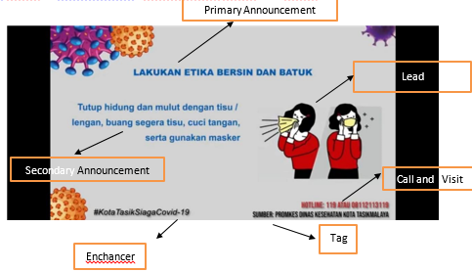Figure 1. Lakukan Etika Batuk dan Bersin
There are three elements which found in this picture, they are lead, display and emblem.
- Lead
The lead of this picture is the most silent image because it is the main focus of the attention, which attracts the viewers while watching the advertisement. Here, the main focus can be seen from the visual of Cough and Sneeze. It describes that people who have cough and sneeze must be get away from around or close their mouth with a sniffer.

- Linguistic element
There are three elements that found in this advertisement they are in the Primary Announcement
    - Primary Announcement


Etika bersin dan batuk

Lakukan

Goal Material Process

This clause material process, it means that the process of human physically or need the action “lakukan” is the point if the process determined, the participant can be understood “ Etika bersin dan batuk” is participant II is called the goal.
    - Secondary Announcement
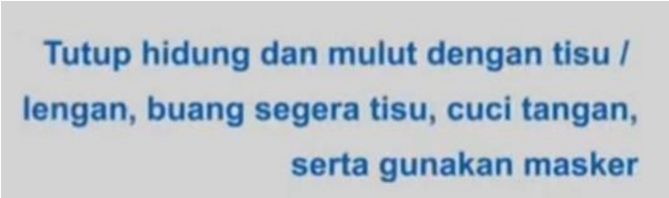

Bersin / Batuk Dengan tisu , masker/ cuci tangan Agar Mencegah dan mengurangi resiko virus yang menular

Actor Material Process Goal
    - Enhancer
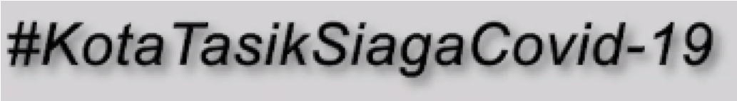

Kota Tasik Siaga Covid-19
Actor Material Process Phenomenon
    - Tag
Sumber: Promkes Dinas Kesehatan Kota Tasikmalaya

Material Procces circumstance location
Conclusion
After analyzing the data, the researcher had the conlusion that:
- Visual represented by images. The visual images consist of two elements. They are Lead 5 and Display 1, which are found in Covid-19 Advertisement. The dominant visual is Lead, while the least is the display. This is because, in data analysis, it was located five different leads in 5 images, while for production, there is only one display that is the same in 5 shots. Linguistic is represented by text. They are Primary Announcement 5, Secondary Announcement 5, Call and Visit 1, Enhancer 1, Tag 1, which are found in Covid-19 advertisement. Primary Announcement and Secondary Announcement are dominant in linguistic elements. Of 5 images, each has 5 Primary and Secondary Announcements. In contrast, the least are call and visit, tag, and enhancer because five shots have the same label, enhancer, call, and visit. 1
2. In the visual text of the Covid-19 advertisement, the conceptual process consists of Material Process 11, Actors 6, Circumstance 3, Location 1, Goals 10. The analysis of linguistic in advertisement showed that advertisers convey messages that can construct the components of conceptual function. This can be demonstrated through the dominant conceptual role in Covid-19 promotion, namely Material Process. It takes 11 materials from 31 total linguistic ideational functions.
References

Bull, G and Michele Anstey. 2010. Envolving Pedagogies: Reading and writing in a multimodal world. Melbourne: Education Service Australia
Caffarel, Alice, J.R. Martin, Christian M.I.M Matthiessen. 2004. Language Topology: A functional perspective. Berlin : John Benjamins B.V
Halliday, M and Gunther. R. Kress. 1976. Halliday : System and function in language. Oxford: Oxford University Press
Halloran, K. 2004. Multimodal Discourse Analysis: Systemic Functional Perspectives. London: A&C Black
Kress, and van Leeuwen, T.2006. Reading Images: The Gramar of Visual Design. (2nd ed.). London: Routledge
Kotler, P and Gary Amstrong. 2006. Principles of Marketing. New Jersey: Pearson Prentice Hall
M, Najafian and S, Ketabel. 2011. Advertising social semiotic: A critical approach. Isfahan: International Journal of Industrial Marketing
Flergin, Anthony. 2014. Language of Persuasion: A Discourse Approach to Advertising Language. Vol. 3 (1) 62-68.
Chaer, A. (2007). Linguistic umum. Jakarta: Rineka Cipta.
Koteko, Nelya and Nerlich, Brigitte. 2018. Multimodal Discourse Analysis of Probiotic Web Advertising. Nottingham: The Journal International Language, Social and Culture.
Putranto, Kristian Dwi, Sigit Ricahyono, Rosita Ambarwati. 2008. Generic structure potential of rollingstone magazine cover February 9th, 2006 edition; critical multimodal analysis. Vol 6 (1).
Aisyah, Sarah. 2017. “A Multimodal Analysis of Cosmetic Advertisement”. Skripsi. Faculty of Cultural Sciense. Universitas Sumatera Utara. Medan
Suprakisno. 2015. Analis Multimodal Iklan “Indomie”. Jurnal Bahas Unimed. Vol26, No 1(2015) https://media.neliti.com/media/publications/78384- IDnone.pdf accessed on June 10th 2020
Juliana, J and Arafah, Sarah . The Multimodal Analysis of Advertising Tagline “Tolak Angin Sidomuncul“ Through Systemic Functional Linguistics Approach. Journal MELT (Medium for English LanguageTeaching). Vol 3, No 2 (2018) http://e-journal.potensi utama . ac . id / ojs /index .php /MELT / article / viewFile /475/ 562. accessed on June 10th 2020
Adisty, Primy Wulan. 2017. Analisis Wacana dan Edukasi: Semiotic Multimodal Kartun Indonesia “Adit Sopo Jarwo Episode Bakso Hilang” Vs Kartun Malaysia Upin-Ipin “Episode Ekosistem”. Yogyakarta. The 5th Flurecol Proceeding. http://lpp.uad.ac.id/wp-content/uploads/2017/05/191-Adisti1104-1117.pdf . accessed on march 9th 2021

