Timestamp | Nick Name | Class | 1. Using that game is easy | 2. Using that game make you happy in joining the English class in online learning | 3. Using that game make you enjoy the teaching learning process | 4. Using that game make you motivate in online learning English | 5. Using that game are give timid student more oportunities to express their opinion and feeling in english | 6. Using that game help you remember new words faster and better | 7. Using that game help you to understand English easier | 8. Using that game make you want and try to be a winner during the games play
2/11/2022 14:59:11 | Man | 7 | Yes | Yes | Yes | Yes | Yes | Yes | Yes | Yes
2/11/2022 15:00:26 | Ball | 7 | Yes | Yes | Yes | Yes | No | Yes | No | Yes
2/11/2022 15:01:13 | Idea | 7 | Yes | Yes | Yes | Yes | No | No | Yes | No
2/11/2022 15:02:00 | Tae | 7 | Yes | Yes | Yes | Yes | Neutral | Yes | Yes | No
2/11/2022 15:02:39 | Lettuce | 7 | Yes | Yes | Yes | Yes | Neutral | Yes | Yes | No
2/11/2022 15:03:19 | Bass | 7 | Yes | Yes | Yes | Yes | Yes | Yes | Yes | Yes
2/11/2022 15:03:56 | Kim | 7 | Yes | Yes | Yes | Yes | No | Yes | Yes | Yes
2/11/2022 15:04:25 | Fay | 7 | Yes | Yes | Yes | Yes | Yes | Yes | Yes | No
2/11/2022 15:05:03 | Crep | 7 | Yes | Yes | Yes | Yes | Neutral | No | Yes | Yes
2/11/2022 15:05:30 | Jek | 7 | Yes | Yes | Yes | Yes | Yes | Yes | Yes | Yes
2/11/2022 15:07:02 | Rung | 7 | Yes | Yes | Yes | Yes | Yes | Yes | Yes | Yes
2/11/2022 15:07:42 | Nun | 7 | Yes | Yes | Yes | Yes | Yes | Yes | Yes | Yes
2/11/2022 15:08:22 | Nook | 7 | Yes | Yes | Yes | Yes | Yes | Yes | Yes | Yes
2/11/2022 15:08:53 | Cheek | 7 | Yes | Yes | Yes | Yes | Neutral | Yes | Yes | Neutral
2/11/2022 15:09:22 | Ford | 7 | Yes | Yes | Yes | Yes | Yes | Yes | Yes | No
2/11/2022 15:09:46 | Grape | 7 | Yes | Yes | Yes | Yes | Yes | Yes | Yes | Yes
2/11/2022 15:10:06 | Wong | 7 | Yes | Yes | Yes | Yes | Yes | Yes | Yes | Yes
2/11/2022 15:10:26 | Guy | 7 | Yes | Yes | Yes | Yes | Yes | Yes | Yes | Yes
The result of Questionnaires

Documentation
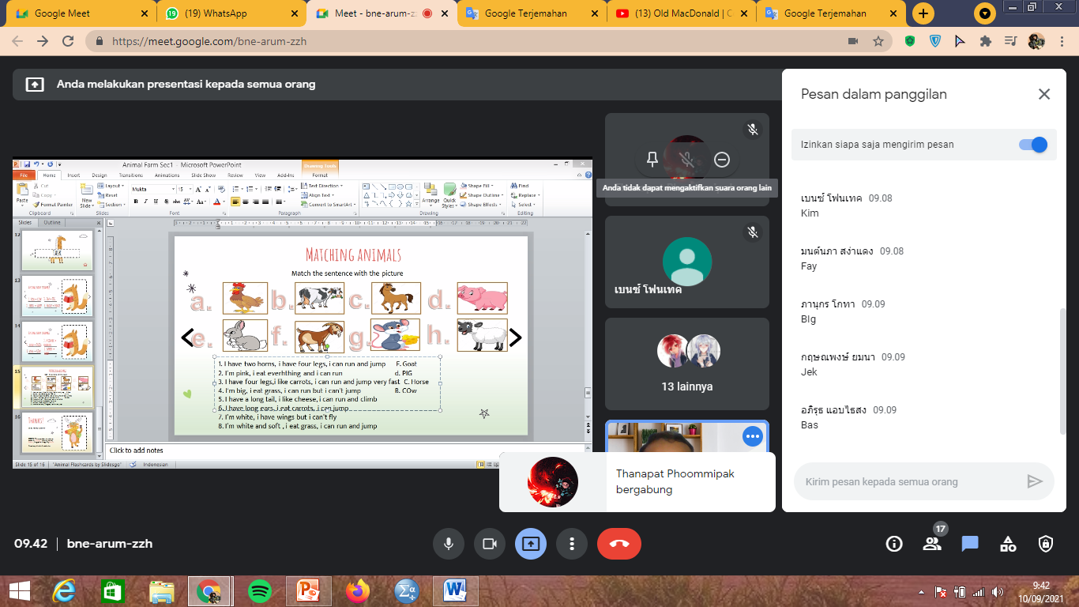
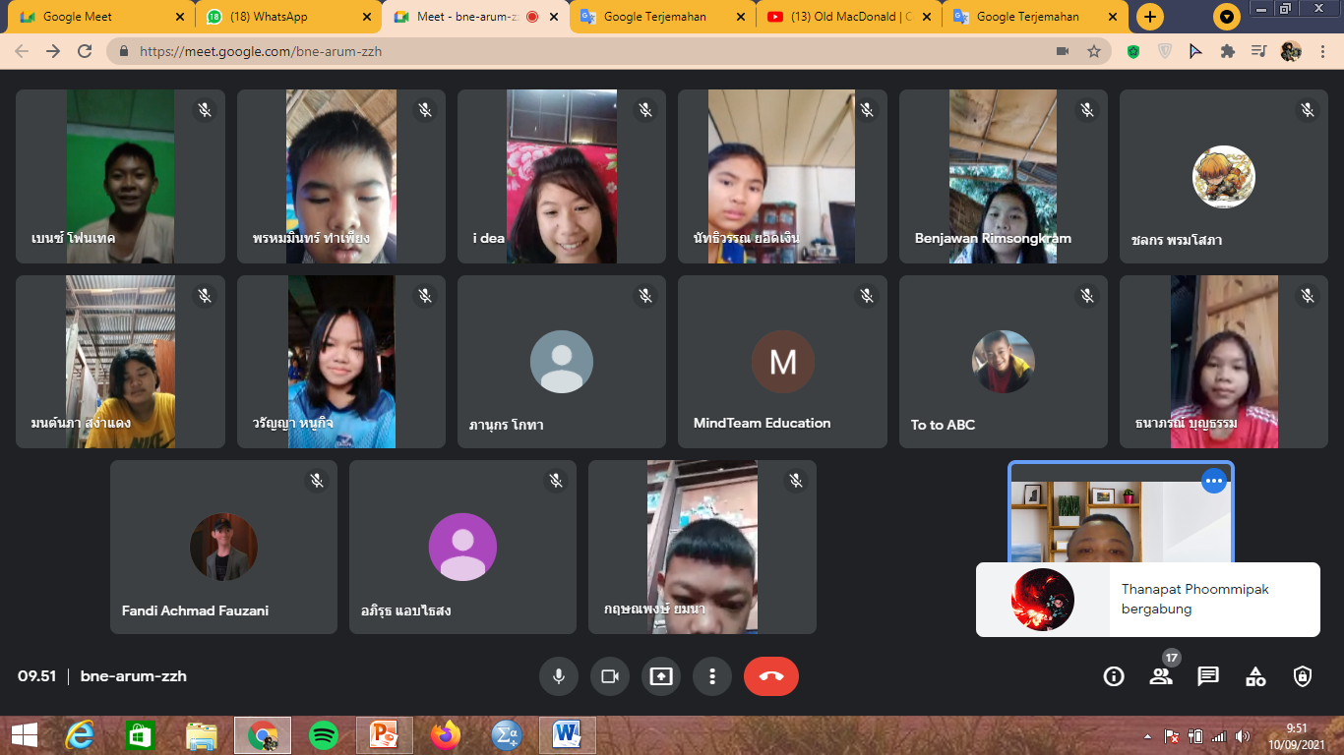
The result of Questionnaires

