- Validity and Reliability Test

Table 2. The Result of Validity Test

Item | r-count | r-tabel | Explanation
1 | 0,384 | 0,334 | Valid
2 | 0,377 | 0,334 | Valid
3 | 0,398 | 0,334 | Valid
4 | 0,348 | 0,334 | Valid
5 | 0,397 | 0,334 | Valid
6 | 0,355 | 0,334 | Valid
7 | 0,355 | 0,334 | Valid
8 | 0,354 | 0,334 | Valid
9 | 0,412 | 0,334 | Valid
10 | 0,404 | 0,334 | Valid
11 | 0,539 | 0,334 | Valid
12 | 0,391 | 0,334 | Valid
13 | 0,456 | 0,334 | Valid
14 | 0,345 | 0,334 | Valid
15 | 0,513 | 0,334 | Valid
16 | 0,387 | 0,334 | Valid
17 | 0,431 | 0,334 | Valid
18 | 0,373 | 0,334 | Valid
19 | 0,470 | 0,334 | Valid
20 | 0,354 | 0,334 | Valid
21 | 0,391 | 0,334 | Valid
22 | 0,370 | 0,334 | Valid
23 | 0,539 | 0,334 | Valid
24 | 0,413 | 0,334 | Valid
25 | 0,513 | 0,334 | Valid

Table 3. The Validity output:
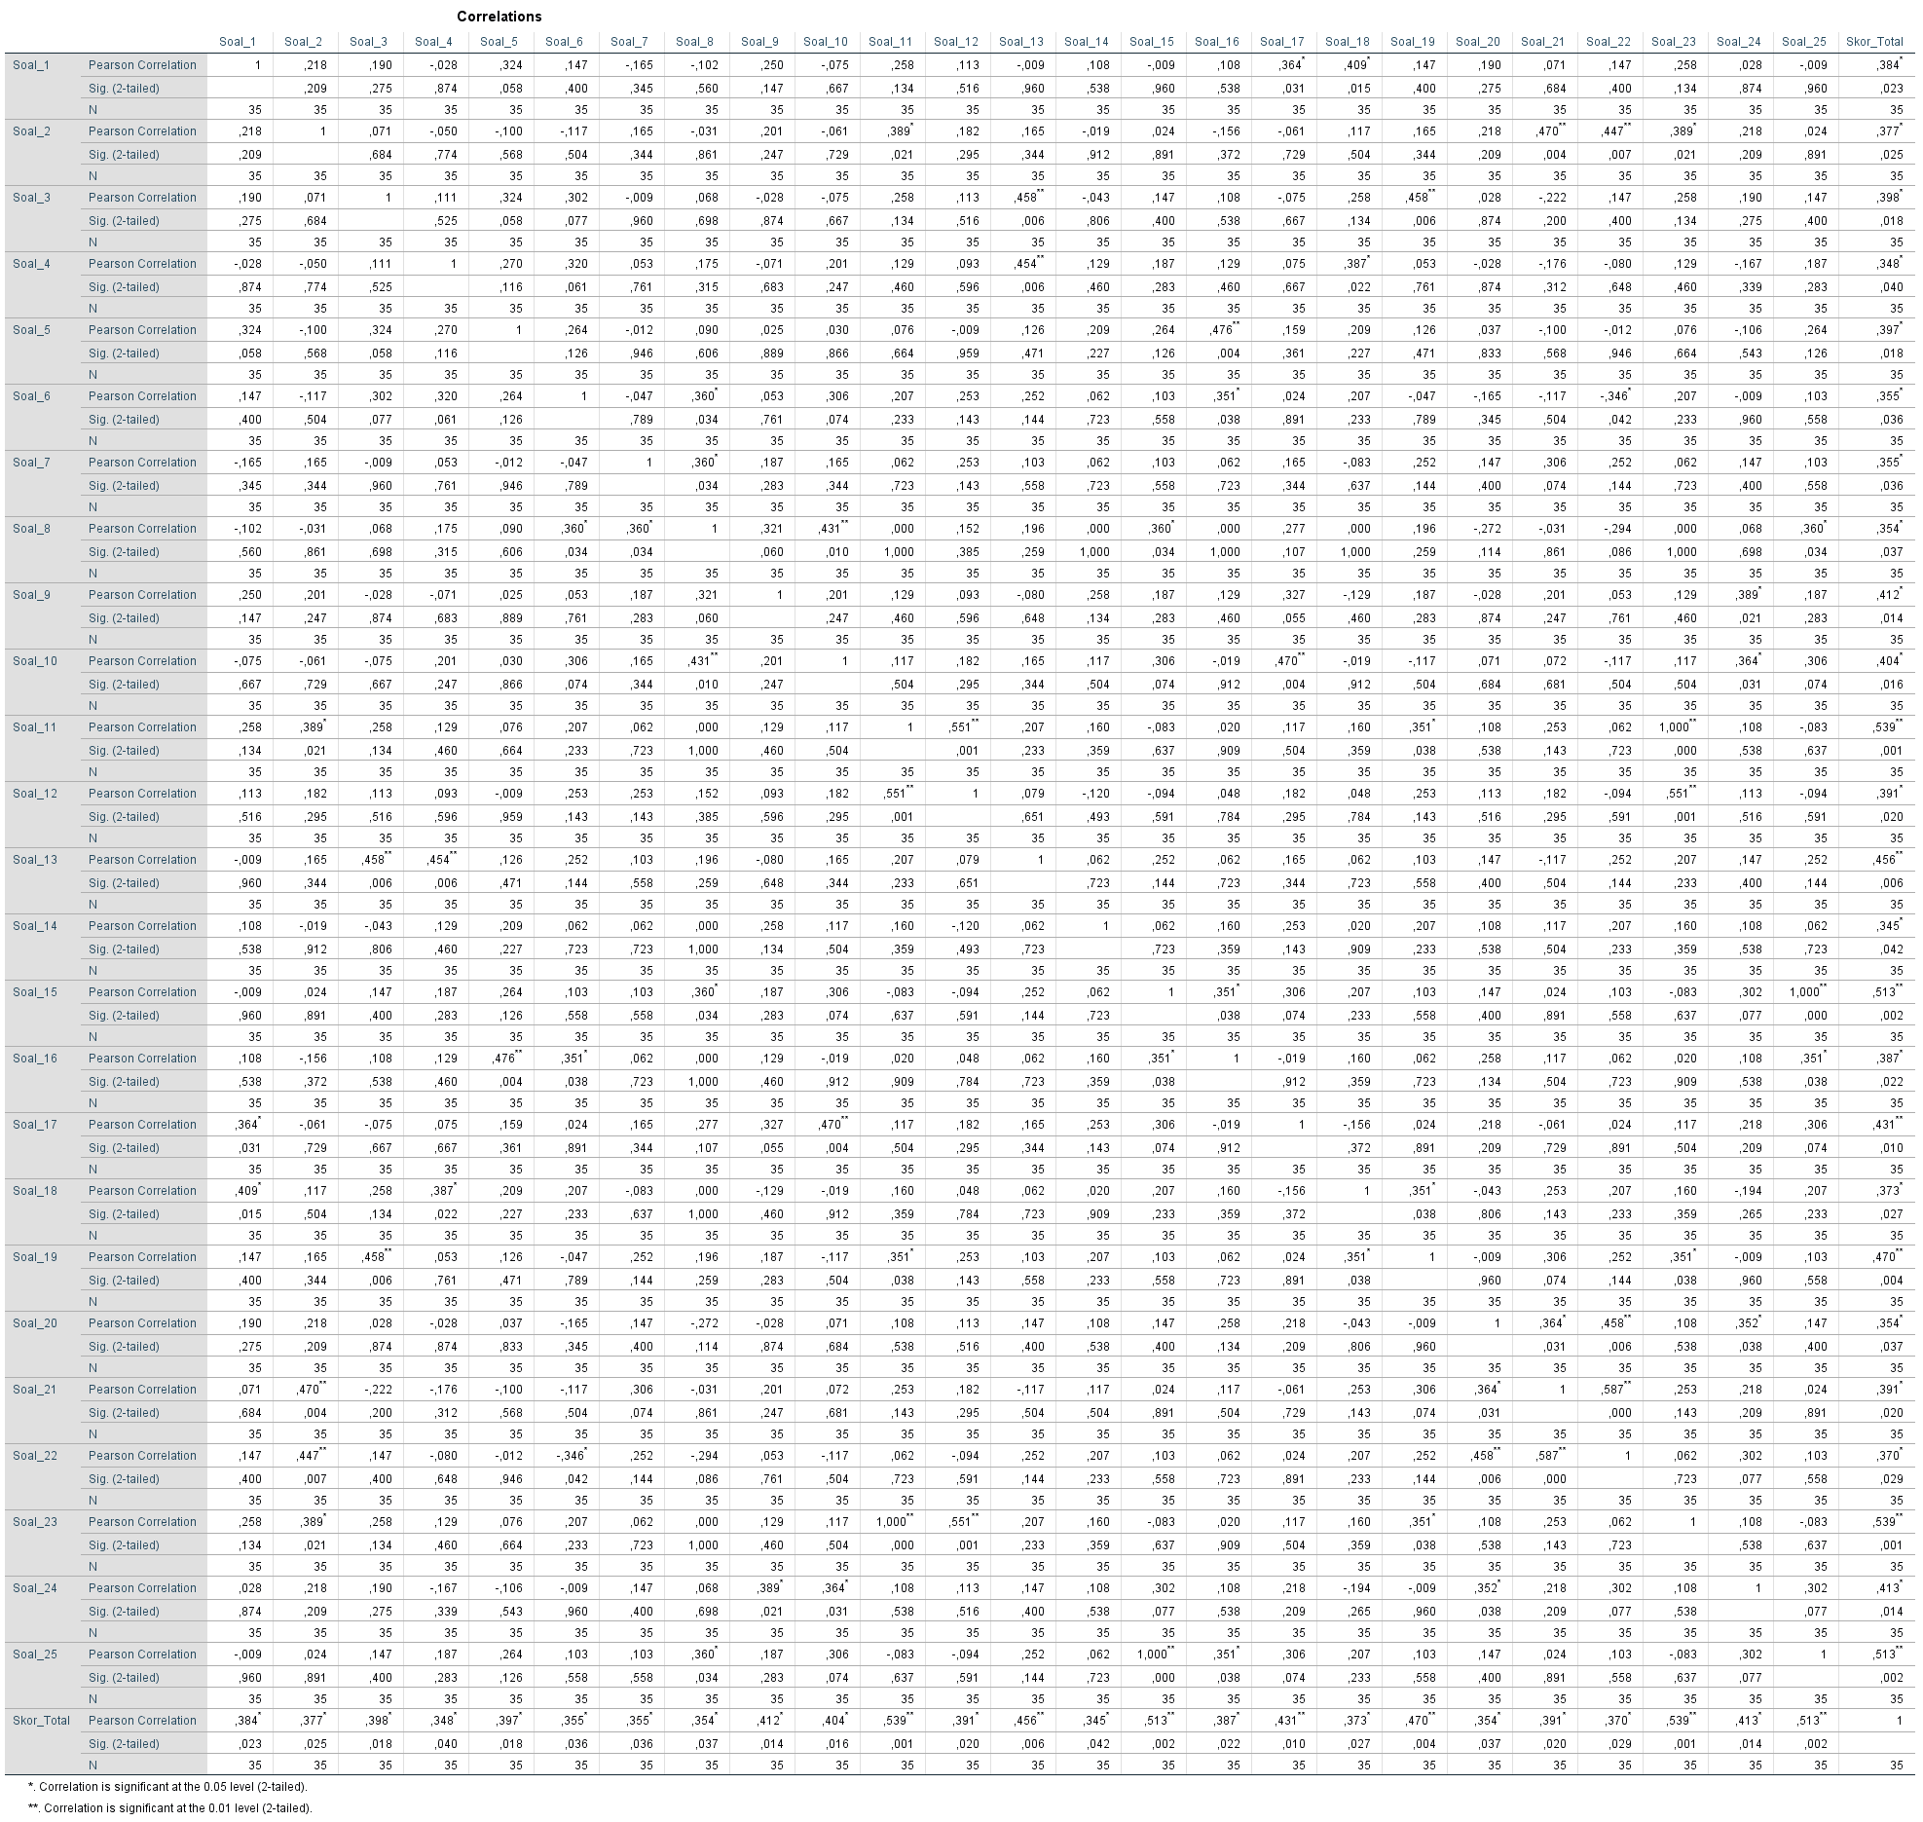

Table 4. The Result of Reliability Test

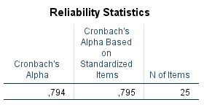

- Students’ Pre-test and Post-Test Score

Table 5. Score of Pre-test

No | Initial Name | Score | No | Initial Name | Score
1 | AF | 60 | 21 | MP | 56
2 | AARP | 48 | 22 | MSA | 48
3 | AS | 56 | 23 | NN | 60
4 | AA | 64 | 24 | NVZ | 56
5 | AR | 52 | 25 | RMS | 72
6 | AP | 60 | 26 | SR | 56
7 | AN | 56 | 27 | S | 40
8 | AN | 64 | 28 | SC | 56
9 | CAP | 60 | 29 | SPA | 52
10 | DS | 48 | 30 | SD | 48
11 | DAN | 40 | 31 | SFAR | 60
12 | ESN | 56 | 32 | VDN | 72
13 | FM | 48 | 33 | ZAR | 60
14 | IRP | 52
15 | IFH | 52
16 | JQ | 48
17 | KNA | 60
18 | LR | 52
19 | MTR | 48
20 | MZA | 60

No | Initial Name | Score | No | Initial Name | Score
1 | AF | 96 | 21 | MP | 88
2 | AARP | 88 | 22 | MSA | 92
3 | AS | 96 | 23 | NN | 88
4 | AA | 96 | 24 | NVZ | 92
5 | AR | 76 | 25 | RMS | 80
6 | AP | 96 | 26 | SR | 84
7 | AN | 80 | 27 | S | 84
8 | AN | 80 | 28 | SC | 92
9 | CAP | 84 | 29 | SPA | 88
10 | DS | 76 | 30 | SD | 92
11 | DAN | 80 | 31 | SFAR | 92
12 | ESN | 84 | 32 | VDN | 84
13 | FM | 80 | 33 | ZAR | 88
14 | IRP | 88
15 | IFH | 76
16 | JQ | 96
17 | KNA | 96
18 | LR | 84
19 | MTR | 80
20 | MZA | 96
Table 6. Score of Post-test

