Zoom Application As Teaching Media To Improve Students’ Speaking Skill
Dharmawati
dharmawati66@yahoo.com
Engineering and Computer Science Faculty, Universitas Harapan Medan, Medan, Indonesia

Abstract
This study seeks to investigate the use of zoom application as teaching media to improve students’ speaking skill. Zoom application becomes the most popular tool in teaching learning process for pandemic era, especially in teaching speaking The main purpose of this study how to improve students’ speaking skill in English by using zoom application. It allows students and lecturer to make calls, send messages and do video conferencing online. This study was action research by combining quantitave and qualitative. The subject of this study was 25 second semester students of informatics department at Universitas Harapan Medan in the academic year of 2020/2021. The data were in the forms of qualitative and quantitative. The qualitative data were obtained by observing the teaching and learning process of speaking and interviewing and the quantitave data were acquired through pre-test and post-test. The result of the study showed the improvement the students’ score from 6.9 in pre-test to 13.29 in the post-test proved that teaching English using zoom application was able to improve their speaking skill. The procedure of improving speaking skill by using zoom application consists of preparation, presentation, practice, evaluation and expansion.

Keywords: Speaking Skill, Teaching Media, Zoom Application

Introduction
The COVID-19 Pandemic has run for several months in Indonesia. It has impacted teaching learning process from elementary school to higher education (universities). It forces students to learn out of the classroom. Having this situation, students and leacturers continue their teaching learning interaction from thir home through online teaching). Online teaching can expand existing curriculum to students in a regional, national, and international level (Heriyandi, 2020). by using WA, moodle, google classroom, edmodo, quipper, etc and also video calls like WA, skype, google meet, zoom, etc. The Zoom application as a video conferencing service has the practical ability to present an online meeting atmosphere (Halim, 2022).

Zoom application provides communication services by using a webcam and a headset. The user can have face by face for person to person or person to group online chats or conferences, which enables communication without the limitations of time and space. Speaking interaction on videoconferencing contains eye contact, gestures and turn-taking, which can enhance students’ positive mind and attitudes and also motivation to learn English. In creating teaching speaking, we have to invite the students to join zoom for their meeting room. In other words, their meetings had been scheduled at their lecturer. After students join the online class, the lecturer can create the best way to teach speaking for the students. Recently zoom application allows as teaching media in this pandemic era as a replacement teaching learning interaction in the classroom. Zoom Application can be useful by English lecturer who wants to improve students’ English skill such as listening, reading, writing and speaking. To provide those skills and components in online learning, different methods are needed (Ermawati, 2021).
Speaking is the most important skill in learning English. Speaking a foreign language is a very complex skill, including vocabulary; grammar, pronunciation, and fluency, the ability to structure talk or even non-verbal abilities (Mirostaw dkk, 2011). According to Rebecca (2006), “speaking is the first mode in which children acquire language, it is part of the daily involvement of most people in language activities, and it is the prime motor of language change”. It provides our main data for understanding bilingualism and language contact. speaking in interactive and according to accomplish pragmatic goals through interactive discourse with other speaker of language (Huges, 2007: 57). In English language learners teaching, speaking ability is an aspect that need special attention and instruction. Furthermore, speaking skill is also one of the central elements of communication (Yohanes, 2017).
The objective of teaching speaking is the development of students’ skill to interact successfully in that language. The objective of English teaching in university is to make students able to communicate English well. It is suitable to 2013 curriculum which states that English teaching based on the curriculum, the ultimate goal of English instruction is to develop students’ English communicative competence in the form of oral and written language, namely: listening, speaking, reading and writing”.
The previous researches about the use of video application in teaching learning process argued that teaching learning process by using video converencing gave affected the results (Li-Tang Yu, 2018). The next study was done by Guzacheva (2020). She stated taht the innovative approach in using Zoom technology enhances positive learning outcomes, Barbara Loranc and Paszylk (2015) also researched about speaking skill by using video conferencing. They stated that video conferencing as bridge that allow geographical distances in learning foreign language.
Based on the observation, there are a lot of students difficult to speak in English especially for university students majoring informatics. They fell shy and difficult to express their ideas in English. They felt difficult to catch the lecturer’s explanation, so the students felt bored during teaching process. In this pandemi era, the English lecturers have to find the best methods and tools in teaching English especially speaking skill because education must go on during this pandemi. One of the best tools can be used is Zoom application.
Based on these previous studies, the purpose of this study is how to improve students’ speaking skill in English by using zoom application. The objective of the study is to investigate the use of zoom application as teaching media to improve students’ speaking skill.

Method
This research was action research. The method was combined into quantitave and qualitative. This research was aimed to find how to improve students’ speaking skill in English by using zoom application. The subject of this research was 25 second semester students of informatics department at Universitas Harapan Medan in the academic year of 2020/2021. The data were in the forms of qualitative and quantitative. The qualitative data were obtained by observing the teaching and learning process of speaking and interviewing. The quantitave data were acquired through pre-test and post-test. The prosedure of teaching speaking is preparation, presentation, practice, evaluation and expansion, the prosedures can be seen in the figure below.

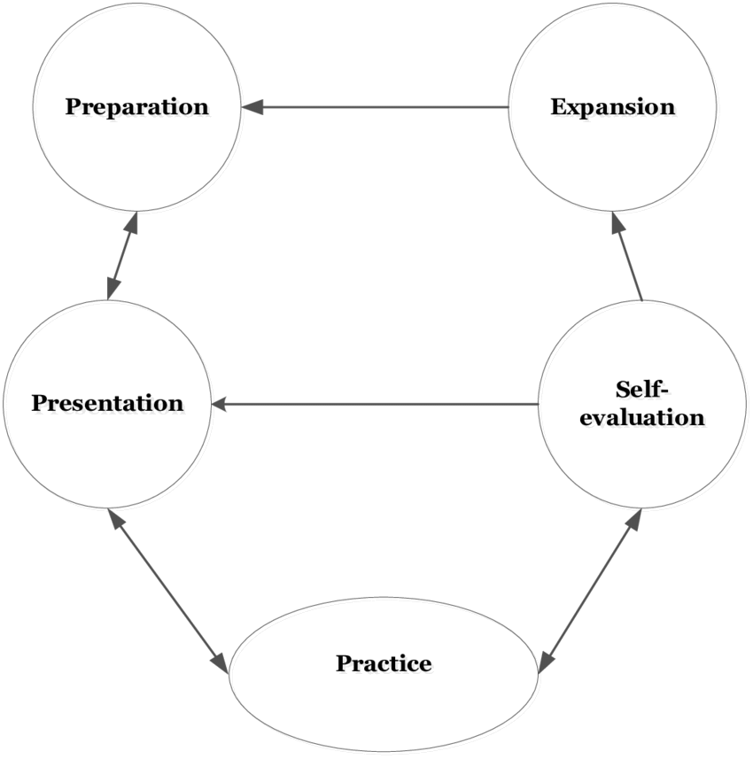

Figure 1 The Procedure of Teaching Speking
Results
Findings
Teaching learning process for English subject at Universitas Harapan Medan was done by using Zoom application which gave lecture and students’ interection effectively. In analizing this study, the students’ speaking skills were tested through pre-test. The students were divided into some groups and given one topic tobe discussed in the forum. In pairs, the students performed speaking consisting expressions of asking, giving idea and refusing. The students responded that the use of zoom application as teaching media make their learning more fun and interactive. The result of the post-test was given after the implementation of the actions as shown below.

Table 1. Pre Test and Post test Result
No. | Test | Pronounciation | Vocabulary | Grammar | Fluency
1. | Pre-Test | 60 | 66.5 | 58.5 | 65.5
2. | Post-Test | 66 | 70.5 | 62 | 72

The pre-test and post-test result showed that there is an improvement in students’ speaking skill. The table below also shows the comparison between the pre-test and post-test results in general.

Table 2. The Comparison Between Pre Test and Post test Result
Score | Pre-Test | Post-Test
Mean | 6,9 | 13, 29

The table above showed that students’ scores increased. The students got 6.9 in pre-test, and increase their score up to 13.29 in the post-test. It showed that they were successful to share their interaction by sharing idea. They also were able to improve their speaking skill. In conclusion, teaching speaking by using zoom application was effective to improve the students’ speaking skills. Learning by using zoom application also improved the students’ confident to speak in English. Althoug sometimes the made mistake, but they were brave to speak English in forum. The results of pre-test and post-test can be seen in this following figure:

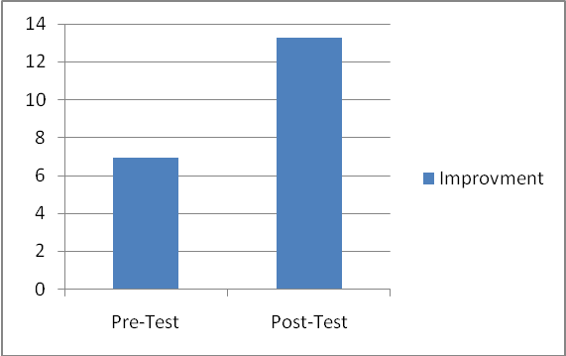
Figure 2: The Comparison between the Result of Pre-test and Post-test

The results of the students’ speaking performed during teaching learning processes were presented to support the the result of the use zoom application to improve the students’ speaking skills.

Discussion
- Preparation
The online class started when the students had joined zoom. Then the lecturer gave students a large outline goals and teaching activities so they knew what goal to be reached. If the students were ready to follow the lesson, the lecturer Helped them focus by expressing their existing knowledge of the topics. In this pre teaching activities, the lecturer could create student readiness by guiding students in preparing the topic of material given. The material had been explained by the lecturer during teaching learning process. The lecturer explained the material before asking them to have presentation.
In this preparation, the lecture also gave motivation to the students so that they were motivated in learning activities. The motivated was given by encouraging the studenst to speak up and advising them to be brave in sharing their ideas.

- Presentation
Presentation is an activity to organize the language input that can support students in expressing their speaking. The input comes from the lecturer and teaching materials. The teaching materials designed for Informatics’ students at Universitas Harapan Medan usually provide the explaination from reading text, grammar as language focus, expressions as language function, exercises and are written in English. The teaching material determine what topic must be presented in class and decide which exercises to do in class. After doing presention the lecturer devide students into group. Then the lecture decided the topic to be discussed by the students. In this time the lecturer also support and give respond to students in improving their speaking skills.

- Practice
The most important part from this section is the students’ courage in expressing their idea. Students work in pairs or small groups on a topic given by the lecturer. They have to speak up to express their idea that they know along the practice time. The lecturer observes the groups when they practice their speaking skill. When the students have question and anothe group can’t solve their problem, the lecturer will handle the situation. One group presents the topic for 10 minute, the process can be seen in the figure below.


Figure 2 Sharing Idea

When the speaker from group A gave presentation, students from group B and C listen and pay attention. After presenting, students from group A will ask to students from group B and C whether they understand about the topic that they have presented. Here students from group B and C will give respon by giving question to group A. By doing this activity students will discuss and share their idea in the class (zoom application). The students asked and answered their friends and also responded their lecturer’s comment actively. This activity was carried out more for the purposes of maintaining social relationships than for transferring facts and information.

- Evaluation
When all students have finished their speaking practice, the lecturer will evaluate the activity. The lecturer asks students to give examples and problem of how they were practicing their speaking skill. The lecturer must know how far their students understanding of the topics discussing by using zoom application. The evaluation is done to:
- Strengthen the teaching material that was discussed by the students
- Give opportunity for students to ask question about the teaching material that they don’t understand.
- Give opportunity for students to speak up
- Know individual student comprehension and learning
- Conclude the teaching learning process.

- Expansion
Expansion activity is the final step in teaching learning process. In this activity, students should apply the knowledge they have got in the online classroom to situations outside of the class. Expansion activity involves out of online assignment. The lecturer asks students to do some exercises or make a report about the material they have learned.

Conclusion
Zoom application allows as teaching media in this pandemic era as a replacement teaching learning interaction in the classroom. The students were given pre-test and post test. The students got 6.9 in pre-test, and increased their score up to 13.29 in the post-test. It showed that they were successful to share their interaction by sharing idea. The way to improve students’ speaking skill was done by prosedure of teaching speaking namely preparation, presentation, practice, evaluation and expansion. During the steps, the students looked interesting and enjoy the process of English learning through zoom application. Beside improving students’ speaking skill, zoom application also can imprive students’ confidence.
The suggestion from this study can be addressed to first lecturer who is teaching Englis, Students and reseracher. Zoom application becomes one of media in teaching language. It can be applied not only for teaching speaking, but for teaching reading, listening and writing. It can make the teaching English more effective and more enjoyable and improve students’ speaking skill. Second, students who is learning language like zoom application can be used to improve our achievement in learning language. Third for further researcher, they can conduct the same scope of research by involving other ways or prosedures.

References
Barbara Loranc, Paszylk. (2015). Videoconferencing as a Tool for Developing Speaking Skills. Issues in Teaching, Learning and Testing Speaking in a Second Language, Second Language Learning and Teaching, DOI 10.1007/978-3-642-38339-7_12
Ermawati, Ermawati; Nurchalis, Nur Fadillah; Sardi, Ahmed. (2021). Online EFL Teaching and Learning: Different Skills, Different Challenges. IDEAS: Journal on English Language Teaching and Learning, Linguistics and Literature, v. 9, n. 1, p. 373-382.
Guzacheva N. (2020). Zoom Technology As An Effective Tool For Distance Learning In Teaching English To Medical Students. Bulletin of Science and Practice, Vol 6, No. 5, 457-460.
Halim, Shanty. (2022). Students Perception towards English Online Classroom Via Zoom During the Covid-19 Pandemic. IDEAS: Journal on English Language Teaching and Learning, Linguistics and Literature, v. 10, n. 1, p. 1017-1026.
Heryandi Y, Said I, Herlina. (2020). Online Teaching in Writing by Using Means of Slack Application. Journal of English Education and Teaching (JEET), Vol 4, No. 1, 49-68
Hughes, Dewi. (2007). Public Speaking. Jakarta: Gramedia Widiasarana.
Hughes, Rebecca. (2006). Spoken English, TESOL, and Applied Linguistic: Challenge for Theory and Practice. Great Britain: CPI Anthony Rowe.
Li-Tang Yu. (2018). Native English Speaking Teachers’ Perspectives on using Video Conferencing in Learning English by Taiwanese Elementary School Students. Jalt Call Journal, Vol. 14, No.1, 61–76.
Mirostaw Pawlak, Ewa Waniek-Klimczak and Jua Majer. (2011). Speaking and Instructed Foreign Language Acquisition. Great Britain: MPG Books Library.
Yohanes Paulus, F.E. (2017). Improving Second Semester Students’ Speaking Ability Through Storytelling Learning Model at English Study Program of Timor University (A Classroom Action Research Method). METATHESIS: Journal of English Language, Literature, and Teaching, Vol. 1, No. 2.
Ahmed, S., & Alamin, A. (2014). Assessing speaking ability in academic context for fourth year Taif University students. International Journal of English Linguistics, Vol. 4 No. 6, 97–103.
Trialika V.S, Puspita H, Sabarudin S. (2017). English Learners’ Strategies In Learning Speaking Skill (A Study Of Undergraduate Student Of English Education Study Progrm At Universitas Bengkulu In 2016/2017 Academic Year). Journal of English Education and Teaching (JEET) Vol.1, No.1, 9-21.

