Videos in Teaching Listening: A Systematic Literature Review
Marisatul Khasanah
marisatulkhasanah@gmail.com
SMP Negeri 1 Sawangan, Magelang, Jawa Tengah

Abstract
The purpose of this study was to evaluate at articles published between 2017 and 2022 that explored the benefits and impact of using video-based learning in the classroom to teach listening. It was considered as a Systematic Literature Review. Data were obtained from ERIC as an online journal database which served a number of reputable journals. They were gathered and analyzed through a systematic examination covering four phases, such as identification, screening, eligibility, and exclusion. In the first phase, 132 articles were obtained however at the last after filtering process, there were only 5 articles remaining. Actually, most of the sources stated that videos play its roles well in enhancing students’ listening skills. Yet, another innovation in using videos in teaching listening were really expected to be investigated for future studies.
Keywords: listening, review, student, video

Introduction
Listening is a fundamental ability in many learning processes. It plays an important part in the process of second language and foreign language learning as well; it is the first and most important requirement for speaking (Rakhmyta, 2019). has two primary goals: maintaining the communicational connection (interactional function) and transferring knowledge (transactional function). Hearing, understanding, and evaluating are the three main phases of listening. Listening comprehension work is not as numerous in the literature as, instance, reading comprehension research. EFL teachers must realize that such negligence may greatly affect the process of learning a foreign language since EFL learners may be unable to establish and maintain contact. Without a question, listening skills are critical in English language teaching and learning (Fuady & Mutalib, 2018)..
The modern digital era has revolutionized not just people's lifestyles, but also education and learning methods (Tananuraksakul, 2016). The use of video media in learning has the advantage of supplementing students' basic knowledge when they discuss, read, and practice (Pimenta, 2021). Videos may depict everyday items that are not visible, such as the heart beating. Videos may motivate and boost student motivation while also instilling attitudes and other affective factors. Videos include positive qualities that can spark thinking and conversation in student groups, and they can be used to communicate events to large groups of students. Furthermore, audiovisual media in education may control time and space, allowing pupils to be encouraged to travel anywhere yet being restricted by classrooms. Video can also show items that are too little, too large, unsafe, or even impossible for pupils to visit. Video media's abilities may also be depended on in the field of study that teaches motor skills and trains activity skills. The benefits of streaming video files made by educators include the ability to visually stimulate more fascinating information as well as assist students and instructors in dealing with volatile or fast obsolete material.
However, the disadvantage of using video learning media is generally expensive and time-consuming to obtain videos; when the video is played, the image and sound will continue so that not all students are able to follow the information conveyed through the video; and the available videos are not always appropriate (Widiastuti et al., 2020). Unless the video is particularly created and produced for the learner's requirements and desired aims.
The purpose of this study is to evaluate at articles published between 2017 and 2022 that explore the benefits and impact of using video-based learning in the classroom to teach listening. It is very beneficial in the learning process. Through video media, educators may easily convey what cannot be delivered directly. The use of video material for learning broadens students' comprehension, as does the influence of video-based learning on student outcomes. Students who already use based media video have better learning outcomes than students who do not use based media video. This review on video-based learning was intentionally conducted in order to guide future investigations.

Method
Design employed in this study was Systematic Literature Review. It was a process of identification, evaluation, interpretation, and analysis of findings from available research related to a particular topic or issue (Shahrol et al., 2020). The purpose of this study is to explore about the use of videos as an effort to improve individuals' language skills, especially listening. Thus, this will provide some details such as types of research, implementation, participants, and the effect of using video in teaching listening.
Data were obtained from ERIC as an online journal database which served a number of reputable journals. Then they were gathered and analyzed systematically through SLR stages analysis proposed by Nair and Yunus (2021). There were four phases which were explained as follows.
Phase 1: Identification
This stage focused on how data in the form of articles is gathered. The issue, specifically the use of video to teach listening, was clearly defined in the previous section. The literature used in this study were published between 2017 to 2022. The article search also employed a number of keyword combinations. such as listening, video, digital media, using video in teaching listening, and digital media in improving listening skills. Finally, 132 articles were presented in the database.
Phase 2: Screening
After retrieving the articles from the database, a screening phase was carried out. They were re-examined in consideration of the author's requirements. Free-accessed articles were included in this study, otherwise, they were excluded. It also excluded certain irrelevant sources and articles, such as book chapters, reports, and literary reviews. Finally, 63 articles met the requirements while the others were excluded.
Phase 3: Eligibility
The next phase is to determine if the articles were eligible. This phase was crucial since the author started to review the contents. Examining the abstract, 21 articles were included based on the listed criteria presented in Table 1.
Table 1. Inclusion Criteria
Inclusion Criteria
Use of video in teaching listening
Research methodologies: qualitative, quantitative, mix-method
Sample from various level of education
Published from 2017 - 2022
Phae 4: Exclusion
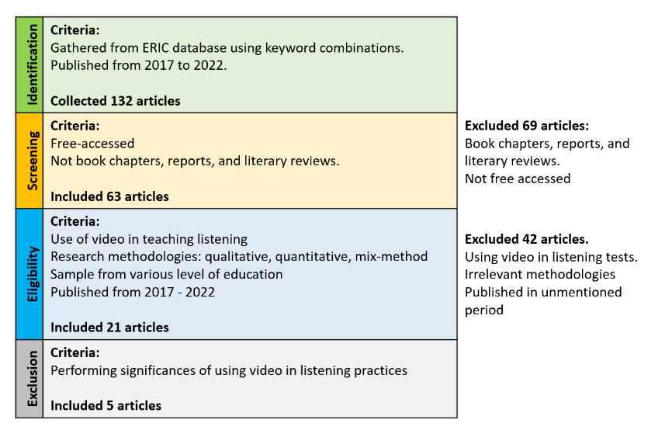
The last phase was exclusion where the author examined the article's contents. During this phase, the information was not only gathered from the abstract, but it was also explored deeper from whole parts of the article. Finally, 5 articles were included in this study. Figure 1 depicted the clearer procedures of the phases.

Figure 1. Article Selection Phases
Results
This study was aimed to explore the use of video to improve individuals’ listening skills. Based on the phases mentioned in the previous section, 5 articles were considered to be appropriate and eligible. Therefore, they were examined through this Systematic Literature Review. The focus of this study was to reveal in detail about the type of research, implementation in learning, participants, and the effect on listening skills presented in Table 2.
Figure 2. Research type, implementation, participants, effects of listening of existing works
Author | Research type | Implementation | Participants | Effects on Listening skills
Tekin & Gunes (2018) | Quasi-experimental design with factorial design | Parts of the movie that containing Present Tense is selected to be watched by students from the experimental group. | University students | Significant disparities were seen in short and lengthy movie sequences, as well as the total score gained from these sequences, with male students outperforming female students.
Metruk (2018) | Case study | watching English movies on a daily or biweekly basis, which may be assumed extensive listening practice The participants appear to view videos on video sharing and social networking websites on a regular basis. | University students | The frequency with which video sharing and social networking websites were performed for watching videos was also investigated, as were students' views on watching authentic English videos in regard to improving their listening comprehension skills.
Polat & Erişti (2019) | pretest-posttest true experimental design with control group | Providing authentic videos for experimental group | Students from different proficiency levels taking Key English Test (KET) | Authentic movies yield effective outcomes in the development of listening skills. Experimental groups who made more success in the development of listening skills showed more improvement of other language skills.
Gavenila et al. (2021) | Case study | Providing frequent TED Talks in extensive listening | Indonesian-speaking  university students | They improved their listening fluency and understanding by watching TED videos on a regular basis.
Kaynar & Sadik (2021) | Mixed method | Authentic interactive videos synchronized with seven units of the course book used in face-to-face courses were prepared. The students were provided realistic and engaging movies made on the online tool on a weekly basis. | Students of English preparatory school of a university | Authentic and engaging video activities were beneficial to students because they improved their extra listening practices and perspectives while also providing an entertaining learning experience.

Discussion
The benefits of using video as a listening teaching medium are to improve students' listening skills, improve students' language skills, as a listening assessment, can understand the material conveyed from the video easily, students can imitate the language style said by the speaker, make it easier for the teacher to arrange the material to be delivered, helps increase their motivation, provides great access to listening material, and allows them to enjoy great content.
Meanwhile, the effects of using learning videos as a medium for teaching listening are that students generally like to use videos, and like to learn listening subjects using videos, and provide a significant increase in listening skills. The use of this video also has a strong influence on the correlation between the development of listening, reading, writing, and speaking. This video media is more effective than using other media because in addition to increasing listening skills, other skills also increase. Authentic and interactive use of videos is useful and beneficial for students as they create a positive effect on their extra listening practice and perception and provide fun learning activities.
Problems that often arise in the use of video media include students' signal problems when accessing videos, students are not used to applying videos, teachers are not knowledgeable about how to deliver material in video form, lack of time for teachers to make learning videos, lack of teacher understanding, and more teachers. comfortable using other learning media.

Conclusion
Listening learning is less efficient in its use during the teaching and learning process. This is due to students' lack of enthusiasm in listening learning. As a result, students receive poor grades. V video-based learning approaches must be used to provide assistance. Video-based learning is a technique of learning that makes use of supporting material in the form of videos. The goal of this video-based listening learning experience is to make students feel passionate and at ease with learning since they are engaged. The video-based listening learning strategy has been shown to improve pupils' test results.

Acknowledgement
Here I would like to thank Principal and teachers of SMPN 1 Sawangan, Magelang for the support and sharing so that this Systematic Literature Review could be finished.
References
Fuady, R., & Mutalib, A. A. (2018). Audio-Visual Media in Learning. Journal of K6, Education, and Management, 1(2), 1–6. https://doi.org/10.11594/jk6em.01.02.01
Gavenila, E. I., Wulandari, M., & Renandya, W. A. (2021). Using TED talks for extensive listening. Pasaa, 61(1), 147–175.
Kaynar, N., & Sadik, O. (2021). The Effects of Authentic and Inte ractive Video Tasks on Students ’ Extra Listening Practices Özgün ve Etkileşimli Video Alıştırmalarının Öğrencilerin Dinleme Uygulamaları Üzerindeki Etkileri Educational technology includes many beneficial tools and resou. Journal of Theoretical Educational Science, 14(3), 291–307. https://doi.org/http://doi.org/10.30831/akukeg.836313
Metruk, R. (2018). Extensive listening practice of EFL learners with authentic English videos. Teaching English with Technology, 18(4), 3–19.
Nair, V., & Yunus, M. M. (2021). A systematic review of digital storytelling in improving speaking skills. Sustainability, 13(17), 1–15. https://doi.org/10.3390/su13179829
Pimenta, S. S. (2021). Development and validation of chemistry learning videos as learning media in the era of the COVID-19 pandemic. Journal of Sustainability Science and Technology, 1(2), 80–88. https://doi.org/10.23960/josst.v1i2.12
Polat, M., & Erişti, B. (2019). The Effects of Authentic Video Materials on Foreign Language Listening skill Development and Foreign Language Listening Anxiety at Different Levels of English Proficiency. International Journal of Contemporary Educational Research, 6(1), 135–154. https://doi.org/10.33200/ijcer.567863
Rakhmyta, Y. A. (2019). Students’ Difficulties in Listening and Understanding Speech. As-Salam, 3(1), 28–35.
Shahrol, S. J. M., Sulaiman, S., Samingan, M. R., & Mohamed, H. (2020). A systematic Literature Review on Teaching and Learning English Using Mobile Technology. International Journal of Information and Education Technology, 10(9), 709–714. https://doi.org/10.18178/ijiet.2020.10.9.1447
Tananuraksakul, N. (2016). Blended e-learning as a requirement for teaching EFL in a Thai academic context. Teaching English with Technology, 16(4), 48–55.
Tekin, C., & Gunes, G. (2018). Environmental awareness in university students and the affecting factors. International Journal of Community Medicine and Public Health, 5(2), 422–429.
Widiastuti, W., Sulaiman, I., & Salam, S. (2020). Increasing Single Skills in the Empty Raw Hands Through Audiovisual Media. International Journal of Engineering Technologies and Management Research, 6(8), 48–56. https://doi.org/10.29121/ijetmr.v6.i8.2019.439

