Shifting Norms and Sensitivity of the Jomok Meme: Critical Multimodal Discourse Analysis
Andika Dwi Pratama
English Literature, UIN Syarif Hidayatullah Jakarta, Tangerang Selatan, Banten

Article Info |  | Abstract
Received: 2025 - 12- 20  Revised: 2026 04-25  Accepted: 2026 06-01  Keywords:  Meme Jomok, Critical Discourse Analysis, Social Cognition, Hiperreality, Multimodality, Homosexuality.  DOI:  10.24256/ideasv14i1.8970  Corresponding Author:  Andika Dwi Pratama  ap523401@gmail.com  English Literature, UIN Syarif Hidayatullah Jakarta, Tangerang Selatan, Banten | This study aims to reveal a specific and contextual flow of interpretation within the controversial phenomenon frequently referred to as the Jomok meme. These memes, which are closely identified with figures such as Amba, Rusdi, Mas Fuad, and others, are often invoked when a meme relates to elements of gay or homosexual jokes featuring specific Black actors. This research employs a qualitative descriptive approach using netnographic methods for data collection and purposive research sampling. Data analysis was conducted through Teun A. Van Dijk’s Socio-Cognitive model. This research is also complemented by Kress & Van Leuween's visual grammar framework and Jean Baudrillard's Simulacra concept. A total of 10 data samples were analyzed (memes and comments). This research produces findings that the cognitive processes within the readers' mental models are reciprocal, dissociative, and reconstructive. This study contributes to the increasingly complex field of digital meme discourse recently, through the phenomenon of shifting digital community norms with the emergence of communities of fans of homosexual and vulgar memes.

1. Introduction
In practice, language, especially in the digital world, can be used in many ways, one of which is to convey comedy through memes (Ismail et al., 2023). Memes are widely recognized as tools for humorous expression on social media that integrate text with visual elements to entertain, satirize, create sarcasm regarding specific issues, or even provide social criticism. In its history, the concept of the "meme" was originally introduced by Richard Dawkins in 1976, who creatively likened memes to genetic mutations possessing the capability to effectively replicate and multiply themselves throughout a population (Fubara, 2020; Moussa et al., 2020)
Although memes often present clear topics, the messages contained within them are not always presented explicitly. A full understanding of a meme truly requires the reader's ability to interpret the conveyed implicit meanings, as memes inherently contain implicature. In certain cases, readers are also required to master specific knowledge schemas to understand layers of meaning that are connotative in nature.
The complex interaction between visual and textual elements in memes to convey these unspoken intentions has attracted the attention of several researchers, who specifically investigate how images and text work together to articulate the implicit meaning behind the meme, as studied by several prominent academics (Nugroho, 2024). According to Hakoköngäs et al (2020), the power of visual imagery has ability to crystallize abstract meanings into an easily disseminable form. This proves that visual imagery, as a form of linguistic modality, is capable of conveying messages that cannot be expressed verbally.
Because of its significant role in controlling a discourse, its dissemination cannot be underestimated. Memes have become a tool of social control that shapes how society thinks, acts, and spreads stereotypes toward a phenomenon. One type of meme that has frequently trended recently revolves around criticism of political policies (Wahyudi, 2025). Apart from political issues, there is one area that is rarely touched upon, especially by researchers of multimodal discourse analysis of memes, namely the existence of "Jomok" memes. Etymologically, "Jomok" is an acronym for "Jokes Homok" (homo/gay jokes), which has seemed taboo lately because it presents controversy by blurring the boundaries between humor, symbolic harassment, and the representation of sexual identity (Sembiring & Pratiwi, 2025a)
These "Jomok" memes create a distinct layer of discourse for audiences who understand various randomly created terms. Figures such as Mas Rusdi, Mas Amba, Mas Fuad, and others are merely fictitious names (as they originated from the African-American race and naturally possess English names). The same applies to the fictitious locations often known by familiar fans, such as the names of cities in Central to East Java like Mojokerto (frequently distorted into Jomokerto), Ngawi, and Grobogan, where each of these cities also does not represent the original meaning or identity behind the creation mechanism of the jomok discourse unit. In other words, the reason for labeling these names against real places in the physical world is nothing more than absurdity that relies on illogicality, shock, and a lack of clear context to trigger laughter.
The exposure of this humor does not lie in how absurd the underlying context is, but rather shifts into a form of discrimination and the perpetuation of prejudice framed within the context of jokes that are "not serious" or "just kidding." In Indonesia, the culture of heteronormativity serves as the standard social norm, and it remains quite taboo to disseminate propaganda related to homosexuality within entertainment media.
In the practice of humorous discourse, Van Dijk's sociocognitive model approach is used to study how discussions create context and mental models that impact people's social cognition (Perangin-angin et al., 2025; Van Dijk, 2015). This cognitive device is interlap with personal and collective knowledge, opinions of what people think, attitudes, norms, feelings, etc which contribute to the meaning making (Adebomi, 2025; Kress, 2011; Van Dijk, 2001).
The main element of meme is modality. Modality refers to the sign structures used to construct meaning, which encompass language, images, layout, music, and even gestures (Norris, 2004). According to Kress & Van Leeuwen (2020), multimodality analysis combines two aspects in the process of digesting text to derive meaning, namely the verbal mode and the image mode, which can be utilized to convey messages and significance, represent perspectives, and articulate the meaning of the displayed visual imagery. Consequently, the Multimodality Analysis method is considered the most effective approach for analyzing the meanings interpreted from memes or the visual images presented (Gumilang & Juanda, 2018; Alugbin, 2026)
Beyond presenting an absurd combination of text and images, the meanings referenced in "Jomok" memes frequently shift away from what should be derived from the signs they contain. If this deviation of meaning represents the authentic orientation of the message, then another referential layer is formed as a consequence of distorting the intended core direction. This scheme brings the conflict of guided meaning toward Baudrillard’s concept of simulacra, which marks the disappearance of the boundary between reality and representation (Chandler, 2022; Baudrillard, 1994)
The mechanism of the "Jomok" meme operates similarly, the audience does not see the actions or the background of the actors' race as Black individuals, but instead views them entirely from the perspective of a neutral meme consumer, without being directed in the slightest toward how the meme was produced, disseminated, or the raw scenes from which the meme originated (gay pornographic scenes) (Cundall & Sills, 2026; Sharma, 2026). In shorts, everything present in the meme is intended for the sake of a joke with the addition of text that is completely irrelevant and out of sync with reality (Baudrillard, 1994)
There are several previous studies that utilize memes as objects of multimodal discourse analysis, one of which was conducted by Sembiring & Pratiwi, (2025) which also explores the Jomok meme but through the lens of racial and gender intersectionality to clearly dismantle stereotypes of marginalized groups. Because previous studies focused purely on sociological impacts, there is an empirical gap regarding the audience's mental mechanisms in cognitively processing this discourse construction.
The second study conducted by (Sasongko & Andaninggar, 2021). Their study employed Van Dijk’s framework and Van Leeuwen’s visual semiotics to illustrate humorous discourse touching upon government issues in handling societal problems. These findings confirm that multimodal discourse with humorous nuances operates as a bottom-up social control mechanism capable of rivaling dominant state narratives through the simplification of persuasive and witty messages.
Guntar et al., (2024) elaborated the microstructural analysis by adopting Van Dijk’s Critical Discourse Analysis framework to dissect Instagram meme stylistic and rhetorical elements. This study reveals that Instagram educational discourse construction is dominated by slang usage (29%) and denotative diction (27%). The high slang frequency serves as a strategy to express audience familiarity and to portray student life everyday situations, while denotative diction usage conveys clear understanding and avoids meme misinterpretation.
- Stemming from the meme dissemination phenomenon as a multifaceted communication tool where ideology and intersubjectivity relationships are negotiated, this research contributes to expanding the understanding of "Jomok" meme intertextuality relationships. This interpretation process requires specific social cognition mental responses toward repulsive elements or those defying heteronormativity. Consequently, this study proposes three research questions: How does the multimodality structure in Jomok memes represent Black male social actors and sexual expressions as grotesque humor objects (repulsive or explicit)? How is the hyperreality form realized due to the annihilation of the pure essence and nature that initially formed the meme? How does the social cognition role categorize these jokes as pure humor while disregarding normative perspectives?

2. Method
This research employs a qualitative descriptive design with a critical paradigm. The critical paradigm was chosen because this study aims to demystify power structures, racial biases, and gender ideologies operating within the content. Data were collected through passive netnography techniques (Creswell & Creswell, 2018; Kozinets, 2015). The researcher conducted observations on digital archives and conversation traces across major social media platforms where these memes circulate, such as Facebook (especially on comments section), pinterests (related with jomok), TikTok, and Instagram with hashtags #Jomok or #jmk48.
Beyond merely collecting meme image samples as primary sources, this study also includes of netizen opinions in the comment sections reacting to the uploaded content. These comments then categorized according to their opinion tendencies, specifically whether they lean toward agreeing or understanding the meme context, or disagreeing and opposing the meme's widespread dissemination. Total meme were analysed is 6 and then followed by 4 public narratives portrayed on comments section.
The time period of meme was posted in the last 2-3 years, so that these are still fresh. The collection of data uses purposive sampling technique to execute meme accurately based on 3 criterias: high engagement, diverse opinion, and semi or high explicit content. From this classification, Van Dijk’s social cognition model can be tested to understand how text is processed within minds and society, while visual grammar framework is utilized to dissect the images' visual grammar using various expression modes, such as text, images, sound, and gestures, to convey meaning.

3. Result and Discussion
The main findings from the jomok memes to be analyzed were randomly selected from various media such as Pinterest, TikTok, and Instagram comments. The findings section will describe several memes below that have been coded to facilitate further analysis in the next session.

JMK1 | 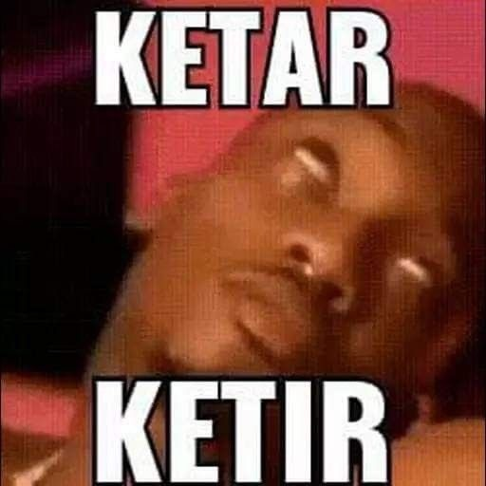 | The image on the right shows a figure known as Ambatukam with eyes rolled back. His expression depicts the peak of ecstasy during masturbation. However, the text shows a completely different meaning.
JMK2 | 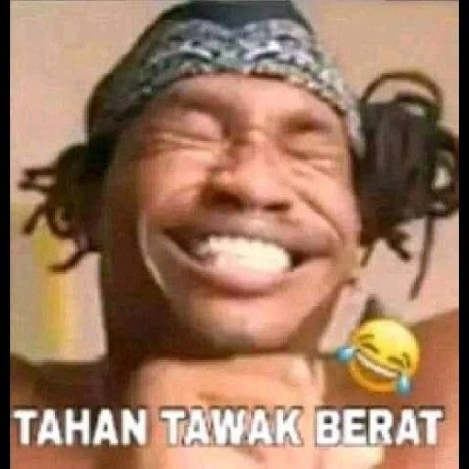 | The meme shows Ambatukam laughing, but with a satisfied expression. As before, the caption shows a similar correlation, namely “tahan tawak berat.” meaning he is holding laugh hardly.
JMK3 | 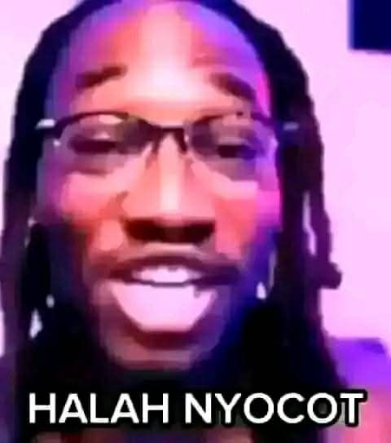 | The meme shows Ambatukam with an expression that seems to mock the reader, with his mouth half open in a tone of derision that matches the meaning of the text.
JMK4 | 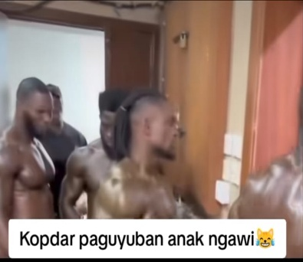 | The photo shows a group of dark-skinned people marching/gathering, but the caption “Kopdar paguyuban anak Ngawi” does not reflect the actual context of the situation at all.
JMK5 | 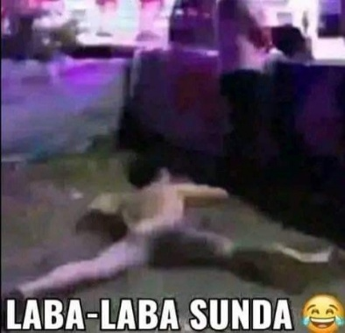 | The photo shows a man lying face down in a public place in a state of nudity. However, the text dismisses the context of the image through the phrase “Laba-laba sunda” and has a completely different meaning.

4. Discussion
Visual Representation of the Author
Jomok memes consistently display visual patterns that focus on specific and repetitive representations of social actors in various images above. Most of the data, especially JMK1, JMK2, and JMK3, use images of black men deliberately taken from adult entertainment videos. According to visual grammar, the choice of a close-up angle forces the audience into an artificially intimate interaction with a subject they do not know personally. Viewed through the lens of Kress's visual semiotic representational aspect, this composition is dominated by the Extreme Close Up technique. This type of framing is usually reserved for intimate relationships or moments of deep introspection that demand the emotional involvement of the audience. Because this visual proximity is imposed unilaterally without any real social relationship, the audience automatically responds by creating a psychological distance that reduces the subject to nothing more than an exotic object of spectacle.

Additionally, one common characteristic of this collection of memes is the broken, blurry image quality. Instead of having clear image quality, so that the audience is not visually disturbed, these jomok memes do the opposite. As in JMK5, which displays vulgar scenes, but with blurring techniques, the meme can ultimately be consumed safely by the public without having to feel uncomfortable with the parts of the body that should be censored. In addition, this trick is quite effective in circumventing the censorship policies of the media platforms where the memes are published. Without having to scribble over or censor the image, censorship can be achieved simply by completely blurring the image. At this point, audiences who are quite disturbed by the visual distortion still understand the reason why the photo is blurred, while also understanding the comedy behind the comprehensive censorship system.

Incongruity Elements
In JMK 2, there is still a correlation between the facial expression and the text below, which appears to be holding back laughter. However, the incongruity here operates at a macro level, referring to the original content obtained from the graphic video. In the actual context, Amba is shown at the peak of ecstasy and sexual satisfaction from masturbation, not because he was holding back laughter from something funny. So the reader, at the first recognition will process the mental models of imagination to “what he was did suspiciously” despite the shown text was referred.
In JMK 4 and 5, there is an extreme mismatch between the image elements and text elements, which act as the main cognitive elements that drive the logic of humor in these visual works. Although Kopdar refers to ‘Kopi daring’, which is a term for an offline gathering of an online community, the scene that refers to the image is more like a gay party scene. Similarly, the phrase “Laba-laba Sunda,” represented by the figure of a man lying on his stomach, has no correlation whatsoever with either the mental model of the reader or the knowledge base of the author of the meme. The naming of these two memes is purely an authentic feature of language, namely arbitrariness, but with a layer of abstract contextual knowledge.
The space for interpretation in the image convincingly proves the existence of a pattern of absurd meme meaning produced through a series of highly unstructured visual semiotic manipulations from the outset. Neither the reader nor the meme creator understands what the essential meaning model is that then transforms into a humorous element. Because each visual and textual component is deliberately measured to distort the audience's initial perception, the process of humor emergence always involves complex decoding stages that greatly burden the collective memory capacity of that specific community.

Social Cognitive and Hyperreality Condition
In Teun A. van Dijk sociocognitive framework social cognition serves as a mediating bridge between discourse structures and social structures where text operates within individual mental models and subsequently accelerates into meme consumer collective knowledge. This stable collective knowledge spreads through social media comments on that humorous content. Such phenomena create new meaning layers by blurring reality boundaries shifting literal message understanding into a full simulacra phase where representative copies entirely replace authenticity essence.
In this context memes function as cognitive triggers activating latent sexuality masculinity and race knowledge while simultaneously providing discursive tools to dampen potential moral conflicts arising from same sex pornographic content circulation in digital public spaces. Morality boundary blurring from a reader perspective becomes clear when they respond to vulgar memes with even more random and absurd reactions leading both consumers and creators into pretense or gimmicks atop an immoral discourse stage. This section presents several comment snapshots and a popular horror game streamer Reza Auditore opinion obtained from TikTok posts featuring several clips interspersed with jomok memes.
The following is a video transcription from TikTok account @hemburgir_ clipping a statement by a horror streamer named Reza Auditore who is known for profane and absurd yet comedic mediashare content during gameplay:
"Gini guys, ngomongin jokes jomok ya... ini konteksnya serius guys. Ngerti nggak sih? Yang bikin lucu dari jomok itu apa? Kayak Amba ngocok, Aldo, segala macem. Itu... yang bikin lucu tuh bukan... bukan karena dia jomok, bukan karena dia gay, tapi kelakuannya tuh aneh. Coba... gini. Kalian cowok, pasti pernah ngocok lah, oke? Tapi pernah nggak lu ngocoknya begini?" Streamer itu menirukan ekspresi amba seperti yang sudah dibahas diatas.
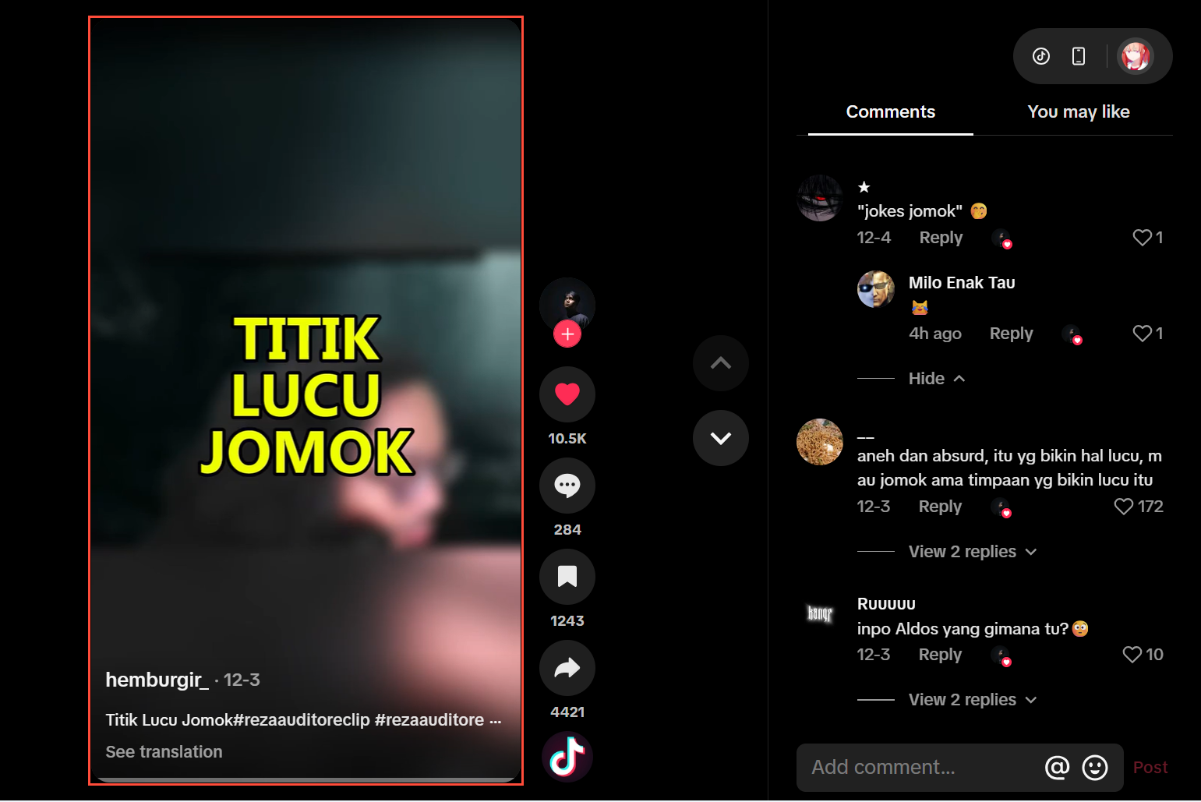
JMK6. Postingan @hemburgir_

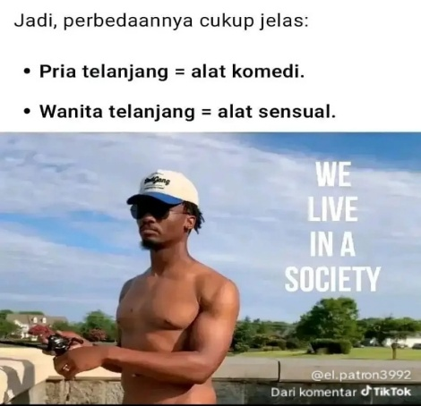
From that statement one conclusion is that he orients the meme as a weird joke regardless of how vulgar or explicit the social actor's actions are even though the meme originated from pornographic video recordings taken from prohibited sites. However the meme has undergone recontextualization causing the total loss of the intended impression from its original source. The use of negation "not because he is jomok/gay" functions as a crucial rhetorical feature. Van Dijk identifies this as a disclaimer strategy providing initial clarification as a mechanism where meme acceptance only begins once the Amba figure has been reduced to a meme object within jomok discourse. He realizes that his topic (same sex pornography) carries heavy social consequences and stigma. To discuss it without losing credibility as a heterosexual male he must immediately deny that the humor stems from sexual orientation itself. The streamer attempts to instill a specific social understanding that strictly distinguishes between personal identity and specific content consumption or actions. Individuals presenting this narrative persuasively convince their audience and likely themselves that enjoying these memes does not automatically grant someone a gay identity or "jomok" in the negative connotation attached to the term (Aslan, 2022). Consider one of the comment snapshots from that post below.
JMK 7. Salah satu komentar Netizen
Above comment snapshots serve as additional evidence that declares that the position of men, when associated with nudity and sensuality, serves as a tool for comedy. Meanwhile, women become objects of sexual gratification. From a photo posted by one user, it is clear that there is a significant cultural imbalance. Because mainstream culture consistently reduces the value of women to their physical attractiveness, any visual representation that shows exposed skin immediately triggers a sexualized response from mainstream society (Gill, 2008). Thus, female nudity in pop culture is rarely interpreted as a neutral narrative or something to laugh about, because its meaning has been shifted by the gender hierarchy that controls how women's bodies are represented and consumed.
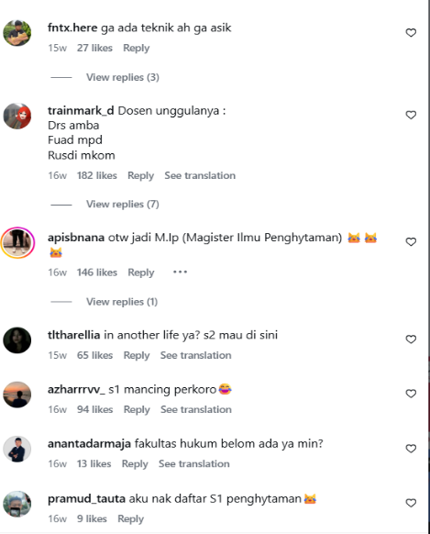
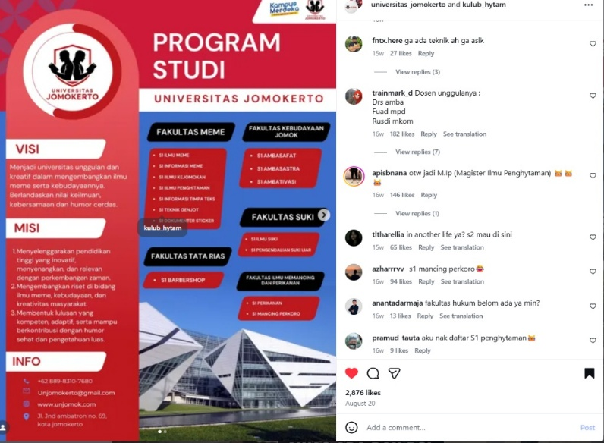
Conversely, visual exposure to male bodies trigasgers very different cognitive defense mechanisms among heteronormative audiences to avoid social panic related to their orientation. Therefore, when groups of men see images of other men exposing their bodies, they must unconsciously deflect the potential erotic threat into comedic material in order to keep their masculine identity safe (Sedgwick, 2003). This process of cognitive trivialization transforms male nudity into an absurd spectacle that frees the audience from the burden of making judgments based on desire or physical attraction (Kimmel, 2012). Because the dominant norm strictly prohibits the objectification of other men in a sensual context, laughter becomes a socially acceptable escape for responding to these images without arousing suspicion. This mechanism of meaning transfer ensures that the meme-loving community can continue to interact with these bare-chested images without undermining the sexual orientation boundaries they have established in the public sphere. In this framework, digital humor potentially reflects complex social dynamics; it can act as a tool of emancipation while simultaneously serving as an instrument of hegemony (Salman Farid & M Radiamoda, 2026)
JMK 8. Postingan @universitas_jomokerto

While previous meme focal points emphasized erotic and amoral nuances from photo fragments, this Instagram post presents the opposite within formal educational institution contexts. This sample represents a perfect collective mental model of social cognition and a simulacra model where participant involvement becomes crucial in perfecting and strengthening the ongoing discourse construction. The Instagram upload featuring a "Universitas Jomokerto" New Student Admission (PMB) brochure stems from shared understanding regarding the previously defined "Jomok" subculture.
At the most basic cognitive processing level, the brochure visual design is engineered to activate official institution schemas in the viewer's mind. Reader brains are guided to process this seemingly serious information before their reasoning is broken and clashed against lexical content completely contradictory to the visual format. The study program list, specifically "S1 Ambasafat," "S1 Ilmu Penghitaman," and "S1 Teknik Genjot," represents signifiers referring to how this community perceives bodies and morality.
The term "Ambasafat" is a unique linguistic fusion between "Amba" (the central Jomok figure) and "Filsafat" (the pinnacle of intellectual thought), so associating these two vastly different discourses produces no inherent meaning essence but merely triggers humor. "Ilmu Penghitaman" tends to touch upon racism issues since the social actors in these memes are predominantly Black. Lastly, "Teknik Genjot" refers to sexual activities that are taboo within societal norms.
Interestingly this post's appeal lies not in how unique the format used in meme presentation is because it is wrapped in formal and serious academic narratives. Initially it creates an impression for readers to examine and digest this information as seen from the new student admission brochure form but the text content is entirely constructed into units and fragments with vastly different contexts and inferences while references are nonexistent since the meme universe exists within a hyperreality dimension. Interactions in the photo comment section provide evidence of how this mental model is adopted and expanded by the audience.

Social Responses of Jomok Memes
Every social event in this world needs to be grounded in context regardless of how trivial it may seem because context allows individuals to fully understand occurrences without creating misconceptions. This also applies to mass entertainment media like memes where almost every type and genre is intertextual as one text always relates to another. If the role of social cognition is vital in how society interprets a meme toward a specific orientation it eventually creates a simulacra layer where race and sexuality aspects have completely transformed into joke material while ignoring taboo standards. This happens through agreements and presuppositions among audiences to treat the entirety of meaning as fictitious which means the authenticity and purity of the original discourse source have faded. Therefore it is clear that establishing a mental model within these cognitive patterns requires a socially recognized context even if it is not comprehensive or universal as it applies only to specific situations and meme community groups (Shifman, 2014; Wiggins, 2020)
Context serves a central function in helping speakers and listeners accurately capture meaning relationships because understanding never exists independently of its surrounding environment and relations. Context encompasses more than just physical conditions during communication since it also involves prior knowledge shared experiences and implicitly understood assumptions among communicating parties so that meaning can be interpreted harmoniously within its social and cognitive situations (Akbari et al., 2024)
The social context in Indonesia which remains highly heteronormative provides a significant reaction to Jomok meme acceptance. Representations of homosexuality and erotic male bodies are generally considered taboo in formal or exhibitionist public spaces. However in Jomok memes such content is accepted as humor because it is framed as a joke format that does not demand moral seriousness. In this regard several of its functions resemble dark humor which uses tragic or ironic events to create a sensation of release or liberation from tension (Rahmanadji, 2007). Humor acts as a social buffer that lowers normative tension allowing audiences to participate without feeling as though they are violating their sexual identity or social values. This process demonstrates how dominant norms are not openly challenged but are instead negotiated through ambiguous sign play.
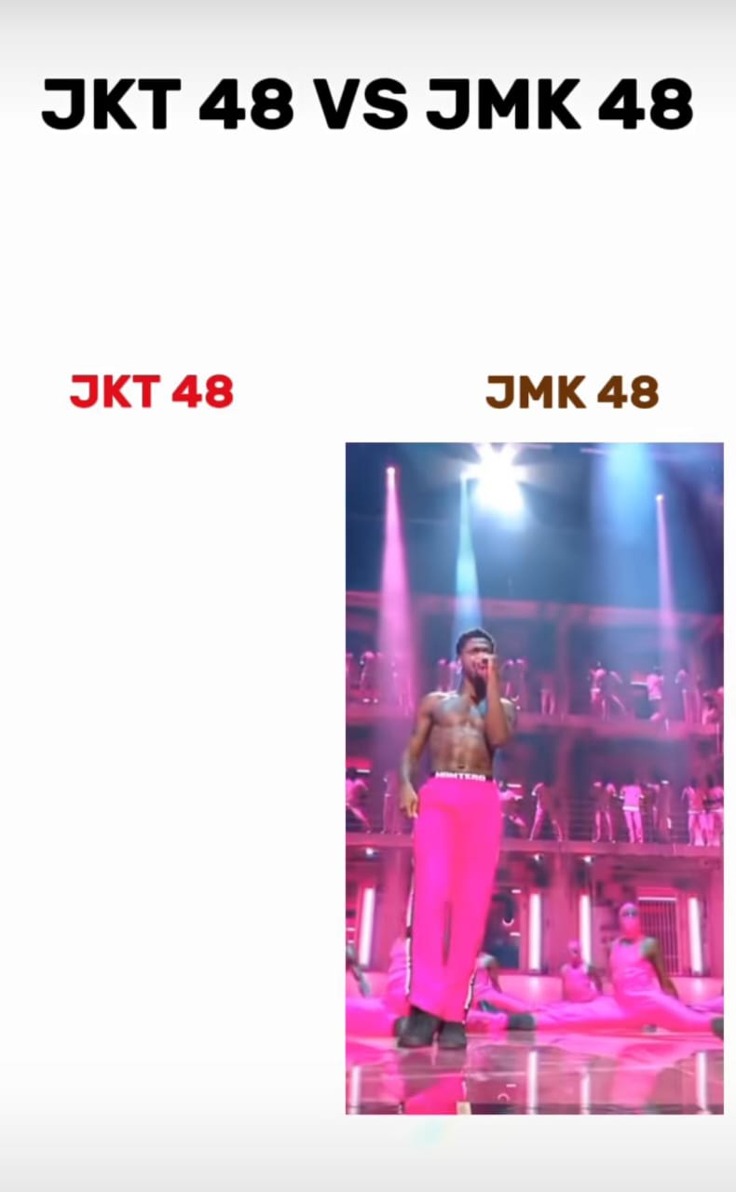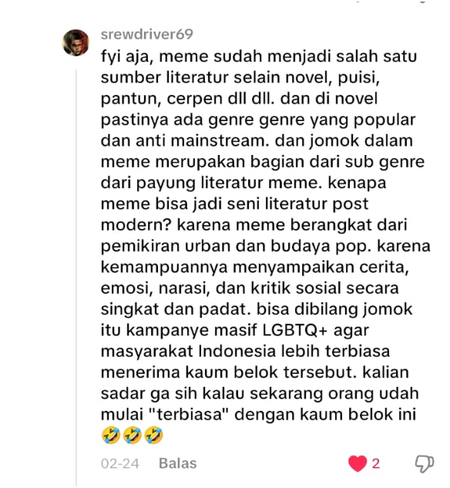
JMK 9. This image is clipped from a TikTok short video

One subparody resulting from the jomok meme is the comparison between the JKT48 idol group pop culture and a fictitious group called JMK48 where identity settings seem to mirror each other but with separate intentions. While the actual idol group presents an image of innocent femininity packaged as a male visual desire consumption object #JMK48 displays the opposite through muscular Black male figures often associated with the adult film industry and then edited to form a seemingly cute idol group. This phenomenon operates within layered social contexts because on one hand it can be read as a sharp satire against excessive idol worship practices while on the other hand it produces specific ideological meanings that require critical reading.
Within Van Dijk discourse analysis framework this meme opens a homosocial space for men to express emotional closeness and affection through intimate greetings without fear of homosexual stigma because the entire interaction is wrapped in an irony and "jomok" humor framework serving as a social shield. This serves as the primary context overshadowing all jomok memes being produced which is a reluctance to uphold morality prerequisites just to consider humor as funny. This setting only operates in Indonesia because its majority population holds strong religious norms and heterogeneous traditional cultural derivatives. Through the disclaimer pattern described above any accusations regarding homosexual humor preferences are immediately contested due to firm belief in their sexual identity which leads to a sense of elitism regarding humor styles full of twists and complex meaning and context reconstruction.
Netizen opinion states that jomok memes are primarily intended to accustom society to sexual minorities. This has a strong cognitive impact on gender discourse if it continues to be produced and consumed repeatedly in everyday life. The public will gradually experience a decline in sensitivity due to massive exposure to homosexual content. This causes the moral reflexes embedded in public perception to weaken and also has a habituation effect. The habituation effect produced by exposure to jomok memes has a very paradoxical social impact on the sustainability of the minority group itself. Minority groups essentially gain a much grander stage of visibility in the digital realm due to the rapid and uncontrolled cycle of meme circulation (Shifman, 2014).
Because their presence is always framed in the form of grotesque jokes and symbolic abuse, society is only willing to accept their existence as mere objects of lowbrow entertainment. Thus, society may appear to be increasingly accustomed to the presence of queer discourse in the public sphere as respect for the human dignity of the subjects concerned disappears.
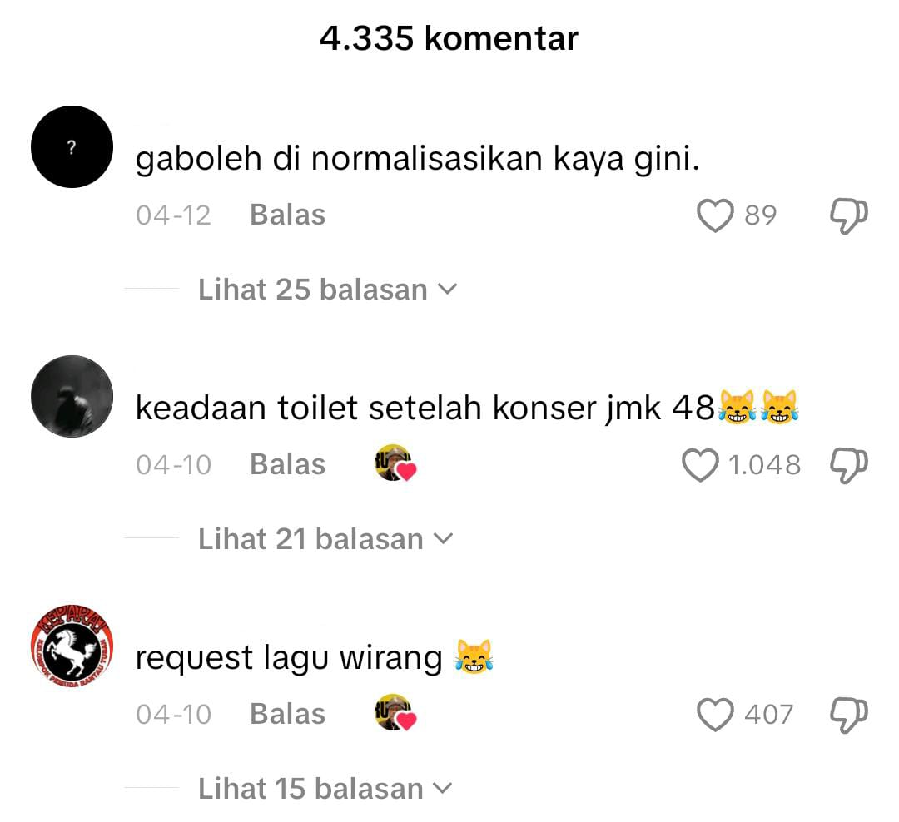
JMK 10. Comments section of previous content

The comments above demonstrate a massive wave of pros and cons within this discourse dimension. Although seemingly in the minority the fact remains that this meme triggers significant rejection from heteronormative circles that uphold social norms public ethics and obedience to natural rules. Even though the schema sequence has been completely altered some parties still refuse to tolerate these representation copies because they believe that allowing small things like memes can lead to a larger erosion of cultural values. Furthermore many public figures state that becoming gay can stem from factors like jokes that gradually increase to a level of comfort at which point they will establish legitimacy for such deviant actions (Ford & Ferguson, 2004; Wieringa et al., 2015).
If pulling back to the initial premise that memes should be aimed at releasing tension then memes that slightly cross the boundaries of what is appropriate will inevitably cause a functional failure which Michael Billig refers to as unlaughter or a deliberate lack of laughter as a form of social discipline. According to Michael Billig humor often loses its safe nature when a joke enters taboo territory or crashes against what is perceived as natural rules so that laughter no longer works as a tension release mechanism but instead appears as a sign of defiance that potentially carries serious social and symbolic risks (Billig, 2005; Warren et al., 2021). At the opposite pole the group of enthusiasts who remain secure in their sexual identity while consuming "Jomok" memes is explained by Simon Weaver who suggests that the function of irony as a cognitive device allows individuals to distance themselves from the serious consequences of a joke so that taboo material can still be enjoyed without triggering moral attachment or truth claims over its content. In this context Jomok memes are understood by enthusiasts not as a reflection of social reality or a form of support for queer agendas but as an absurd construction whose humor arises precisely from its incongruity with their own life experiences (Weaver, 2018)

5. Conclusion
This research yields findings regarding the involvement of unique instruments within multimodal discourse operating on social media platforms through meme materials. The intended impression for readers is not direct but requires a dialectical relationship among fellow meme enthusiasts within a specific community. Through multimodal visual analysis, the conception of hyperreality or simulacra transforming into a humorous existence reality, and the context and cognitive dissociation patterns constructing a discourse of normalized deviance, this study contributes significantly to humor studies, particularly within a multimodal discourse analysis framework.
The Jomok meme phenomenon developing in digital spaces has transformed into a unique, absurd, and unstructured narrative universe. This results in audience involvement that demands creativity and interpretative skills to maintain the image patterns they have built. Ultimately, a meme creator begins as a meme consumer, and the habit of consuming memes with similar types, themes, and categorizations can influence how individuals think and negotiate their identities to be more hybrid, flexible, and open toward content that leans into deviant and explicit actions. This occurs with the caveat that the content creator or consumer has already passed the self-acceptance stage mentioned above, ensuring that the resulting psychic effects do not significantly impact doubt or regret after becoming fully involved in the group.

6. References
Adebomi, O. O. (2025). ‘The land of your fathers lieth in ruins’: A multimodal critical discourse analysis of Nigeria’s 2023 pre-election crises-related internet memes. Discourse & Society, 36(1), 3–22.
Akbari, A., Noortyani, R., & Rafiek, M. (2024). Kajian Pragmatik Terhadap Kritik Sosial Melalui Humor Dark Jokes Tretan Coki Pada Akun “Tiktok” Komedi. Gelapp (Pragmatic Study Of Social Criticism Through Humor Dark Jokes Tretan Coki On The Komedi. Gelapp “Tiktok” Account). JURNAL BAHASA, SASTRA, DAN PEMBELAJARANNYA (JBSP), 14(2), 224–240.
Alugbin, M. (2026). “No Gree for Anybody”: Internet Memes and the Framing of Resistance in Nigerian Online Discourse. In Conflict and Representation in Online Communication (pp. 63–102). IGI Global Scientific Publishing.
Aslan, E. (2022). Review of the Pragmatics of Internet Memes: Chaoqun Xie, John Benjamins, Amsterdam/Philadelphia, 2022 (Hardback), ISBN: 978-90-272-1136-1.
Baudrillard, J. (1994). Simulacra and simulation. University of Michigan press.
Billig, M. (2005). Laughter and ridicule: Towards a social critique of humour. Sage.
Chandler, D. (2022). Semiotics: The basics. Routledge.
Creswell, J. W., & Creswell, J. D. (2018). Research design: Qualitative, quantitative, and mixed methods approaches (Fifth edition). SAGE.
Cundall, M., & Sills, L. (2026). Ethics of Representation in Memes. Thinking Through Memes: Understanding How Memes Work, 141.
Fadia, F. A., & Afriza, N. A. (2023). Tafsir and Gender Normativity in the Digital Age: A Critical Discourse Analysis of Career Women in Instagram Memes. Journal of Ushuluddin and Islamic Thought, 1(2), 164–196.
Ford, T. E., & Ferguson, M. A. (2004). Social Consequences of Disparagement Humor: A Prejudiced Norm Theory. Personality and Social Psychology Review, 8(1), 79–94. https://doi.org/10.1207/S15327957PSPR0801_4
Fubara, S. J. (2020). A Pragmatic Analysis of the Discourse of Humour and Irony in Selected Memes on Social Media. International Journal of Language and Literary Studies, 2(2), 76–95. https://doi.org/10.36892/ijlls.v2i2.281
Gill, R. (2008). Empowerment/sexism: Figuring female sexual agency in contemporary advertising. Feminism & Psychology, 18(1), 35–60.
Griffiths, P., Merrison, A. J., & Bloomer, A. (Eds.). (2020). Language in Use: A Reader (1st ed.). Routledge. https://doi.org/10.4324/9781003060994
Gumilang, L., & Juanda, M. (2018). Interpretation of meme conversations using multimodality analysis. 135–144.
Guntar, M., Husein, R., & Pulungan, A. H. (2024). Stylistic and Rhetoric Elements on Memes in Education Context: A Critical Discourse Analysis. Jurnal Lingua Idea, 15(1), 60. https://doi.org/10.20884/1.jli.2024.15.1.8402
Hakoköngäs, E., Halmesvaara, O., & Sakki, I. (2020). Persuasion Through Bitter Humor: Multimodal Discourse Analysis of Rhetoric in Internet Memes of Two Far-Right Groups in Finland. Social Media + Society, 6(2), 2056305120921575. https://doi.org/10.1177/2056305120921575
Interseksionalitas Ras dan Gender di Media Sosial. Warta Ikatan Sarjana Komunikasi Indonesia, 8(2), 354-371.
Ismail, A., Saleh, M., Malik, A. R., Salam, S., & Rahim, A. (2023). MEME POLITIK SEBAGAI KRITIK WACANA DALAM AKUN FACEBOOK KOMIKKITA: ANALISIS WACANA KRITIS NORMAN FAIRCLOUGH. Lingue : Jurnal Bahasa, Budaya, dan Sastra, 5(2), 1–15. https://doi.org/10.33477/lingue.v5i2.5936
Khairiah, I., & Prihatini, A. (2023). Kritik Sosial dalam Animasi Tekotok: Analisis Wacana Kritis Van Dijk. Satwika: Kajian Ilmu Budaya Dan Perubahan Sosial, 7(2), 328–348.
Kimmel, M. S. (2012). The gender of desire: Essays on male sexuality. State University of New York Press.
Kozinets, R. V. (2015). Netnography: Redefined. sage.
Kress, G. (1990). Critical Discourse Analysis. Annual Review of Applied Linguistics, 11, 84–99. https://doi.org/10.1017/S0267190500001975
Kress, G. (2011). Discourse analysis and education: A multimodal social semiotic approach. In An introduction to critical discourse analysis in education (pp. 205–226). Routledge.
Kress, G., & Van Leeuwen, T. (2020). Reading images: The grammar of visual design. Routledge.
Masruddin, M., Amir, F., Langaji, A., & Rusdiansyah, R. (2023). Conceptualizing linguistic politeness in light of age. International Journal of Society, Culture & Language, 11(3), 41-55.
Moussa, M. B., Benmessaoud, S., & Douai, A. (2020). Internet memes as “tactical” social action: A multimodal critical discourse analysis approach. International Journal of Communication, 14, 21.
Norris, S. (2004). Analyzing multimodal interaction: A methodological framework. Routledge, Taylor & Franics. https://doi.org/10.4324/9780203379493
Nugroho, A. (2024). A Multimodal Analysis of Implicature and Gender Representation in English and Indonesian Memes. 210–220.
Perangin-angin, A. Br., Ulfa, M., Putri, C. A., & Sujatmoko, K. (2025). Feminist Narratives in Memes through Socio-Cognitive Analysis. Tradition and Modernity of Humanity, 5(2). https://doi.org/10.32734/tmh.v5i2.21671
Rahmanadji, D. (2007). Sejarah, teori, jenis, dan fungsi humor. Jurnal Bahasa Dan Seni, 35(2), 213–221.
Salman Farid, A., & M Radiamoda, A. (2026). Digital Satire as Political Discourse: Humor, Memes, and Resistance in Philippine Internet Culture. Asian Journal of Media and Culture, 2(1), 49–71. https://doi.org/10.63919/ajmc.v2i1.68
Sasongko, G. S., & Andaninggar, D. R. R. (2021). A Critical Discourse Analysis: Social Propaganda in English Joke Memes. SALIENCE: English Language, Literature, and Education, 1(1).
Sedgwick, E. K. (2003). Between men: English literature and male homosocial desire (Nachdr.). Columbia Univ. Press.
Sembiring, F. R. P., & Pratiwi, A. (2025). Meme Jomok sebagai Representasi
Setiawan, E. I., Masruddin, M., & Zainuddin, Z. (2023). Semiotic Analysis and Ethnography Study on the Implementation of Local Wisdom in Economic Field at Luwu Society. IDEAS: Journal on English Language Teaching and Learning, Linguistics and Literature, 11(2), 1912-1925.
Sharma, R. (2026). Memes, Media, and Meaning: Racial Discourse in Digital Popular Culture. Baltic Journal of Multidisciplinary Research, 3(1), 1–5.
Shifman, L. (2014). Memes in digital culture. The MIT Press.
Van Dijk, T. A. (2001). Discourse, ideology and context.
Van Dijk, T. A. (2015). Critical discourse analysis. The Handbook of Discourse Analysis, 466–485.
Wahyudi, U. (2025). Narasi Meme sebagai Mekanisme Kontrol Sosial: Analisis Wacana Visual dalam Budaya Digital. Journal of Mandalika Social Science, 3(1), 48–54.
Warren, C., Barsky, A., & McGraw, A. P. (2021). What makes things funny? An integrative review of the antecedents of laughter and amusement. Personality and Social Psychology Review, 25(1), 41–65.
Weaver, S. (2018). The rhetoric of racist humour: US, UK and global race joking. Ashgate.
Wieringa, S. E., Bhaiya, A., Katjasungkana, N., Qadar, A. A., Situmorang, B. S., Borah, B. M., Sulistyowati, E., Hidayana, I., Rao, P., Munti, R. B., Adhlaka, R., Berar, S., & Santoso, W. (2015). Heteronormativity, Passionate Aesthetics and Symbolic Subversion in Asia. Liverpool University Press. https://doi.org/10.2307/j.ctv32bm16t
Wiggins, B. E. (2020). The discursive power of memes in digital culture: Ideology, semiotics, and intertextuality (First issued in paperback). Routledge.

